
BHADRAK ENGINEERING SCHOOL & TECHNOLOGY (BEST), ASURALI, BHADRAK


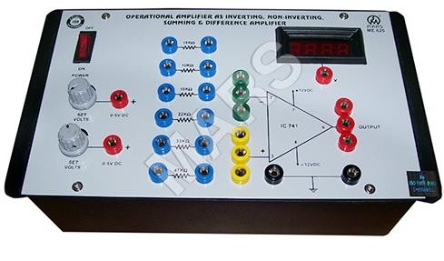
Analog Electronics & Linear IC
(Th- 04)
(As per the 2019-20 syllabus of the SCTE&VT, Bhubaneswar, Odisha)

Fourth Semester

Electronics & Tele-communication Engg.
Prepared By: Er D Mohapatra

ANALOG ELECTRONICS & LINEAR IC
CHAPTER-WISE DISTRIBUTION OF PERIODS & MARKS

Unit No. | Name of the Unit | No. of Periods as per Syllabus | Expected Marks
01 | DIODE, TRANSISTORS & CIRCUITS | 10 | 20
02 | AUDIO POWER AMPLIFIER | 08 | 15
03 | FIELD EFFECT TRANSISTOR(FET) | 10 | 10
04 | FEED BACK AMPLIFIER&OSCILLATOR | 08 | 10
05 | TUNED AMPLIFIER&WAVE SHAPING CIRCUIT | 12 | 15
06 | OPERATIONAL AMPLIFIER CIRCUITS & FEEDBACK CONFIGURATION | 14 | 15
07 | APPLICATION OF OPERATIONAL AMPLIFIER, TIMER CIRCUTS & IC VOLTAGE REGULATOR | 13 | 15
Total |  | 75 | 100

UNIT NO.- 01
DIODE, TRANSISTORS AND CIRCUITS

LEARING OBJECTIVES:
  - Working principle of diode & its current equation, specification & uses of pn junction diode.
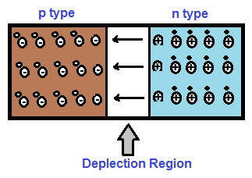
  - Breakdown of diode (avalance&zener break down) &construction, working, characteristics.
  - Classification of rectifiers & working of different types of rectifiers-Half wave rectifier, Full wave rectifier (CT & BRIDGE type).
  - Working of PNP & NPN transistors & different types of transistor connections (CB, CE&CC) &input and output characteristics of transistor in different connections.
  - Define alpha, bita and gamma of transistors in various modes. Establish the mathematical relationship between them.
  - Basic concept of biasing, types of biasing-parameter model of BJT,load line(AC&DC)and determine the Q-point.
  - Types of coupling, working principle and use of R-C coupled amplifier & frequency responses of R-C coupled amplifier & draw the curve.

WORKING PRINCIPLE OF DIODE & ITS CURRENT EQUATION, SPECIFICATION & USES OF PN JUNCTION DIODE:

CONSTRUCTION & WORKING PRINCIPLE OF DIODE: -
    - When a p-type semiconductor is suitably joined to n-type semiconductor, the contact surface is called PN-junction.

Formation of PN – junction:
    - The formation of pn junction in a single crystal due to doping with p type and n type material is shown in figure below.

    - In the above figure, left side of crystal is p type while the right side is n type. The positively charged donor ions in n type is shown by encircled plus sign while negatively charge acceptor ions are shown by encircled minus sign. The circuit symbol of pn junction diode is shown below.

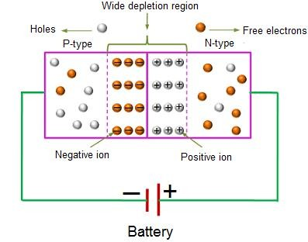
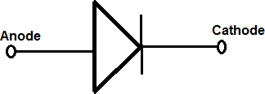

Working Principle of pn Junction Diode: -

Forward bias of PN junction diode: -
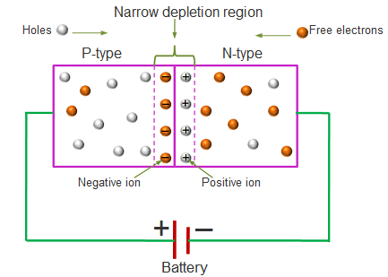
The diode is forward biased. The positive terminal of the battery is connected to the anode of a diode and negative terminal to the cathode.
      - When battery is not connected, there is a barrier potential of 0.3 V for Silicon and 0.7 V for Germanium across the across the P-N junction of a diode.
      - Due to majority charge carriers the external applied voltage of forward bias is opposed by the barrier voltage and the diode does not conduct the current.
      - The applied voltage is increased above the barrier potential, it overcome the opposition of barrier potential and diode conducts the current due to majority carriers.
      - This current is known as forward current and flows from anode to cathode through the diode.
      - It is of the order of 20 to 50 mA at about 1V.

Reverse bias of PN junction diode: -

        - The negative terminal of the battery is connected to the anode of a diode and positive terminal of battery is connected to cathode. Hence, the diode is reverse bias.
        - When diode is reverse biased, majority carriers are blocked and only a small current flow through the diode due to the minority charge carriers.
        - As the reverse voltage is increased from zero, the reverse current very quickly reaches its saturation value which is also called as leakage current or reverses saturation current.
        - It is of the order of nanoamperes (nA) for Silicon and microamperes (µA) for Germanium.
Current Equation of PN Junction Diode: -
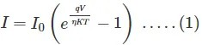
    - Diode current equation expresses the relationship between the current flowing through the diode as a function of the voltage applied across it. Mathematically it is given as,

Where,
I is the current flowing through the diode
I0 is the dark saturation current,
q is the charge on the electron,
V is the voltage applied across the diode,
η is the (exponential) ideality factor.
is the Boltzmann constant
T is the absolute temperature in Kelvin.

Uses of PN Junction Diode: -
- P-N junction diode can be used as a photodiode.
- It can be used as a solar cell.
- It can be used in LED lighting applications.
- It is used as rectifiers and as a voltage-controlled oscillator in varactors.

BREAKDOWN OF DIODE (AVALANCE&ZENER BREAK DOWN) &CONSTRUCTION, WORKING, CHARACTERISTICS:

VOLT-AMPERE (V-I) CHARACTERISTICS OF PN JUNCTION: -
    - Volt-ampere or V-I characteristic of a pn junction is the curve between voltage across the junction and the circuit current.
    - Usually, voltage is taken along x-axis and current along y-axis. Fig. shows the circuit arrangement for determining the V-I characteristics of a pn junction.
    - The characteristics can be studied under three heads namely:
- Zero external voltage
- Forward Bias
- Reverse Bias.

ZERO EXTERNAL VOLTAGE: -
  - When the external voltage is zero, i.e., circuit is open at K; the potential barrier at thejunction does not permit current flow.
  - Therefore, the circuit current is zero as indicated by point O in Fig.

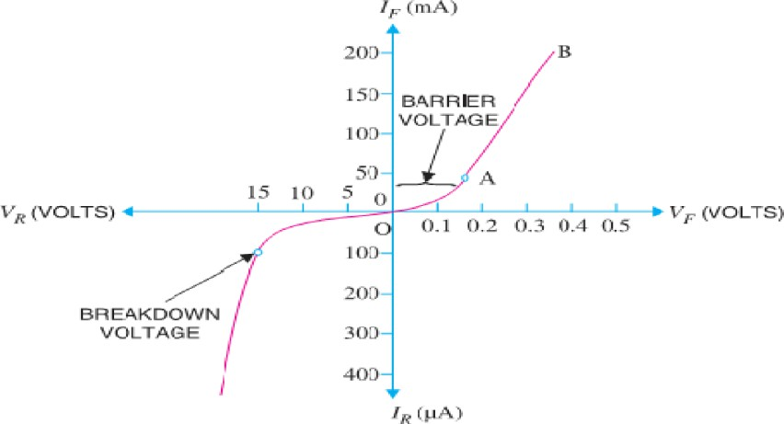
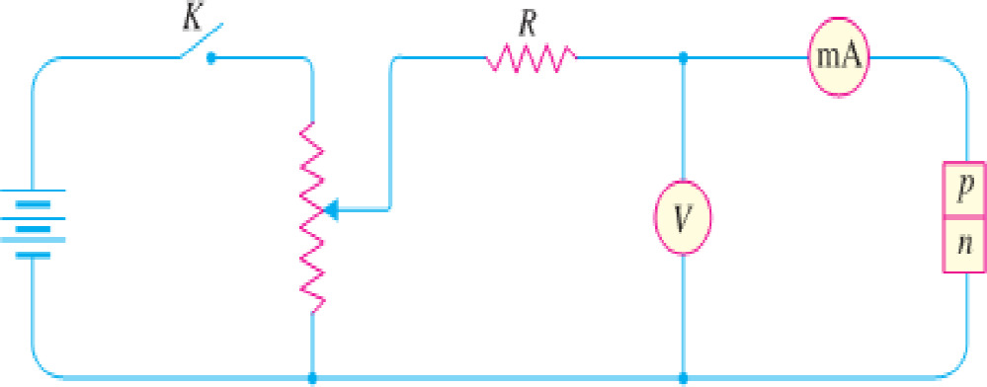
FORWARD BIAS: -
  - With forward bias to the pn junction i.e., p-type connected to positive terminal and n-type connected to negative terminal, the potential barrier is reduced.
  - At some forward voltage (0.7 V for Si and 0.3 V for Ge), the potential barrier is altogether eliminated and current starts flowing in the circuit.
  - From now onwards, the current increases with the increase in forward voltage.
- Thus, a rising curve OB is obtained with forward bias as shown in Fig. From the forward characteristic, it is seen that at first (region OA), the current increases very slowly andthe curve is non-linear.
- It is because the external applied voltage is used up in overcoming the potential barrier.
  - However, once the external voltage exceeds the potential barrier voltage, the pn junction behaves like an ordinary conductor.
  - Therefore, the current rises very sharply with increase in external voltage (region AB on the curve). Here the curve is almost linear.

REVERSE BIAS: -
  - With reverse bias to the pn junction i.e., p-type connected to negative terminal and n-type connected to positive terminal, potential barrier at the junction is increased.
- Therefore, the junction resistance becomes very high and practically no current flows through the circuit.
  - However, in practice, a very small current (of the order of μA) flows in the circuit withreverse bias as shown in the reverse characteristic.
  - This is called Reverse Saturation Current (Is) and is due to the minority carriers.
  - It may be recalled that there are a few free electrons in p-type material and a few holes in n-type material.
  - These undesirable free electrons in p-type and holes in n-type are called minority carriers. Therefore, a small current flow in the reverse direction.
    - If reverse voltage is increased continuously, the kinetic energy of electrons (minority carriers)

may become high enough to knock out electrons from the semiconductor atoms.
    - At this stage breakdown of the junction occurs, characterized by a sudden rise of reverse current and a sudden fall of the resistance of barrier region. This may destroy the junction permanently.
    - Note: -The forward current through a p-n junction is due to the majority carriers produced by the impurity.
    - However, reverse current is due to the minority carriers produced due to breaking of some covalent bonds at room temperature.

IMPORTANT TERMS: -
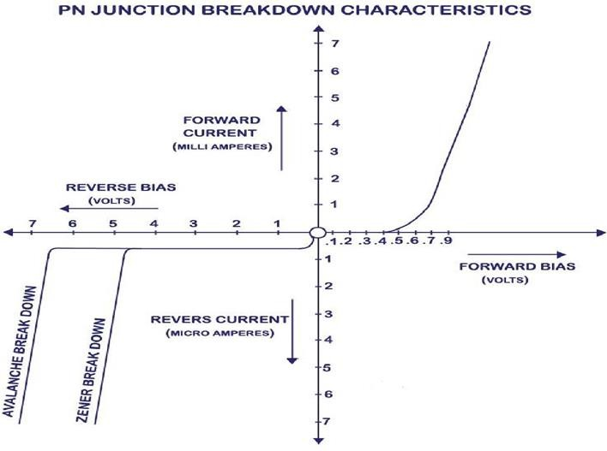
- BREAKDOWN VOLTAGE: - It is the minimum reverse voltage at which pn junction breaks down with sudden rise in reverse current.
- KNEE VOLTAGE: - It is the forward voltage at which the current through the junction starts to increase rapidly.
- PEAK INVERSE VOLTAGE (PIV): - It is the maximum reverse voltage that can be applied to the pn junction without damage to the junction. If the reverse voltage across the junction exceeds its PIV, the junction may be destroyed due to excessive heat.
- MAXIMUM FORWARD CURRENT: - It is the highest instantaneous forward current that a pn junction can conduct without damage to the junction.
- MAXIMUM POWER RATING: - It is the maximum power that can be dissipated at the junction without damaging it.

DC LOAD LINE: -
  - The line obtained by joining the maximum values of Ic and Vce in the output characteristics of a CE configuration transistor is known as the DC Load Line.

PN JUNCTION BREAKDOWN: -

  - Electrical break down of semiconductor can occur due to two different phenomena.Those two phenomena are,
- Zener breakdown
- Avalanche breakdown

ZENER BREAKDOWN: -
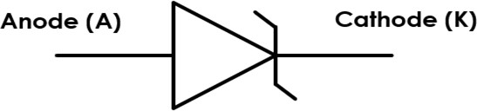
  - A properly doped crystal diode whichhas a sharp breakdown voltage is knownas a Zener Diode.

  - It has already been discussed that when the reverse bias on a crystal diode is increased, a critical voltage, called Breakdown Voltage is reached where the reverse current increasessharply to a high value.
  - The breakdown region is the knee of the reverse characteristic as shown in Figure.
  - The breakdown voltage is sometimes called Zener Voltage and the sudden increase in current is known as Zener Current.
  - The breakdown or Zener voltage depends upon the amount of doping. If the diode is heavily doped, depletion layer will be thin and consequently the breakdown of the junction will occur at a lower reverse voltage.
  - On the other hand, a lightly doped diode has a higher breakdown voltage. Fig. shows the symbol of a Zener diode. It may be seen that it is just like an ordinary diode except that the bar is turned into z-shape.

AVALANCHE BREAKDOWN: -
  - Avalanche breakdown occurs in a p-n junction diode which is moderately doped and has a thick junction (means its depletion layer width is high).
  - Avalanche breakdown usually occurs when we apply a high reverse voltage across the diode (obviously higher than the Zener breakdown voltage, say Vz).
  - By increasing the applied reverse voltage, the electric field across junction will keep increasing. If applied reverse voltage is Va and the depletion layer width is d, then the generated electric field can be calculated as Ea =Va/d.
  - This generated electric field exerts a force on the electrons at junction and it frees them from covalent bonds. These free electrons will gain acceleration and it will start moving across the junction with high velocity.
  - This results in collision with other neighboring atoms. These collisions in high velocity will generate further free electrons. These electrons will start drifting and electron-hole pair recombination occurs across the junction. This results in net current which rapidly increases.

CLASSIFICATION OF RECTIFIERS & WORKING OF DIFFERENT TYPES OF RECTIFIERS-HALF WAVE RECTIFIER, FULL WAVE RECTIFIER (CT & BRIDGE TYPE):

RECTIFIERS: -
INTRODUCTION: -
    - Rectifier is an electronic ckt which converts AC to pulsating DC.
    - The following two rectifier circuits can be used: -
- Half-wave rectifier
- Full-wave rectifier

HALF-WAVE RECTIFIER: -
    - In half-wave rectification, the rectifier conducts current only during the positive half-cycles of input
A.C. Supply.
    - The negative half-cycles of A.C. Supply is suppressed i.e. during negative half-cycles, no current isconducted and hence no voltage appears across the load.
    - Therefore, current always flows in one direction.

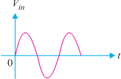
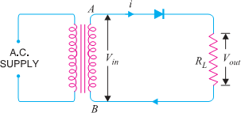
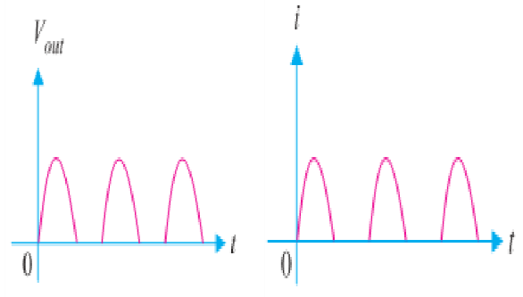
(INPUTWAVEFORM) (Half wave Rectifier Circuit) (Output voltage wave) (Output Current) Circuit Details: -
      - The above Fig shows the circuit where a single crystal diode acts as a half-wave rectifier.
      - The A.C. Supply to be rectified is applied in series with the diode and load resistance RL.
      - Generally, Supply is given through a transformer.
      - The use of transformer permits two advantages.
      - Firstly, it allows us to step up or step down the A.C. input voltage as the situation demands.
      - Secondly, the transformer isolates the rectifier circuit from power line and thus reduces the risk of electric shock.

OPERATION: -
      - The A.C. voltage across the secondary winding AB changes polarities after every half-cycle.
      - During the positive half-cycle of input A.C. voltage, end A becomes positive w.r.t. end B. This makes the diode forward biased and hence it conducts current.
      - During the negative half-cycle, end A is negative w.r.t. end B. Under this condition, the diode is reverse biased and it conducts no current.
    - Therefore, current flows through the diode during positive half-cycles of input A.C. voltage only; it is blocked during the negative half-cycles. In this way, current flows through load RL always in the same direction. Hence D.C. output is obtained across RL.
      - It may be noted that output across the load is pulsating D.C.

Disadvantages: -
The A.C. supply delivers power only half the time. Therefore, the output is low.

FULL-WAVE RECTIFIER: -
    - In full-wave rectification, current flows through the load in the same direction for both half- cycles ofinput A.C. voltage. This can be achieved with two diodes working alternately.
    - For the positive half- cycle of input voltage, one diode supplies current to the load and for the negativehalf-cycle, the other diode does so; current being always in the same direction through the load.
    - Therefore, a full-wave rectifier utilizes both half-cycles of input A.C. voltage to produce the D.C. output.
    - The following two circuits are commonly used for full-wave rectification: -
(I)Centre-tap full-wave rectifier
(II) Full-wave bridge rectifier

CENTRE-TAP FULL-WAVE RECTIFIER: -

Circuit Details: -
  - The circuit employs two diodes D1 and D2 as shown in Fig below. A Centre tapped secondary windingAB is used with two diodes connected so that each uses one half-cycle of input A.C. voltage.
  - In other words, diode D1 utilizes the A.C. voltage appearing across the upper half (OA) of secondarywinding for rectification while diode D2 uses the lower half winding OB.

Circuit Operation: -
  - During the positive half-cycle of secondary voltage, the end A of the secondary winding becomespositive and end B negative. This makes the diode D1 forward biased and diode D2 reverse biased.

  - Therefore, diode D1 conducts while diode D2 does not. The conventional current flow is through diodeD1, load resistor RL and the upper half of secondary winding as shown by the dotted arrows.
  - During the negative half-cycle, end A of the secondary winding becomes negative and end B positive.
  - Therefore, diode D2 conducts while diode D1 does not. The conventional current flow is through diodeD2, load RL & lower half winding shown by solid arrows.
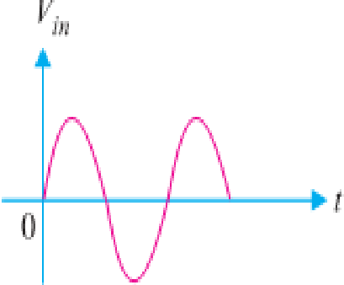
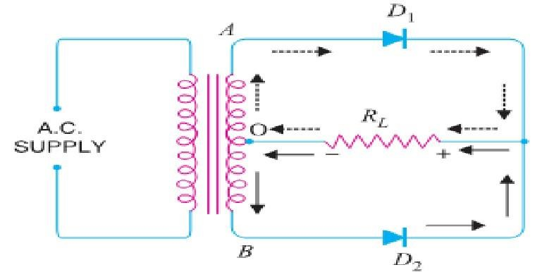
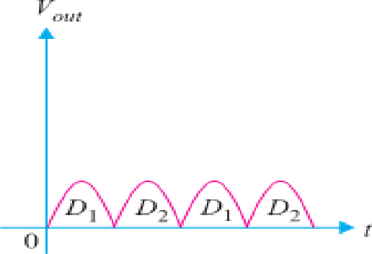
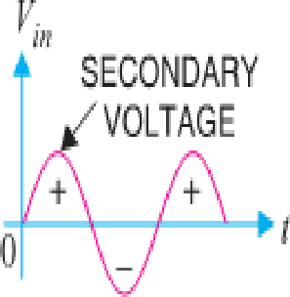
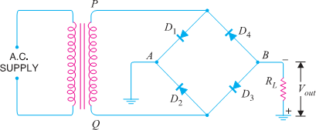
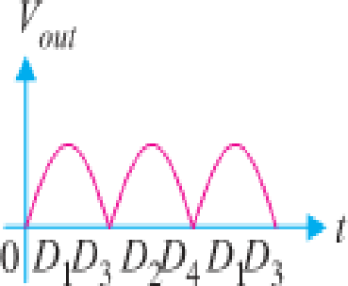
  - It may be seen that current in the load RL is in the same direction for both half-cycles of input A.C.voltage. Therefore, D.C. is obtained across the load RL.

(Input Wave form) (Centre-Tap Full-Wave Rectifier Circuit) (Output wave form) Advantages: -
- The D.C. output voltage and load current values are twice than that of a half wave rectifier.
- The ripple factor is much less (0.482) than that of half rectifier (1.21).
- The efficiency is twice (81.2%) than that of half wave rectifier (40.6%).

Disadvantages: -
- It is difficult to locate the Centre tap on the secondary winding.
- The D.C. output is small as each diode utilizes only one-half of the transformer secondary voltage.
- The diodes used must have high peak inverse voltage.

FULL-WAVE BRIDGE RECTIFIER: -

Circuit Details: -
  - The need for a Centre tapped power transformer is eliminated in the bridge rectifier.
  - It contains four diodes D1, D2, D3 and D4 connected to form bridge as shown in Fig below.
    - The A.C. supply to be rectified is applied to the diagonally opposite ends of the bridge through thetransformer.
  - Between other two ends of the bridge, the load resistance RL is connected.

(Input Wave Form) (Full-Wave Bridge Rectifier Circuit) (Output wave form)

CIRCUIT OPERATION:
    - During the positive half-cycle of secondary voltage, the end P of the secondary winding becomes positive and end Q negative.
    - This makes diodes D1 and D3 forward biased while diodes D2 and D4 are reverse biased.
    - Therefore, only diodes D1 and D3 conduct. These two diodes will be in series through the load RL

as shown in Fig. below. The conventional current flow is shown by dotted arrows. It may be seen that current flows from A to B through the load RL.
    - During the negative half-cycle of secondary voltage, end P becomes negative and end Q positive. This makes diodes D2 and D4 forward biased whereas diodes D1 and D3 are reverse biased.
    - Therefore, only diodes D2 and D4 conduct. These two diodes will be in series through the load RL as shown in Fig. below. The current flow is shown by the solid arrows.
    - It may be seen that again current flows from A to B through the load i.e., in the same direction as for the positive half-cycle. Hence, D.C. output is obtained across load RL.

Advantages: -

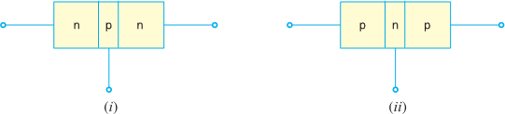
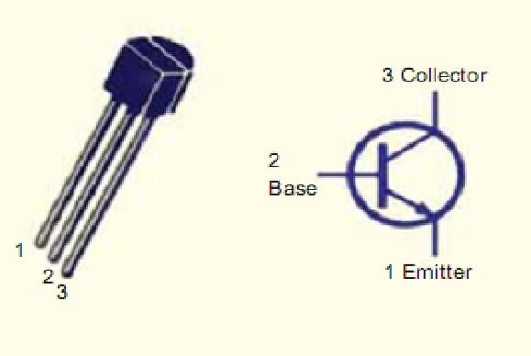
- The need for Centre-tapped transformer is eliminated.
- The output is twice that of the Centre-tap circuit for the same secondary voltage.
- The PIV is one-half that of the Centre-tap circuit (for same D.C. output).

Disadvantages: -
  - It requires four diodes.
  - Internal resistances high.

WORKING OF PNP & NPN TRANSISTORS & DIFFERENT TYPES OF TRANSISTOR CONNECTIONS(CB, CE&CC) &INPUT AND OUTPUT CHARACTERISTICS OF TRANSISTOR IN DIFFERENT CONNECTIONS:

TRANSISTORS: -

INTRODUCTION: -
    - A transistor is a semiconductor device used to amplify or switch electronic signals.
    - A transistor is formed by connecting two PN junction back-to-back.
    - Hence Transistor is classified into two types, namely: -
(i) n-p-n transistor (ii) p-n-p transistor
    - An n-p-n transistor is composed of two n-type semiconductors separated by a thin section of p-type.
    - However, a p-n-p transistor is formed by two p-sections separated by a thin section of n-type as shown in Figure below.

NAMING: -
    - A transistor has two pn junctions. One junction is forward biased and the other isreverse biased.
    - The forward biased junction has a low resistance path whereas a reverse biased junction has a high resistance path.

NAMING THE TRANSISTOR TERMINALS: -
    - A transistor (PNP or NPN) has three terminals.i.e, i.Emitter
- Base
- Collector

Emitter: -
    - The section on one side that supplies charge carriers (electrons or holes) is called the emitter.
    - The emitter is always forward biased w.r.t. base so that it can supply a large number of majority carriers.

Base: -
    - The middle section which forms two PN-junctions between emitter & collector is called base.
    - The base-emitter junction is forward biased, allowing low resistance for the emitter circuit.
    - The base-collector junction is reverse biased and provides high resistance in the collector circuit.

(iii)Collector: -
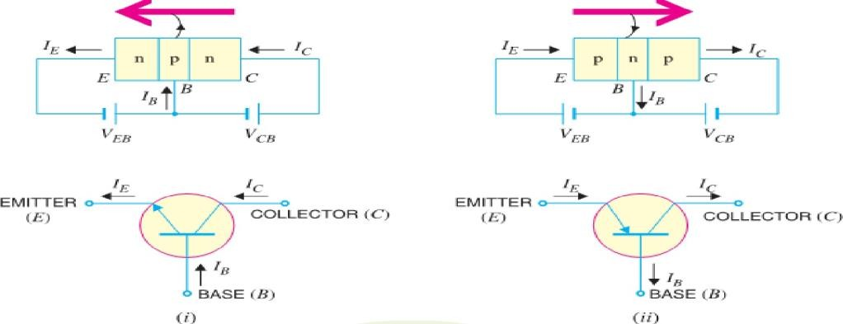
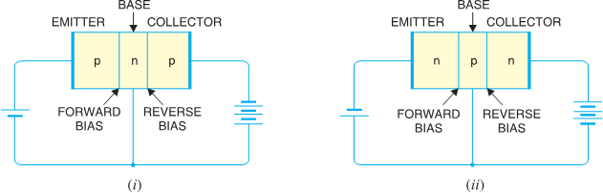
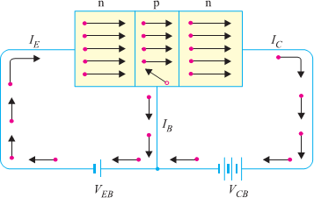
    - The section on the other side that collects the charges is called the collector. The collector is always reverse biased. Its function is to remove charges from its junction with the base.

TRANSISTOR SYMBOL:-

WORKING OF NPN TRANSISTOR (NPN): -
    - The NPN transistor with forward bias to emitter- base junction & reverse bias to collector-base junction.
    - The forward bias causes the electrons in the n-type emitter to flow towards the base.
    - This constitutes the emitter current IE. As these electrons flow through the p-type base, they tend to combine with holes.
    - As the base is lightly doped and very thin, therefore, only a few electrons (less than 5%) combine with holes to constitute base current IB.
    - The remainders (more than 95%) cross over into the collector region to constitute collector current IC.
    - In this way, almost the entire emitter current flowsin the collector circuit.
    - It is clear that emitter current is the sum of collector and base currents i.e., IE = IB + IC

WORKING OF PNP TRANSISTOR (PNP): -
    - Fig. shows the basic connection of a PNP transistor.
    - The forward bias causes the holes in the p-typeemitter to flow towards the base.
    - This constitutes the emitter current IE.

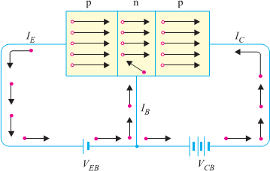
    - As these holes cross into n-type base, they tend to combine with the electrons.
    - As the base is lightly doped and very thin, therefore,only a few holes (less than 5%) combine with the electrons. The remainder (more than 95%) cross intothe collector region to constitute collector current IC.
    - In this way, almost the entire emitter current flows in the collector circuit.
    - It may be noted that current conduction within PNP transistor is by holes. However, in the external connecting wires, the current is still by electrons.

TRANSISTOR CONNECTIONS: -
    - Transistor can be connected in a circuit in the following ways: -
    - Common Base connection
    - Common Emitter connection
    - Common Collectorconnection

Common Base Connection:
    - In this circuit arrangement, input is applied between emitter and base and output is taken fromcollector and base.
    - Here, base of the transistor is common to both input and output circuits and hence the name
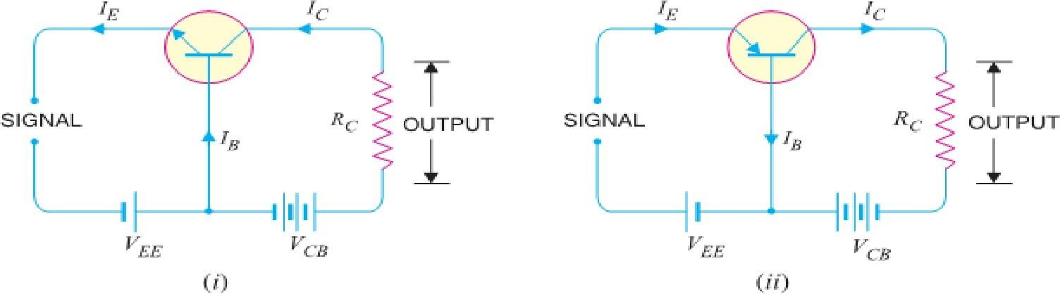
Common Base connection. A Common Base NPN and PNP in figure below.

Common Emitter Connection:
    - In this circuit arrangement, input is applied between base and emitter and output is taken fromthe collector and emitter.
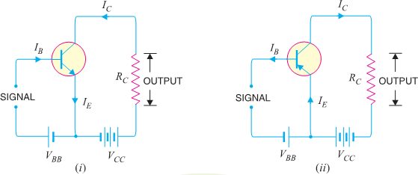
    - Here, emitter of the transistor is common to both input and output circuits and hence the name Common Emitter connection. A Common Emitter NPN and PNP transistor circuit is shown in figure below.

Common Collector Connection:
    - In this circuit arrangement, input is applied between base and collector while output is taken between the emitter and collector.
    - Here, collector of the transistor is common to both input and output circuits and hence the name

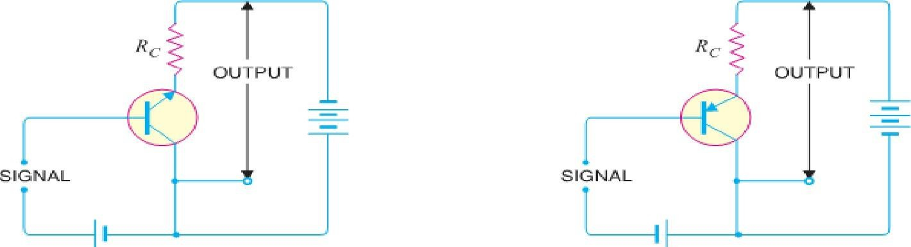
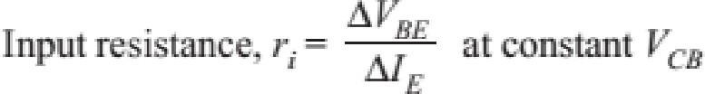
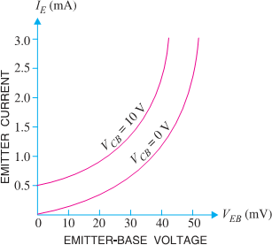
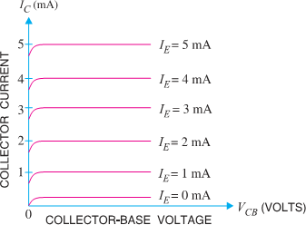
Common Collector connection. A Common Collector NPN and PNP in figure below.

TRANSISTOR CHARACTERISTICS: -

Characteristics of Common Base Connection: -
    - The complete electrical behavior of a transistor can be described by stating the inter relation of the various currents and voltages.
    - These relationships can be conveniently displayed graphically and the curves thus obtained are known as the characteristics of transistor.
    - The most important characteristics of common base connection are input characteristics and outputcharacteristics.

Input Characteristics: -
    - It is the curve between emitter current IE & emitter-base voltage VBE at constant collector-base voltage VCB.
    - The emitter current is generally taken along Y- axis and emitter-base voltage along X-axis. Fig. Shows the input characteristics of a typical transistor in CB arrangement.
    - The emitter current IE increases rapidly with smallincrease in emitter-base voltage VEB. It means that input resistance is very small.
    - The emitter current is almost independent of collector-base voltage VCB. This leads to the conclusion that emitter current (and hence collector current) is almost independent of collector voltage.
    - Input Resistance: - It is the ratio of change in emitter-base voltage (ΔVEB) to the resulting change in emitter current (ΔIE) at constant collector-base voltage (VCB) i.e.

    - In fact, input resistance is the opposition offered to the signal current. As a very small VEB is sufficient toproduce a large flow of emitter current IE, thus, input resistance is quite small, of the order of a few ohms.

Output Characteristics: -
    - It is the curve between collector current IC & collector- base voltage VBC at constant emitter current IE.
    - Generally, collector current is taken along y-axis and
collector-base voltage along x-axis.
    - The fig. shows the input and output characteristics of a typical transistor in CB arrangement.
    - The following points may be noted from characteristics:
    - The collector current IC varies with VCB only at very low voltages (< 1V). The transistor is never operatedin this region.
    - When the value of VCB is raised above 1 − 2 V, the collector current becomes constant as indicated by

straight horizontal curves. It means that now IC is independent of VCB and depends upon IE only. Thisis consistent with the theory that the emitter current
flows almost entirely to the collector terminal. The transistor is always operated in this region.
    - A very large change in collector-base voltage produces only a tiny change in collector current. This means that output resistance is very high.
Output Resistance: - It is the ratio of change in collector-base voltage (ΔVCB) to the resulting change in collector current (ΔIC) at constant emitter current i.e.
∆𝑉_{𝐶𝐵}

𝑂𝑢𝑡𝑝𝑢𝑡, 𝑟₀ =
∆𝑉_{𝐶}
𝑎𝑡 𝑐𝑜𝑛𝑠𝑡𝑎𝑛𝑡 𝐼_{𝐸}

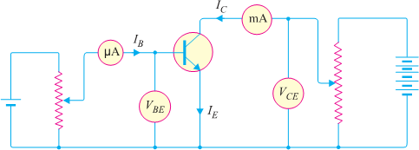
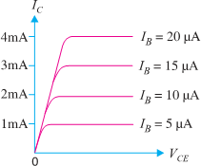
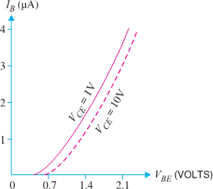
Characteristics of Common Emitter Connection: -
    - The important characteristics of this circuit arrangement are the input characteristic and output characteristic.

(Circuit Arrangement for studying Common Emitter Connection of Transistor)

Input Characteristics: -
    - It is the curve between base current IB & base-emitter voltage VBE at constant collector-emitter volt VCE. The input characteristics of a CE connection can be
determined by the circuit shown in Fig. Keeping VCE constant (Let 10 V), note the base current IB for various values of VBE.
    - Then plot the readings obtained on the graph, taking IB along y-axis and VBE along x-axis. This gives the input characteristic at VCE = 10V as shown in Fig.
    - The characteristic resembles that of a forward biased diodecurve. This is expected since the base- emitter section of transistor is a diode and it is forward biased.
    - As compared to CB arrangement, IB increases less rapidly with VBE. Therefore, input resistance of a CE circuit is higher than that of CB circuit.
    - Input Resistance: - It is the ratio of change in base-emitter voltage (ΔVBE) to the change in base current (ΔIB) at constant VCE. The value of input resistance for CE circuit is of the order of a few hundred ohms

Output Characteristics: -
    - It is the curve between collector current IC and collector- emitter voltage VCE at constant base current IB.
    - The output characteristics of CE circuit can be drawn with
the help of above circuit arrangement in Fig.
    - Keeping the base current IB fixed at some value say, 5 µA, note the collector current IC for various values of VCE.
    - Then plot the readings on a graph, taking IC along y- axis and VCE along x-axis.
    - This gives the output characteristic at IB = 5 µA as

shown in Fig. The test can be repeated for IB= 10 µA to obtain the new output characteristic as shown in Fig.

    - The collector current IC varies with VCE for VCE between 0 and 1V only. After this, IC becomes almost constant & independent of VCE.
    - This value of VCE upto which IC changes with VCE is called the knee voltage (Vknee). The transistors are always operated in the region above knee voltage.
    - Above knee voltage, IC is almost constant. However, a small increase in IC with increasing VCE is caused by the collector depletion layer getting wider and capturing a few more majority carriers before electron-hole combinations occur in the base area.

    - For any value of VCE above knee voltage, the collector current IC is approximately equal to β × IB
    - Output Resistance: - It is the ratio of change in collector-emitter voltage (ΔVCE) to the change incollector current (ΔIC) at constant IB i.e.

𝑂𝑢𝑡𝑝𝑢𝑡 𝑟𝑒𝑠𝑖𝑠𝑡𝑎𝑛𝑐𝑒, 𝑟₀ =
∆𝑉_{𝐶𝐸}
∆𝐼_{𝐶}
𝑎𝑡 𝑐𝑜𝑛𝑠𝑡𝑎𝑛𝑡 𝐼_{𝐵}

    - It may be noted that whereas the output characteristics of CB circuit are horizontal, they have noticeableslope for the CE circuit.
    - Therefore, output resistance of CE circuit is less than that CB circuit. Its value is of the order of 50 kΩ.

Characteristics of Common Collector Connection: -
    - In a Common Collector circuit connection, the load resistor connected from emitter to ground, so thecollector tied to ground even though the transistor is connected in a manner similar to the CE connection.
    - Hence there is no need for a set of common-collector characteristic to choose the parameters of thecircuit. The output characteristic of the CC configuration is same as CE configuration.
    - For CC Connection the output characteristic is plot of IE versus VCE for a constant value of IB.
    - There is an almost unnoticeable change in the vertical scale of IC of the CE connection if IC is replacedby IE for CC connection.
    - The input circuit of CC connection, the CE characteristic is sufficient to obtain the required information.
    - Hence Common Collector circuit connection is known as Emitter Follower.

DEFINE ALPHA, BITA AND GAMMA OF TRANSISTORS IN VARIOUS MODES. ESTABLISH THE MATHEMATICAL RELATIONSHIP BETWEEN THEM:
    - Current amplification factors: (it is the ratio of output current to input current)

Common Base Connection: -
- In a common base connection, the input current is the Emitter Current IE and output current is the Collector Current IC.
- Hence the ratio of change in collector current to the change in emitter current at constant collector- base voltage VCB is known as current amplification factor for CB Connection and is denoted as α (Alpha).

Common Emitter Connection: -
- In a common emitter connection, the input current is the Base Current IB and output current is the Collector Current IC.
- Hence ratio of change in collector current (IC) to the change in base current (IB) at constant collector- emitter voltage VCE is known as current amplification factor for CE Connection and denoted as β (Beta).

Common Collector Connection: -
- In a common collector connection, the input current is the Emitter Current IB and output

current is the Emitter Current IE.
- Hence the ratio of change in emitter current to the change in base current at constant VCC is known as current amplification factor for CC Connection and is denoted as γ (Gamma).
- This circuit provides about the same current gain as the common emitter circuit as ΔIE ≈ ΔIC.

∆𝐼𝐶  𝛼 =  ∆𝐼𝐸 | ∆𝐼𝐶  𝛽 =  ∆𝐼𝐵 | ∆𝐼𝐸  𝛾 =  ∆𝐼𝐵

RELATION AMONG DIFFERENT CURRENT AMPLIFICATION FACTORS:
Relation between β and α
∆𝐼𝐶

𝛽 =

𝛼 =

𝛾 =
∆𝐼𝐵
∆𝐼𝐶
∆𝐼𝐸
∆𝐼𝐸
∆𝐼𝐵

I_{E}=I_{B}+I_{C} (1)
Now taking ∆ of every term, ΔI_{E}=ΔI_{B}+ΔI_{C}
Dividing ∆𝐼𝐵 in each term we get,

ΔIE
=
∆𝐼𝐵
ΔIB
+
∆𝐼𝐵
ΔIC

∆𝐼𝐵

Or, 𝛾 = 1 + 𝛽 (2)
Again transistor eq^{n} I_{E}=I_{B}+I_{C}
Or, ΔI_{E}=ΔI_{B}+ΔI_{C}
Dividing ∆𝐼𝑐 in each term we get,

ΔIE
=
∆𝐼𝑐
ΔIB
+
∆𝐼𝑐
ΔIC

∆𝐼𝑐

Or, ¹ = 1 + 1
𝛼 𝛽
Or, ¹ = 1 − 1
𝛽 𝛼
Or, ¹ = 𝛼
𝛽 1−𝛼

Or, 𝛽 = 𝛼
1−𝛼
Taking eq^{n} 2,
𝛾 = 𝛽 + 1
……..(3)

Or, 𝛾 = 𝛼
1−𝛼
+ 1 (𝛽 = 𝛼 )
1−𝛼

Or, 𝛾 = 𝛼+1−𝛼
1−𝛼

Or, 𝛾 = 1
1−𝛼
………..(4)

Taking eq^{n} (3),
Or, 𝛽 = 𝛼
1−𝛼

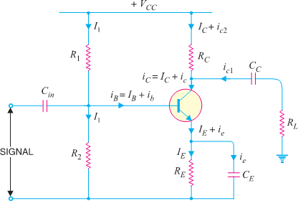
Or, 𝛽 = 𝛼 × 𝛼
1−𝛼
Or, 𝛽 = 𝛼 × 𝛾 (𝛾 = 1 )
1−𝛼

BASIC CONCEPT OF BIASING, TYPES OF BIASING, H- PARAMETER MODEL OF BJT,LOAD LINE(AC&DC)AND DETERMINE THE Q-POINT:
D.C. AND A.C. EQUIVALENT CIRCUITS:
    - Various circuit currents. It is useful to maintain various currents in the complete amplifier circuit. These are shown in the circuit of Fig.

    - Base Current: - When no signal is applied on the base circuit, D.C. base current IB flows due to biasing circuit. When A.C. signal is applied, A.C. base current ib also flows.
    - Therefore, withtheapplication of signal, Total Base Current iB is given by: iB= IB+ ib
Collector Current: - When no signal is applied, a D.C. collector current IC flows due to biasing circuit. When A.C.
signal is applied,
    - A.C. collector current ic also flows.
    - Therefore, the Total Collector Current iCisgiven by: - iC= IC+ ic
    - Where IC= β IB= zero signal collector current and ic= β ib= collector current due to signal.
Emitter Current: - When no signal is applied, a D.C. emitter current IE flows. When A.C. signal is applied, A.C. Emitter Current ie also flows. Therefore, the Total Emitter Current is: -
IE= IB+ IC
    - But base current is usually very small, therefore, as a reasonable approximation, IE ≈ IC .
D. C. Equivalent Circuit: -
In order to draw the equivalent D.C. circuit, the following two steps are applied to the transistor circuit: -
- Reduce all A.C. sources to zero.
- Open all the capacitors.


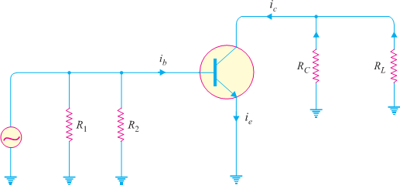
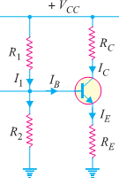
    - ReferringD.C.Equivalent Circuit
D.C. Load RDC= RC+ RE & VCC = VCE+ IC (RC+ RE)
    - The maximum value of VCE will occur when there is no collector current i.e. IC= 0.
∴ Maximum VCE= VCC
    - The maximum collector current will flow when VCE= 0.
Maximum IC= VCC/ (RC+RE)
A.C. Equivalent Circuit: - In order to draw A.C. equivalent circuit, the following two steps are applied to the transistor circuit:
Reduce all D.C. sources to zero (i.e., VCC= 0). Short all the capacitors.
Referring A.C. Equivalentcircuit A.C. loadequal to RC || RL i.e.
A.C. load, RAC = (RCRL/ (RC+RL)

Total maximum collector-emitter voltage, VCE MAX = VCE+ IC RAC
    - Maximum positive swing of A.C. collector- emitter voltage = IC × RAC
    - Maximum positive swing of A.C. collector current = VCE/RAC Total maximum collector current, IC MAX = IC+ VCE/RAC

LOAD LINE ANALYSIS: -
    - In the transistor circuit analysis, it is generally required to determine the collector current for various collector-emitter voltages.
    - One of the methods can be used to plot the output characteristics and determine the collector current at any desired collector-emitter voltage. However, a more convenient method, known as load line method can be used to solve suchproblems.

D.C. LOAD LINE: -
    - It is the line on the output characteristics of a transistor circuit which gives the values of IC and

VCE corresponding to zero signal or D.C. conditions.
    - Consider a common emitter NPN transistor circuit where no signal is applied. Therefore, D.C. conditions prevail in the circuit. The output characteristics of this circuit
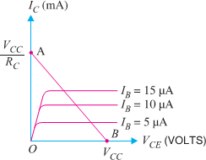
are shown in Fig.

    - The value of collector-emitter voltage VCE at any time is given by;
VCE = VCC– IC RC Or IC RC = VCC - VCE Or IC = VCC/ RC - VCE/ RC
Or IC = (-1/ RC) VCE + VCC/ RC ( ≡ Y= mX + C)
    - As VCC and RC are fixed values, therefore, it is a first-degree equation and can be represented by a straight line on the output characteristics. This is known as D.C. Load Line.

A.C. LOAD LINE.
    - This is the line on the output characteristics of a transistor circuit which gives the values of iC and vCE when signal is applied.
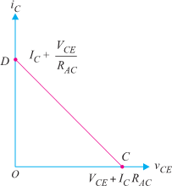
    - Referring back to the transistor amplifier shown in Fig., its A.C. equivalent circuit as far as output circuit is concerned is as shown in Fig.

OPERATING POINT: -
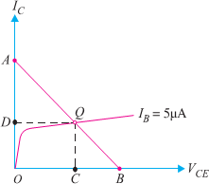
    - The zero signal values of IC and VCE are known as the Operating point.

    - It is called operating point because the variations of IC and VCE take place about this point when signal is applied.

    - It is also called quiescent (silent) point or Q-Point because it is the point on IC –VCE characteristic when the transistor is silent i.e., in the absence of the signal.
    - Suppose in the absence of signal, the base current is 5µA. Then IC and VCE conditions in the circuit must be represented by some point on IB = 5 µA characteristic.
    - But IC and VCE conditions in the circuit should also be represented by some point on the d. c. load line AB.

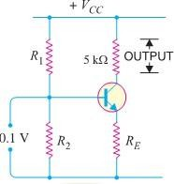
TYPES OF COUPLING, WORKING PRINCIPLE AND USE OF R- C COUPLED AMPLIFIER & FREQUENCY RESPONSES OF R-C COUPLED AMPLIFIER & DRAW THE CURVE:
    - There are different types of couplings, such as:
- Transformer Coupled Transistor Amplifier
- Direct Coupled Transistor Amplifier
- R-C coupled Amplifier

AMPLIFIER: -
    - The device which increases the strength of a weak signal is known as Amplifier. This can achieve by use of Transistor. It may be classified according to the number of stage of amplification, Such as:
- Single stage transistor amplifier.
- Multi stage transistor amplifier.
- Single Stage Transistor Amplifier: - When only one transistor with associated circuitry is used for amplifying a weak signal, the circuit is known as Single Stage Transistor Amplifier.
- Multi stage Transistor Amplifier: -When a transistor circuit containing more than one stage of amplification is known as Multi stage Transistor Amplifier.

SINGLE STAGE TRANSISTOR AMPLIFIER: -

- When in an amplifier circuit only one transistor is used for amplifying a weak signal, the circuit is known as single stage amplifier. When a weak A.C. signal is given to the base of transistor,a small base current startflowing.
- The above fig. shows a single stage transistor amplifier.
- Due to transistor action, a much larger (β times the base current) current flows through the collector load RC.
- As the value of RC is quite high (usually 4-10 kΩ), therefore,alarge voltage appears acrossRC.
- Thus, a weak signal applied in the base circuit appears in amplified form in the collector circuit.
- It is in this way that a transistor acts as an amplifier.

MULTI STAGE TRANSISTOR AMPLIFIER: -
- The output from a single stage amplifier is usually insufficient to drive an output device. In other words,the gain of a single amplifier is inadequate for practical purposes.
- Consequently, additional amplification over two or three stages is necessary. To achieve this, the output of each amplifier stage is coupled in some way to the input of the next stage.

- A transistor circuit containing more than one stage of amplification is known as multistage transistor amplifier.
- In a multistage amplifier, a number of single amplifiers are connected in cascade arrangement i.e. output of first stage is connected to the input of the second stage through a suitable coupling device and so on.

R-C COUPLED TRANSISTOR AMPLIFIER: -
- This is the most popular type of coupling because it is cheap and provides excellent audio fidelity over a wide range of frequency. It is usually employed for voltageamplification.
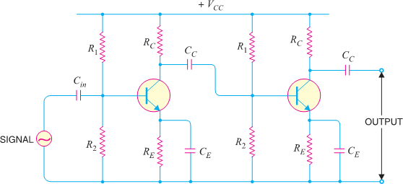
- Fig shows two stages of an RC coupled amplifier. A coupling capacitor CC is used to connect the output of first stage to the base (i.e., input) of the second stage and so on.
- As the coupling from one stage to next is achieved by a coupling capacitor followed by a connection toa shunt resistor, therefore, such amplifiers are called Resistance - Capacitance coupled amplifiers.
- The resistances R1, R2 and RE form the biasing and stabilization network. The emitter bypass capacitor offers low reactance path to the signal. Without it, the voltage gain of each stage would be lost.
- The coupling capacitor CC transmits A.C. signal but blocks D.C. This prevents D.C. interference between various stages and the shifting of operating point.

[Circuit Diagram of RC Coupled Transistor Amplifier]
Operation: -
- When A.C. signal is applied to the base of the first transistor, it appears in the amplified form across its collector load RC. The amplified signal developed across RC is given to base of next stage through coupling capacitor CC.
- The second stage does further amplification of the signal. In this way, the cascaded (one after another) stages amplify the signal and the overall gain is considerably increased.
- It may be mentioned here that total gain is less than the product of the gains of individual stages. It is because when a second stage is made to follow the first stage, the effective load resistance of first stage is reduced due to the shunting effect of the input resistance of second stage. This reduces the gain of the stage which is loaded by the next stage.

FREQUENCY RESPONSE:
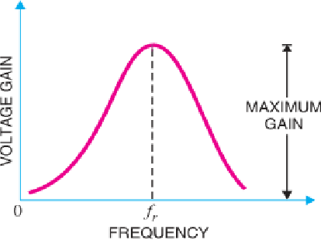
Frequency response: - The curve between voltage gain and signal frequency of an amplifier is known as frequency response.

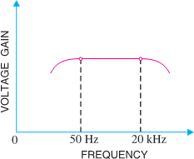
- Fig shows the frequency response of a typical RC coupled amplifier. It is clear that voltage gain drops off at low (< 50 Hz) and high (> 20 kHz) frequencies whereas it is uniform over mid- frequency range (50 Hz to 20 kHz). This behaviour of the amplifier is briefly explained below: -
- At low frequencies (< 50 Hz): - At this stage the reactance of coupling capacitor CC is quite high and hence very small part of signal will pass from one stage to the next stage. Moreover, CE cannot shunt the emitter resistance RE effectively because of its large reactance at low frequencies. These two factors cause a falling of voltage gain at low frequencies.
- At high frequencies (> 20 kHz): -At this stage the reactance of CC is very small and it behaves as a short circuit. These increases the loading effect of next stage and serves to reduce the voltage gain.Moreover, at high frequency, capacitive reactance of base- emitter junction is low which increases the base current. This reduces the current amplification factor β. Due to these two reasons, the voltage gain drops off at high frequency.
- At mid-frequencies (50 Hz to 20 kHz): - At this stage the voltage gain of the amplifier is constant. The effect of coupling capacitor in this frequency range is such so as to maintain a uniform voltage gain. Thus, as the frequency increases in this range, reactance of CC decreases which tends to increase the gain. However, at the same time, lower reactance means higher loading of first stage and hence lower gain. These two factors almost cancel each other, resulting in a uniform gain at mid-frequency.

Applications: -
- The RC coupled amplifiers have excellent audio fidelity over a wide range of frequency, used as
voltage amplifiers e.g., in the initial stages of public address system.
- However, because of poor impedance matching, RC coupling is rarely used in the final stages.

POSSIBLE SHORT TYPE QUESTIONS WITH ANSWER

Define PN-junction? (W-18)
ANS. When a p-type semiconductor is suitably joined to n-type semiconductor, the contact surface is called PN-junction.

Define BREAKDOWN VOLTAGE?
ANS. - It is the minimum reverse voltage at which pn junction breaks down with sudden rise in reverse current.

Define KNEE VOLTAGE? (W-19),(W-18)
ANS. It is the forward voltage at which the current through the junction starts to increase rapidly.

Define PEAK INVERSE VOLTAGE (PIV)? (W-19,O,N)
ANS. - It is the maximum reverse voltage that can be applied to the pn junction without damage to the junction. If the reverse voltage across the junction exceeds its PIV, the junction may be destroyed due to excessive heat.

Define maximum forward current?
ANS. It is the highest instantaneous forward current that a pn junction can conduct without damage to the junction.

Define maximum power rating?
ANS. - It is the maximum power that can be dissipated at the junction without damaging it.

Define dc load line?
ANS. The line obtained by joining the maximum values of Ic and Vce in the output characteristics of a CE configuration transistor is known as the DC Load Line.

Define Bandwidth?
ANS. The range of frequency over which the voltage gain is equal to or greater than 70.7% of the maximum gain is known as bandwidth.

POSSIBLE LONG TYPE QUESTIONS
- Explain volt-ampere (v-i) characteristics of pn junction? (W-18,O,N),(W-14)
- Explain full wave bridge full wave rectifier with ckt dia.?
- Explain transistor connections with ckt diag.?
- Explain RC coupled amplifier with fig.? (W-18),(S-19)
- Define the relation between alpha, beta & gamma? (S-19),(W-11),(W-18),(W-15)(S-23)

LEARING OBJECTIVES:
UNIT NO.- 02 POWER AMPLIFIERS

  - Classify power amplifiers & differentiate between voltage & power amplifiers
  - Working principle of different types of Power Amplifier (Class-A, Class-AB, Class-B and Class-C & Class D amplifier).

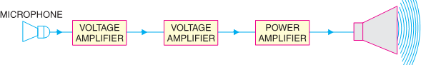
  - Construction and working principle and advantages of Push Pull (Class-B) Amplifiers.

CLASSIFY POWER AMPLIFIERS & DIFFERENTIATE BETWEEN VOLTAGE & POWER AMPLIFIERS:

INTRODUCTION: -
    - A practical amplifier always consists of a number of stages that amplify a weak signal until sufficient power is available to operate a loudspeaker or other output device.
    - The first few stages in this multistage amplifier have the function of only voltage amplification. However, last stage is designed to provide maximum power. This final stage is known as power stage.

Transistor Audio Power Amplifier: -
    - A transistor amplifier which raises the power level of the signals having audio frequency range is known as transistor Audio Power Amplifier. Generally last stage of a multistage amplifier is the power stage.
    - The power amplifier differs from all the previous stages in that here a concentrated effort is made to obtain maximum output power.
    - A transistor that is suitable for power amplification is generally called a power transistor.

DIFFERENCE BETWEEN VOLTAGE AND POWER AMPLIFIERS
    - The difference between the two types is really one of degree; it is a question of how much voltage and how much power.
    - A voltage amplifier is designed to achieve maximum voltage amplification. It is, however, not important to raise the power level.
    - On the other hand, a power amplifier is designed to obtain maximum output power.

Voltage Amplifier.
- The voltage gain of an amplifier is given by:
𝑅_{𝐶}
𝐴_{𝑉} = 𝛽 ×
𝑅
𝑖𝑛
- In order to achieve high voltage amplification, the following features are incorporated in such amplifiers:
- The transistor with high β (>100) is used in the circuit. i.e., Transistors are employed having thin base.
- The input resistance Rin of transistor is sought to be quite low as compared to the collector load RC.
- A relatively high load RC is used in the collector. To permit this condition, voltage amplifiers are always operated at low collector currents (≈ mA). If the collector current is
small, we can use large RC in the collector circuit

Power Amplifier.
- A power amplifier is required to deliver a large amount of power and as such it has to handle large current.
- In order to achieve high power amplification, the following features are incorporated in such amplifiers:
- The size of power transistor is made considerably larger in order to dissipate the heat produced in the transistor during operation.
- The base is made thicker to handle large currents. In other words, transistors with comparatively smaller β are used.
- Transformer coupling is used for impedance matching.

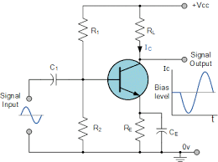
WORKING PRINCIPLE OF DIFFERENT TYPES OF POWER AMPLIFIER (CLASS-A, CLASS-AB, CLASS-B AND CLASS-C & CLASS D AMPLIFIER):
    - Transistor power amplifiers handle large signals. Many of them are driven by the input large signal that collector current is either cut-off or is in the saturation region during a large portion of the input cycle.
    - Therefore, such amplifiers are generally classified according to their mode of operation i.e., the portion of the input cycle during which the collector current is expected to flow. On this basis, they are classified as
- Class A power amplifier
- Class B power amplifier
- Class C power amplifier

CLASS A POWER AMPLIFIER:

  - If the collector current flows at all times during the full cycle of the signal, the power amplifier is known as class A power amplifier.
  - The power amplifier must be biased in such a way that no part of the signal is cut off. Fig shows circuit of class A power amplifier. Note that collector has a transformer as the load which is most common for all classes of power amplifiers.
  - The use of transformer permits impedance matching, resulting in the transference of maximum power to the load e.g., loudspeaker. Fig (ii) shows the class A operation in terms of a.c. load line.
  - The operating point Q is so selected that collector current flows at all times throughout the full cycle of the applied signal. As the output wave shape is exactly similar to the input wave shape, therefore, such amplifiers have least distortion.
  - However, they have the disadvantage of low power output and low collector efficiency (about 35%).

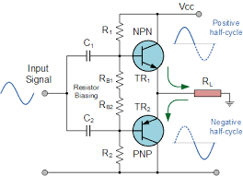
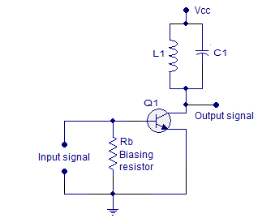
CLASS B POWER AMPLIFIER:

  - If the collector current flows only during the positive half-cycle of the input signal, it is called a class B power amplifier.
  - In class B operation, the transistor bias is so adjusted that zero signal collector current is zero i.e. no biasing circuit is needed at all.
  - During the positive half-cycle of the signal, the input circuit is forward biased and hence collector current flows. However, during the negative half-cycle of the signal, the input circuit is reverse biased and no collector current flows.
  - Fig. shows the class B operation .
  - It is easy to see that output from a class B amplifier is amplified half-wave rectification.
  - In a class B amplifier, the negative half-cycle of the signal is cut off and hence a severe distortion occurs.
  - However, class B amplifiers provide higher power output and collector efficiency (50 − 60%).
  - Such amplifiers are mostly used for power amplification in push- pull arrangement.
  - In such an arrangement, 2 transistors are used in class B operation. One transistor amplifies the positive half cycle of the signal while the other amplifies the negative half-cycle.

CLASS C POWER AMPLIFIER:

  - If the collector current flows for less than half-cycle of the input signal, it is called class C power amplifier.
  - In class C amplifier, the base is given some negative bias so that collector current does not flow just when the positive half-cycle of the signal starts.
  - Such amplifiers are never used for power amplification. However, they are used as tuned amplifiers i.e., to amplify a narrow band of frequencies near the resonant frequency.

CLASS D POWER AMPLIFIER: -
  - Class D power amplifier is a type of audio amplifier were the power handling devices are operated as binary switches. Since the power handling devices (MOSFETS) works as perfect binary switches, no time is wasted in between the transition of stages and no power is wasted in the zero-input condition.
  - Class D power amplifiers are much power efficient when compared to its predecessors like Class A, Class B and Class AB.
  - Out of the list the most efficient Class AB only have a maximum theoretical efficiency of 78.5%. In practical scenario with real speakers as load, the efficiency of Class AB amplifiers can drop as low as 50%.
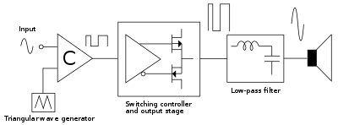
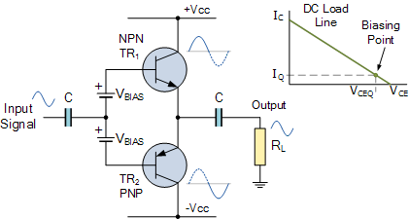
  - At the same time a well-designed Class D amplifier with real speakers as load will never go below 90% in terms of efficiency. The theoretical efficiency of a Class D amplifier is the ideal 100%.

CLASS AB POWER AMPLIFIER:

  - A Class AB amplifier can be made from a standard Class B push–pull stage by biasing both switching transistors into slight conduction, even when no input signal is present. This small biasing arrangement ensures that both transistors conduct simultaneously during a very small part of the input waveform by more than 50 per cent of the input cycle, but less than 100 per cent.
  - The 0.6 to 0.7V (one forward diode volt drop) dead band that produces the crossover distortion effect in Class B amplifiers is greatly reduced by the use of suitable biasing. The pre-biasing of the transistor devices can be achieved in a number of different ways using either a preset voltage bias, a voltage divider network, or by using a series connected diode arrangement.

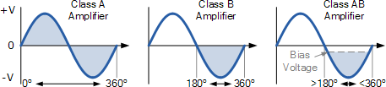
Comparison of the Different Amplifier Classes:

Then the amplifier classes are always defined as follows:
  - Class A: – The amplifiers single output transistor conducts for the full 360º of the cycle of the input waveform.
  - Class B: – The amplifiers two output transistors only conduct for one-half, that is, 180º of the input waveform.
  - Class AB: – The amplifiers two output transistors conduct somewhere between 180º and 360º of the input waveform.

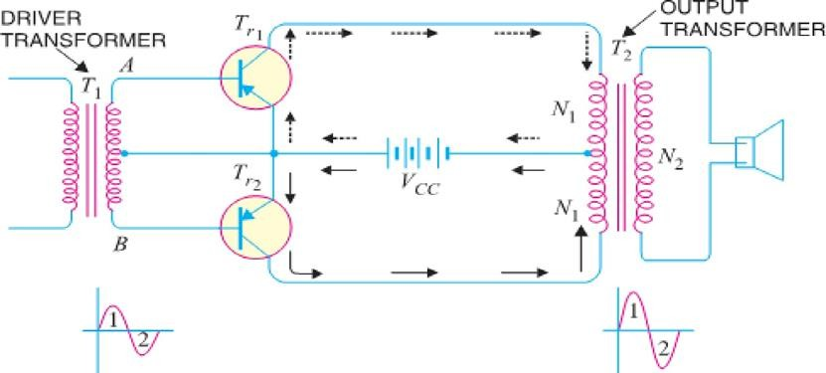
CONSTRUCTION AND WORKING PRINCIPLE AND ADVANTAGES OF PUSH PULL (CLASS-B) AMPLIFIERS:

    - The push-pull amplifier is a power amplifier and is frequently employed in the output stages of electronic circuits. It is used whenever high output power at high efficiency is required. Fig. shows the circuit of a push-pull amplifier.
    - Two transistors Tr1 and Tr2 placed back-to-back are employed. Both transistors are operated in class B operation i.e. collector current is nearly zero in the absence of the signal.
    - The center tapped secondary of driver transformer T1 supplies equal and opposite voltages to the base circuits of two transistors. The output transformer T2 has the center-tapped primary winding. The supplyvoltage VCC is connected between the bases and this center tap.
    - The loudspeaker is connected across the secondary of this transformer.

CIRCUIT OPERATION.
    - The input signal appears across the secondary AB of driver transformer. Suppose during the first half- cycle (marked 1) of the signal, end A becomes positive and end B negative.
    - This will make the base-emitter junction of Tr1 reverse biased and that of Tr2 forward biased. The circuit will conduct current due to Tr2 only and is shown by solid arrows.
    - Therefore, this half-cycle of the signal is amplified by Tr2 and appears in the lower half of the primary ofoutput transformer. In the next half cycle of the signal, Tr1 is forward biased whereas Tr2 is reverse biased. Therefore, Tr1 conducts and is shown by dotted arrows.
    - Consequently, this half-cycle of the signal is amplified by Tr1 and appears in the upper half of the outputtransformer primary. The centre-tapped primary of the output transformer combines two collectorcurrents to form a sine wave output in the secondary.
    - It may be noted here that push-pull arrangement also permits a maximum transfer of power to the Load through impedance matching. If RL is the resistance appearing across secondary of output transformer, then resistance R′L of primary shall become:

𝑅′ = (
𝐿
2𝑁1 2
)
𝑁

𝑅𝐿

2
Where N1 = Number of turns between either end of primary winding and centre-tap ,N2 = Number of secondary turns

ADVANTAGES
- The efficiency of the circuit is quite high (≈ 75%) due to class B operation.
- A high a.c. output power is obtained.

DISADVANTAGES
- Two transistors have to be used.
- It requires two equal and opposite voltages at the input. Therefore, push-pull circuit requires the useof driver stage to furnish these signals.
- If the parameters of the two transistors are not the same, there will be unequal amplification of thetwo halves of the signal.
- The circuit gives more distortion.
- Transformers used are bulky and expensive.

POSSIBLE SHORT TYPE QUESTIONS WITH ANSWER

Define Audio Power Amplifier.
Ans. A transistor amplifier which raises the power level of the signals having audio frequency range is known as transistor Audio Power Amplifier.

Define Distortion.
Ans. The change of output wave shape from input wave shape of amplifier is called
Distortion.

Define class a power amplifier. (S-11)(S-23)
Ans. If the collector current flows at all times during the full cycle of the signal, the power amplifier is known as CLASS A POWER AMPLIFIER.

Define class b power amplifier.
Ans. If the collector current flows only during the positive half-cycle of the input signal, it is called a class B power amplifier.

Define class c power amplifier.
Ans. If the collector current flows for less than half-cycle of the input signal, it is called class C power amplifier.
POSSIBLE LONG TYPE QUESTIONS

- Explain working principle of class A power amplifier. (W-19), (W-15)
- Explain working principle of class B power amplifier.
- Explain working principle of class C power amplifier.
- Explain working principle of class B push pull power amplifier. (S-19)(S-23)
- Difference between voltage and power amplifier.(S-23)

UNIT NO.- 03
FIELDEFFECTTRANSISTOR(FET)

LEARING OBJECTIVES:
  - FET& Its Classifications &Differentiate Between JFET & BJT.
  - Construction, working principle & characteristics of JEFT &Explain JEFT as an amplifier, parameters of JFET & Establish relation among JFET parameters.
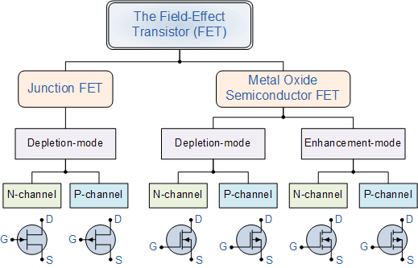
  - Construction & working principle MOSFET & its classification & characteristics (Drain & Transfer)
  - Explain the operation of CMOS, VMOS & LDMOS.

FET& ITS CLASSIFICATIONS &DIFFERENTIATE BETWEEN JFET & BJT:

INTRODUCTION: -
    - In the previous chapters, we have discussed the circuit applications of an ordinary transistor. In this type of transistor, both holes and electrons play part in the conduction process. For this reason, it is sometimes called a Bipolar Transistor.
    - The ordinary or bipolar transistor has two principal disadvantages. First, it has low input impedance because of forward biased emitter junction. Secondly, it has considerable noise level.
    - Although low input impedance problem may be improved by careful design and use of more than one transistor, yet it is difficult to achieve input impedance more than a few mega ohms.
    - The field effect transistor (FET) has, by virtue of its construction and biasing, large input impedance which may be more than 100 mega ohms.
    - The FET is generally much less noisy than the ordinary or bipolar transistor. The rapidly expanding FET market has led many semiconductor marketing managers to believe that this device will soon become the most important electronic device, primarily because of its integrated-circuit applications.

CLASSIFICATION OF FIELD EFFECT TRANSISTORS: -

  - Other types of C-MOS also There Such as: -CMOS, VMOS, LDMOS etc.

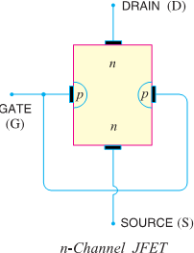
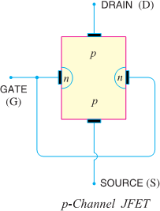
- DIFFERENTIATION BETWEEN BJT & FET: -

FET |  | BJT
✗ | It means Field Effect Transistor | ✗ | Means Bipolar Junction Transistor
✗ | Its three terminals are Source, Gate & Drain | ✗ | Its terminals are Emitter, Base & Collector.
✗ | It is Unipolar devices i.e., Current in the device is carried either by electrons or holes. | ✗ | It is Bipolar devices i.e., Current in the device is carried by both electrons and holes.
✗ | It is Voltage controlled device. i.e., Voltage at the gate or drain terminal controls the amount of current flowing through the devices. | ✗ | It is Current controlled device. i.e., Base Current controls the amount of  collector current flowing through the  devices.
✗ | It has very High Input Resistance and Low Output Resistance. | ✗ | It has very Low Input Resistance and High Output Resistance.
✗ | Low noisy operation | ✗ | High noisy operation
✗ | It is Longer Life & High Efficiency. | ✗ | It is Shorter Life & Low Efficiency.
✗ | It is much simpler to fabricate as IC and occupies less space on IC. | ✗ | It is comparatively difficult to fabricate as IC and occupies more space on IC then FET.
✗ | It has Small gain bandwidth product. | ✗ | It has Large gain bandwidth product.
✗ | It has higher switching speed. | ✗ | It has higher switching speed.

CONSTRUCTION, WORKING PRINCIPLE & CHARACTERISTICS OF JEFT &EXPLAIN JEFT AS AN AMPLIFIER, PARAMETERS OF JFET & ESTABLISH RELATION AMONG JFET PARAMETERS:
    - A junction field effect transistor is a three terminal semiconductor device in which current conduction is by one type of carrier i.e., electrons or holes.
    - In a JFET, the current conduction is either by electrons or holes and is controlled by means of an electric field between the gate electrode and the conducting channel of the device.
    - The JFET has high input impedance and low noise level.

CONSTRUCTIONAL DETAILS.
    - A JFET consists of a p-type or n-type silicon bar containing two pn junctions at the sides as shown in Fig.

    - The bar forms the conducting channel for the charge carriers. If the bar is of n-type, it is called n-channel JFET as shown in Fig (i) and if the bar is of p-type, it is called a p-channel JFET as shown in Fig (ii).
    - The two pn junctions forming diodes are connected internally & a common terminal called gate is taken out.
    - Other terminals are source and drain taken out from the bar as shown. Thus, a JFET has essentially three terminals viz., Gate (G), Source (S) & Drain (D).

JFET POLARITIES: -
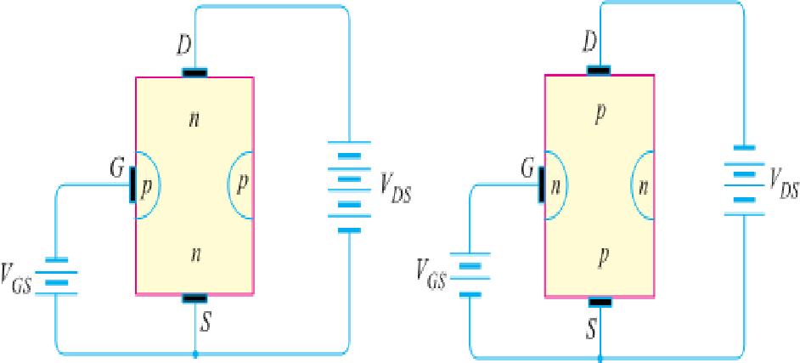
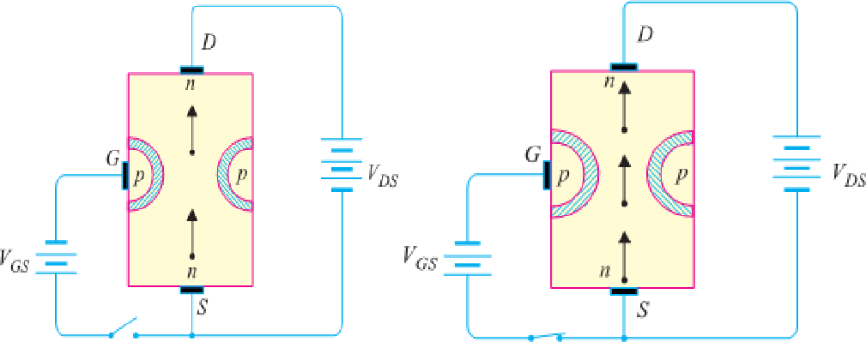
    - Fig (i) shows n-channel JFET polarities whereas Fig (ii) shows the p-channel JFET polarities.

    - Note that in each case, voltage between gate and source is such that the gate is reversing biased.
    - This is the normal way of JFET connection.
    - The drain & source terminals are interchangeable i.e., either end can be used as source and the other end as drain.
    - The following points may be noted:
    - The input circuit (i.e., gate to source) of a JFET is reverse biased. This means that the device has high input impedance.
    - The drain is so biased w.r.t. source that drain current ID flows from the source to drain.
    - In all JFETs, source current IS is equal to the drain current i.e., IS = ID.

WORKINGPRINCIPLE OF JFET: -
Principle: -
    - Fig. shows the circuit of n- channel JFET with normal polarities. Note that the gate is reverse biased.

    - The two pn junctions at the sides form two depletion layers. The current conduction by charge carriers (i.e., free electrons in this case) is through the channel between the two depletion layers and out of the drain.
    - The width and hence resistance of this channel can be controlled by changing the input voltage VGS.
    - The greater the reverse voltage VGS, the wider will be the depletion layers and narrower will be the conducting channel. The narrower channel means greater resistance and hence source to drain current decreases. Reverse will happen should VGS decrease.
    - Thus, JFET operates on the principle that width and hence resistance of the conducting channel can be varied by changing the reverse voltage VGS.
    - In other words, the magnitude of drain current (ID) can be changed by altering VGS.

Working: -
    - When voltage VDS is applied between drain & source terminals and voltage on the gate is zero [See the above Fig (i)], the two pn junctions at the sides of the bar establish depletion layers.
    - The electrons will flow from source to drain through a channel between the depletion layers.
    - The size of these layers determines width of the channel & hence the current conduction through the bar.
    - When a reverse voltage VGS is applied between the gate and source [See Fig (ii)], the width of the depletion layers is increased.
    - This reduces the width of conducting channel, thereby increasing the resistance of n-type bar.

Consequently, the current from source to drain is decreased.
    - On the other hand, if the reverse voltage on the gate is decreased, the width of the depletion layers also decreases. This increases the width of the conducting channel and hence source to drain current.
    - It is clear from the above discussion that current from source to drain can be controlled by the application of potential (i.e., electric field) on the gate.
    - For this reason, the device is called field effect transistor. It may be noted that a p-channel JFET operates in the same manner as an n-channel JFET except that channel current carriers will be the holes instead of electrons and the polarities of VGS and VDS are reversed.

JFET AS AN AMPLIFIER: -
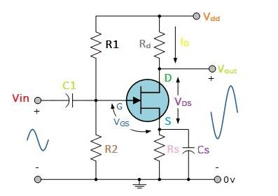
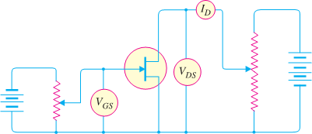
    - Fig shows JFET amplifier circuit. The weak signal is applied between gate and source and amplified output is obtained in the drain-source circuit. For the proper operation of JFET, the gate must be negative w.r.t. source i.e., input circuit should always be reverse biased.
    - This is achieved either by inserting a battery VGG in the gate circuit or by a circuit known as biasing circuit.

      - In the present case, we are providing biasing by the battery VGG. A small change in the reverse bias on the gate produces a large change in drain current.
      - This fact makes JFET capable of raising the strength of a weak signal. During the positive half of signal, the reverse bias on the gate decreases. This increases the channel width and hence the drain current.
      - During the negative half-cycle of the signal, the reverse voltage on the gate increases. Consequently, the drain current decreases.
      - The result is that a small change in voltage at the gate produces a large change in drain current.
      - These large variations in drain current produce large output across the load RL. In this way, JFET acts as an amplifier

OUTPUT CHARACTERISTICS OF JFET
      - The curve between drain current (ID) and drain-source voltage (VDS) of a JFET at constant gate source voltage (VGS) is known as output characteristics of JFET.

      - Fig shows circuit for determining output characteristics of JFET.
      - Keeping VGS fixed at some value, say 1V, the drain source voltage is changed in steps.

      - Corresponding to each value of VDS, the drain current ID is noted.
      - A plot of these values gives output characteristic of JFET at VGS= 1V.
      - Repeating similar procedure, output characteristics at other gate-source voltages can be drawn. Fig. shows a family of output characteristics.

The following points may be noted from the characteristics:

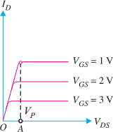
      - At first, the drain current ID rises rapidly with drain-source voltage VDS but then becomes constant.

      - The drain-source voltage above which drain current becomes constant is known as pinch off voltage. Thus in Fig. OA is the pinch off voltage VP.
      - After pinch off voltage, the channel width becomes so narrow that depletion layers almost touch each other.
      - The drain current passes through the small passage between these layers.
      - Thus, increase in drain current is very small with VDS above pinch off voltage.
      - Consequently, drain current remains constant.

PARAMETERS OF JFET: -
      - Like vacuum tubes, a JFET has certain parameters which determine its performance in a circuit. The main parameters of JFET are: -
- A.C. drain resistance
- Transconductance
- Amplification factor.
- A.C. Drain Resistance (rd). Corresponding to the a.c. plate resistance, we have a.c. drain resistance in a JFET. It may be defined as follows:
  - It is the ratio of change in drain-source voltage (ΔVDS)to the change in drain current(ΔID) at constant gate-source voltage i.e

A.C. Drain Resistance, 𝒓_{𝒅}
= ∆𝑽𝑫𝑺 at constant VGS
∆𝑰𝑫

- Referring to the output characteristics of a JFET in Fig., it is clear that above the pinch off voltage, the change in ID is small for a change in VDSbecause the curve is almost flat.
- Therefore, drain resistance of a JFET has a large value, ranging from 10 kΩ to 1 MΩ.
- Transconductance (gfs): -The control that the gate voltage has over the drain current is measured by transconductance gfs & is similar to the transconductance gm of the tube. It may be defined as follows:
- It is the ratio of change in drain current (ΔID) to the change in gate-source voltage(ΔVGS) at constant drain-source voltage i.e.

Transconductance, gfs= ∆𝑰𝑫
∆𝑽𝑮𝑺

at constant VDS

- The transconductance of a JFET is usually expressed either in mA/volt or micro mho. As an example, if a change in gate voltage of 0.1 V causes a change in drain current of 0.3 mA, then, Transconductance,
- Amplification Factor (µ). It is the ratio of change in drain-source voltage (ΔVDS) to the change in gate- source voltage(ΔVGS) at constant drain current i.e

Amplification Factor, 𝝁 = ∆𝑽𝑫𝑺
∆𝑽𝑮𝑺

at constant ID

  - Amplification factor of a JFET indicates how much more control the gate voltage has over drain current than has the drain voltage.

RELATION AMONG JFET PARAMETERS: -
  - The relationship among JFET parameters can be established as under:
  - We know 𝝁 = ∆𝑽𝑫𝑺
∆𝑽𝑮𝑺
- Multiplying the numerator and denominator on R.H.S. by ΔID, we get,

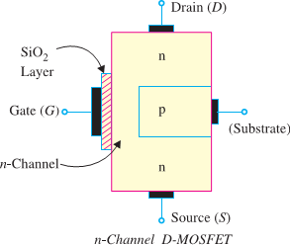
µ = r_{d} × g_{fs}

➔ Amplification Factor = A.C. Drain Resistance × Transconductance

JFET Applications: -
  - As a Buffer amplifier
  - As Phase-shift oscillators
  - As RF amplifier

CONSTRUCTION & WORKING PRINCIPLE MOSFET & ITS CLASSIFICATION & CHARACTERISTICS (DRAIN & TRANSFER):
Metal Oxide Semiconductor FET (MOSFET):
    - Field effect transistor (FET) that can be operated to enhance (or increase) the width of the channel (with consequent increase in conductivity of the channel) i.e., it can have enhancement- mode operation. Such a FET is called MOSFET.
    - A field effect transistor (FET) that can be operated in the enhancement-mode is called a MOSFET.
    - A MOSFET is an important semiconductor device & can be used in any of the circuits covered for JFET.
    - However, a MOSFET has several advantages over JFET including high input impedance and low cost.

TYPES OF MOSFETS: -
- There are two basic types of MOSFETs such as: -

Depletion-type MOSFET or D-MOSFET.
  - The D-MOSFET can be operated in both the depletion mode and the enhancement-mode.

Enhancement-type MOSFET or E-MOSFET.
  - The E-MOSFET can be operated only in enhancement mode. The manner in which a MOSFET is constructed determines whether it is D-MOSFET or E-MOSFET.

D-MOSFET.

- Fig shows the constructional details of n-channel D-MOSFET.
- It is similar to n-channel JFET except with the following modifications/remarks:
- The n-channel D-MOSFET is a piece of n-type material with a p-type region (called substrate) on the right and an insulated gate on the left as shown in Fig.

- The free electrons (Q it is n-channel) flowing from source to drain must pass through the narrow channel between the gate and the p- type region (i.e., substrate).
- Note carefully the gate construction of D-MOSFET. A thin layer of metal oxide (usually silicon dioxide, SiO2) is deposited over a small portion of the channel.
- A metallic gate is deposited over the oxide layer. As SiO2 is an insulator, thus gate is insulated from the channel. Note that the arrangement forms a capacitor. One plate of this capacitor is the gate and other plate are the channel with SiO2 as dielectric. Recall that we have a gate diode in a JFET.
- It is a usual practice to connect the substrate to the source (S) internally so that a MOSFET has three terminals viz Source (S), Gate (G) and Drain (D).
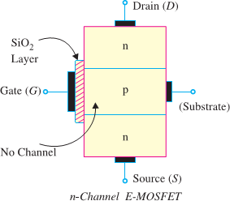
- Since the gate is insulated from the channel, we can apply either negative or positive voltage to the gate. Therefore, D-MOSFET can be operated in both depletion-mode and enhancement-mode. However, JFET can be operated only in depletion-mode.

E-MOSFET.

- Fig shows the constructional details of n-channel E-MOSFET. Its gate construction is similar to that of D-MOSFET.
- The E-MOSFET has no channel between source and drain unlike the D-MOSFET. Note that the substrate extends completely to the SiO2 layer so that no channelexists.
- The E-MOSFET requires a proper gate voltage to form a channel (called induced channel). It is reminded that E-MOSFET can be operated only in enhancement mode.
- In short, the construction of E-MOSFET is quite similar to that of the D-MOSFET except for the absence of a channel between the drain and source terminals.

EXPLAIN THE OPERATION OF CMOS, VMOS & LDMOS:

Power MOSFETs: -
    - With the advancement of technology, the engineers have produced a wide variety of MOSEFTs that are designed specifically for high current, high voltage and high-power applications.
    - Some Examples of Power MOSFET are VMOS, LDMOS etc.

VMOS [V-Grove MOSFET or Vertical MOSFET] :-
- One of the major disadvantages of a typical MOSFET is the reduced power handling level as compared to BJT transistors. The power handling level of a typical MOSFET is less than 1W.
- This drawback of the MOSFET can be overcome by changing the construction mode from one of the planer natures to one with a vertical structure as shown in Fig.


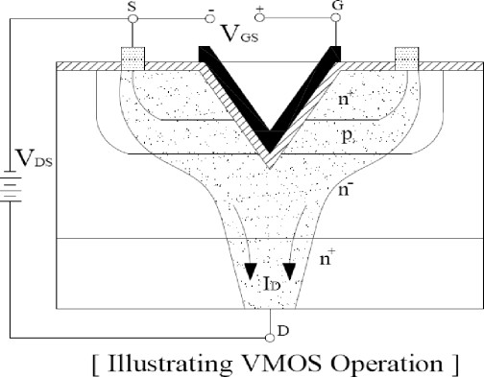
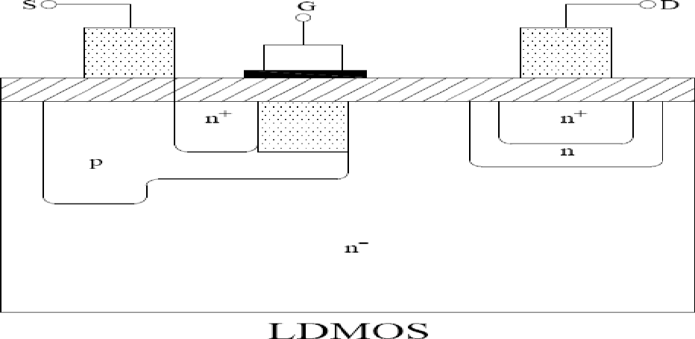

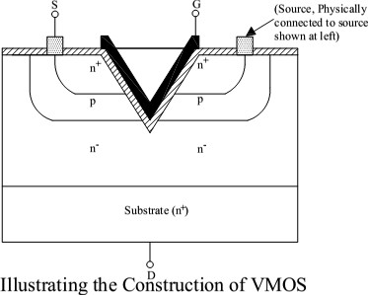
- As seen from this figure, all the elements of the planar MOSFET are present in the vertical metal-oxide silicon FET (or simply VMOS) the metallic surface connection to the terminals of the device.
- The vertical-MOSEFT (or simple VMOS) is a component designed to handle much larger drain currents than the standard MOSEFT.
- The current handling capability of the VMOS is a result of its physical construction which is illustrated in Fig. As seen from this figure, the component gas materials that are labelled as P, N⁺ and N⁻.
- The N⁻ material labels indicate differences in doping levels.
- Also notice that there is no physical channel connecting the source (at top) and the drain (at bottom). Thus VMOS is an enhancement type MOSEFT.
- With V-shaped gate, a larger channel is formed by a positive gate voltage.
- With a large channel, the device is capable of handling large amount of drain current.
- The Operation of VMOS is illustrated in Fig.

VMOS Operation: -
- When a positive gate voltage is applied to the device, an N-type channel forms in the P-type regions. This effective channel connects the source to the drain.
- As seen from the figure the shape of the gate causes a wider channel to form than is created in the standard MOSFET. Hence, the amount of drain current is much higher for this component.
- Moreover, the VMOS can exhibit a higher transconductance and a lower turn-on resistance than the conventional planer MOSFET.
- Other advantages of using VMOS id the fact it is not susceptible to thermal runaway.
- The VMOS has a positive temperature coefficient, means that the resistance of the component increases when temperature increases.
- Thus, an increase in temperature will cause a decrease in drain current.
- The VMOS device can be fabricated with more than one V-grove to increase amount of drain current and some other performance characteristics.

LD MOS: -

- The LDMOS (i.e., Lateral Double Diffused MOSFET) is another type of power MOSFET.
- This MOSFET uses a very small channel region and a heavily doped N-type region (N⁺) to obtain a high drain current and low channel resistance [rd(ON)].
- Fig shows the basic construction of LDMOS.
- As seen from this figure, the narrow channel (Shaded region) is made up of the P-type material that lies between the N⁻ Substrate (lightly doped) and the N⁺ (heavily doped) source region.
- Since only the N-type material lies between the channel and the drain, the effective length of the channel is externally short. This coupled with the N-type material in channel-to-drain path provides an extremely low value of rd (ON).

- With a low channel resistance, the LDMOS device can handle very high amount of current without generating and damaging amount of heat.

C-MOS: -
- C-MOS means complementary MOS. These are mostly used in the field of digital electronics to manufacture logic gates and many other synchronous and asynchronous circuits.
- The logic gates includes AND, OR & NOT gates and their various combinations.
- The synchronous circuit includes flip-flops, counters, memories, A/D and D/A converters.
- The asynchronous circuit includes combinations of logic gates such as decoders, encoders, multiplexers and de-multiplexers etc.
- A CMOS logic circuit consists of combinations of NMOS & PMOS devices.

POSSIBLE SHORT TYPE QUESTIONS WITH ANSWER

Define JFET? (W-18)
Ans. A junction field effect transistor is a three terminal semiconductor device in which current conduction is by one type of carrier i.e., electrons or holes.
  - In a JFET, the current conduction is either by electrons or holes and is controlled by means of an electric field between the gate electrode and the conducting channel of the device.
  - The JFET has high input impedance and low noise level.

What is MOSFET?(W-18)
Ans. Field effect transistor (FET) that can be operated to enhance (or increase) the width of the channel (with consequent increase in conductivity of the channel) i.e., it can have enhancement- mode operation. Such a FET is called MOSFET.

Define V MOS?
Ans. One of the major disadvantages of a typical MOSFET is the reduced power handling level as compared to BJT transistors. The power handling level of a typical MOSFET is less than 1W.
This drawback of the MOSFET can be overcome by changing the construction mode from one of the planer natures to one with a vertical structure known as V MOS.

4 List any two advantages of FET over BJT.(S-23)
Ans. I) FET has longer life than BJT
II) FET are more temperature stable than BJT

Define LD MOS?
Ans. The LDMOS (i.e., Lateral Double Diffused MOSFET) is another type of power MOSFET.
- This MOSFET uses a very small channel region and a heavily doped N-type region (N⁺) to obtain a high drain current and low channel resistance.
POSSIBLE LONG TYPE QUESTIONS
- Write short notes on
- VMOS
- LD MOS
- CMOS
- Explain the characteristics of MOSFET.(S-23)
- Describe the construction of JFET? (W-19(S))

UNIT NO.- 04
FEED BACK AMPLIFIER & OSCILLATOR

LEARING OBJECTIVES:
  - :- Define & classify feedback amplifier,principle of -ve feedback with the help of block diagram, types of feedback-(-ve & +ve):-

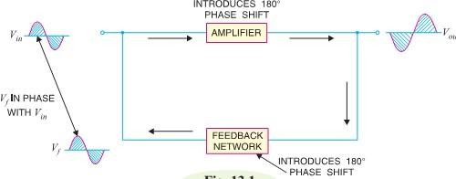
  - :- Types of -ve feedback-voltage-series,voltage-shunt, current-series, current- shunt and charecteristics voltage gain,bandwidth,inputimpidance,outputimpidance,stability,noise,distortion in amplifiers.
  - Oscillator -block diagram of sine wave oscillator, Types Requirement of oscillation- Barkhuisen criterion.
  - RC oscillators – RC phase shift, Crystal, LC oscillators – Colpitts, Hartley & Wien Bridge Oscillators: Circuit operation, circuit diagram, equation for frequency of oscillation & frequency stability.

:- DEFINE & CLASSIFY FEEDBACK AMPLIFIER,PRINCIPLE OF - VE FEEDBACK WITH THE HELP OF BLOCK DIAGRAM,TYPES OF FEEDBACK-(-VE & +VE):

FEEDBACK: -
    - The process of injecting a fraction of output energy of some device back to the input is known as

feedback.
    - Depending upon whether the feedback energy aids or opposes the input signal, there are two basic types of feedback in amplifiers viz Positive Feedback and Negative Feedback.

Positive Feedback:
    - When the feedback energy (voltage or current) is in phase with the input signal and thus aids it, it is called positive feedback. This is illustrated in Fig.
    - Both amplifier and feedback network introduce a phase shift of 180°. The result is a 360° phase shift around the loop, causing the feedback voltage Vf to be in phase with the input signal Vin.
    - The positive feedback increases the gain of the amplifier. However, it has the disadvantages of increased distortion and instability. Therefore, positive feedback is not often employed in amplifiers.
      - One important use of positive feedback is in oscillators. If positive feedback is sufficiently large. As a matter of fact, an oscillator is a device that converts d.c. power into a.c. power of any desired frequency.

Negative Feedback:
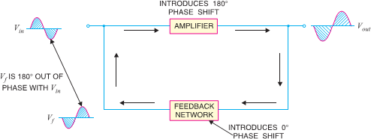
  - When the feedback energy (voltage or current) is out of phase with the input signal and thus opposes it, it is called negative feedback. This is illustrated in Fig.

  - As you can see, the amplifier introduces a phase shift of 180° into the circuit while the feedback network is so designed that it introduces no phase shift (i.e., 0° phase shift). The result is that the feedback voltage Vf is 180° out of phase with the input signal Vin.
  - Negative feedback reduces the gain of the amplifier. However, the advantages of negative feedback are reduction in distortion, stability in gain, increased bandwidth and improved input and output impedances.
  - It is due to these advantages that negative feedback is frequently employed in amplifiers.

:- TYPES OF -VE FEEDBACK-VOLTAGE-SERIES,VOLTAGE- SHUNT, CURRENT-SERIES, CURRENT-SHUNT AND CHARECTERISTICS VOLTAGE GAIN, BANDWIDTH, INPUTIMPIDANCE, OUTPUTIMPIDANCE, STABILITY, NOISE, DISTORTION IN AMPLIFIERS:

Types Of Feedback Connections: -
    - There are four basic types of connecting the feedback signal from an amplifier output to its input : -
(i) Voltage-Series feedback connection.
(ii) Voltage-Shunt feedback connection. (iii)Current-Series feedback connection. (iv)Current-Shunt feedback connection.
    - It means that both voltage and current can be feedback to the input either in series or parallel.
    - In the feedback connection types, the term ‘voltage’ refers to connecting the output voltage as
input to the feedback network.
    - The term ‘current’ refers to tapping off some output current through the feedback network.
    - The term ‘series’ refers to connecting the feedback signal in series with the input signal voltage.
    - The term ‘shunt’ refers to connecting the feedback signal in shunt (parallel) with an input
currentsource.
    - It has been observed that the series feedback connections tend to increase the input resistance, while the shunt feedback connection tends to decrease the input resistance.
    - Moreover, the voltage feedback will tend to decrease the output resistance.

    - As a matter of fact, higher input resistance and lower output resistance is desired for most cascade amplifiers.
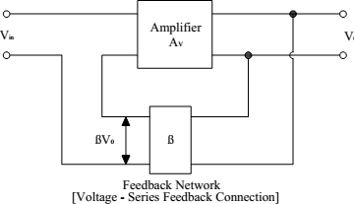
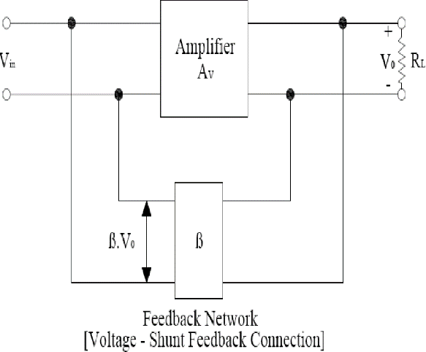
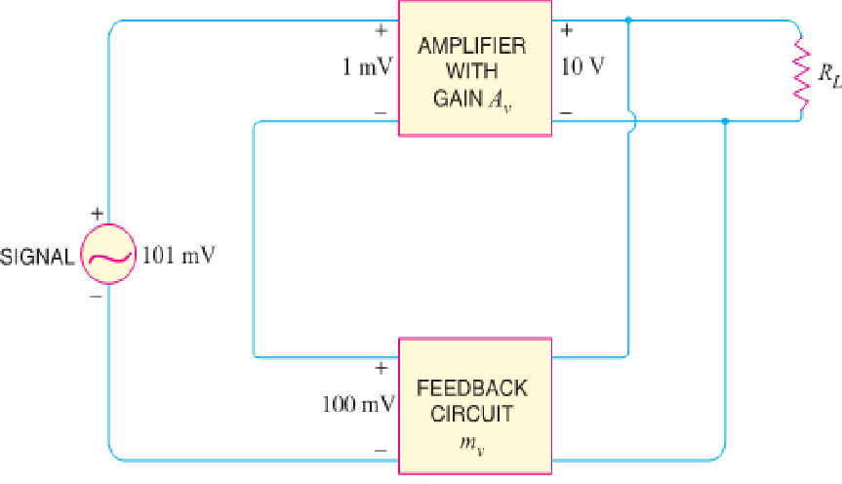
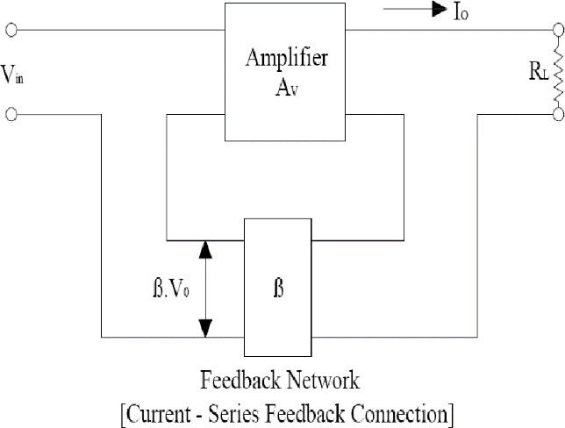
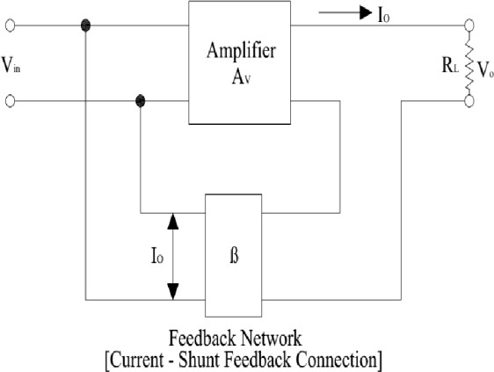
    - Both of these characteristics are obtained by using the voltage – series feedback connection.

PRINCIPLES OF NEGATIVE VOLTAGE FEEDBACK IN AMPLIFIERS:-

    - A feedback amplifier has main two parts such as an amplifier and a feedback circuit.
    - The feedback circuit usually consists of resistors and returnsafraction of outputenergyback to theinput.
    - Fig. shows the principles of negative voltage feedback in an amplifier. Typical values have been assumedto make the treatment moreillustrative.
    - ​
    - The output of the amplifier is 10 V. The fraction mv of this output i.e.100 mV is feedback to the input where it is applied in series with the input signal of 101 mV.
    - As the feedback is negative, therefore, only 1 mV appears at the input terminals of the amplifier.

    - Referring to Fig., we have,
    - Gain of amplifier without feedback, A

=𝑂𝑈𝑇 𝑃𝑈𝑇 𝑉𝑂𝐿𝑇𝐴𝐺𝐸 = 10

= 10

= 10×103 = 104

v 𝐼𝑁𝑃𝑈𝑇 𝑉𝑂𝐿𝑇𝐴𝐺𝐸
1𝑚𝑣
1×10−3 1

−3 −3 −1
    - Fraction of output voltage feedback, m =^{100𝑚𝑣} = 100×10 = 100×10 ×10 = 0.01𝑉

v
    - Gain of amplifier with negative feedback,
10𝑣 10 1

A =𝑂𝑈𝑇 𝑃𝑈𝑇 𝑉𝑂𝐿𝑇𝐴𝐺𝐸 = 10
= 10
= 10×103 = 99.0099

vf 𝐼𝑁𝑃𝑈𝑇 𝑉𝑂𝐿𝑇𝐴𝐺𝐸 101𝑚𝑣

101×10−3

101

    - That means When negative voltage feedback is applied, the gain of the amplifier is reduced. Thus, the gain of above amplifier without feedback is 10,000 whereas with negative feedback, it is only 100.
    - The gain with feedback is sometimes called closed-loop gain while the gain without feedback is called open-loop gain. These terms come from the fact that amplifier and feedback circuits form a “loop”.
    - When loop is “opened” by disconnecting feedback circuit from I/P, amplifier's gain Av ,[open- loop gain]
    - When the loop is “closed” by connecting the feedback circuit, gain decreases to Avf [“closed- loop” gain]

GAIN OF NEGATIVE VOLTAGE FEEDBACK AMPLIFIER: -
    - Consider the negative voltage feedback amplifier shown in Fig.
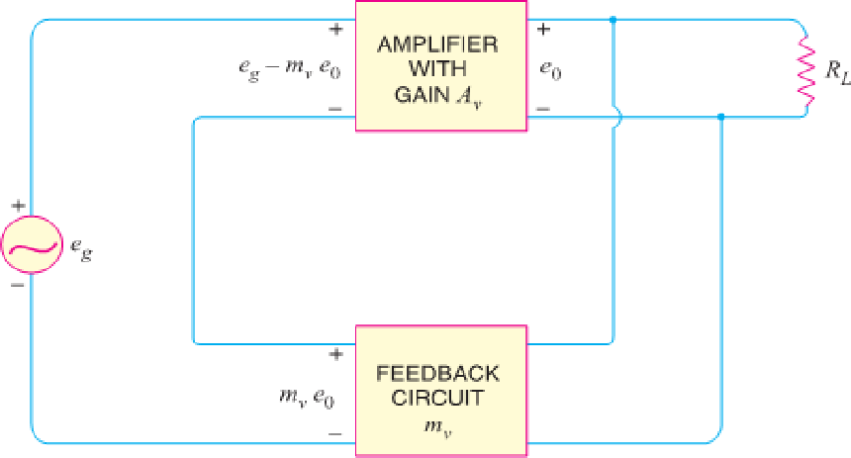
Av - The gain of the amplifier without feedback e0 -Out put of amplifier
mv -Fraction of the feed back ckt. mv e0 -Out put of the feed back ckt. eg -Input voltage.
    - As feedback is a -ve type. So the input to amplifier is (eg-e0mv ).
    - The output e0 must be equal to the product between the input voltage and amplifier gain.
i.e (𝑒_{𝑔} − 𝑒₀𝑚_{𝑣})𝐴_{𝑣} = 𝑒₀
⇒ 𝑒_{𝑔}𝐴_{𝑣} − 𝑒₀𝑚_{𝑣}𝐴_{𝑣} = 𝑒₀
⇒ 𝑒_{𝑔}𝐴_{𝑣} = 𝑒₀ + 𝑒₀𝑚_{𝑣}𝐴_{𝑣}
⇒ 𝑒_{𝑔}𝐴_{𝑣} = 𝑒₀(1 + 𝑚_{𝑣}𝐴_{𝑣})

𝑒_{𝑔}
⇒ 𝑒
0
𝑒_{𝑔}
1 + 𝑚_{𝑣}𝐴_{𝑣}
=
𝐴_{𝑣}
𝐴_{𝑣}

⇒ 𝑒
0
= 1 + 𝑚 𝐴
𝑣
𝑣

𝐴_{𝑣}
⇒ 𝐴_{𝑣𝑓} = 1 + 𝑚
𝑣

𝐴_{𝑣}

Where, 𝑒𝑔 =Gain of the amplifier with feedback.
𝑒0

FEEDBACK CIRCUIT: -


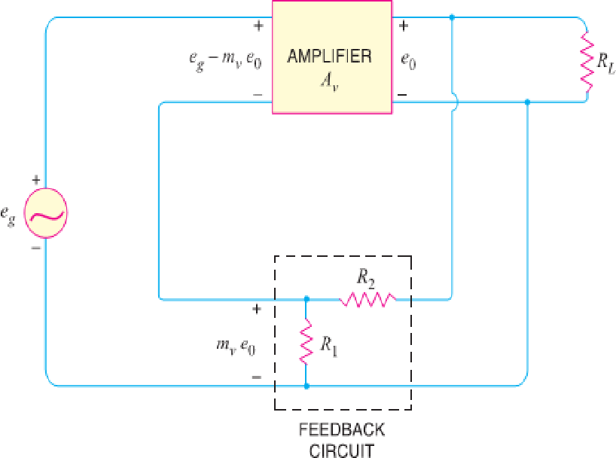
    - The function of the feedback circuit is to return a fraction of the output voltage to the input of the amplifier.
    - Fig. shows the feedback circuit of negative voltagefeedback amplifier. It is essentially a potential divider consisting of resistances R1 and R2.
    - The output voltage of the amplifier is fed to this potential divider which gives the feedback voltage to the input.

    - Referring to Fig. it is clear that: Voltage across R1= 𝑒
0(
𝑅1 )

Feedback fraction, mv= 𝑉𝑜𝑙𝑡𝑎𝑔𝑒 𝑎𝑐𝑟𝑜𝑠𝑠 𝑅1 = 𝑅1
𝑅1+𝑅2

𝑒0 𝑅1+𝑅2

INPUT & OUTPUT IMPEDANCE OF NEGATIVE FEEDBACK AMPLIFIER: -
- Input impedance. The increase in input impedance with negative voltage feedback can be explained . Suppose the input impedance of the amplifier is Zin without feedback and Z′in with negative feedback.
Z’in =Zin(1+AVmv)
    - It is clear that by applying negative voltage feedback, the input impedance of the amplifier is a factor 1 + Aνmv. As Aνmv is much greater than unity.
    - Therefore, input impedance is increased considerably. This is an advantage, since the amplifier will represent less of a load to its source circuit.
- Output impedance. Following similar line, we can show that output impedance with negative voltage feedback is given by:
Z’out= 𝒁𝒐𝒖𝒕
𝟏+𝑨𝒗𝒎𝒗
  - Where Z′out = output impedance with negative voltage feedback Zout = output impedance without feedback
    - It is clear that by applying negative feedback, the output impedance of the amplifier is decreased by a factor 1 + Aνmν.

OSCILLATOR -BLOCK DIAGRAM OF SINE WAVE OSCILLATOR, TYPES REQUIREMENT OF OSCILLATION- BARKHUISEN CRITERION:

SINUSOIDAL OSCILLATORS: -
    - An electronic device that generates sinusoidal oscillations of desired frequency is known as a sinusoidal oscillation.

TYPES OF SINUSOIDAL OSCILLATIONS: -
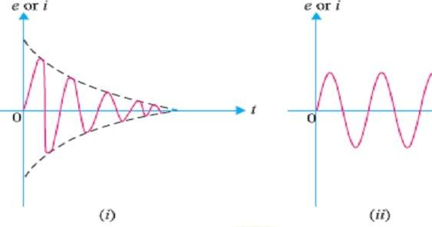
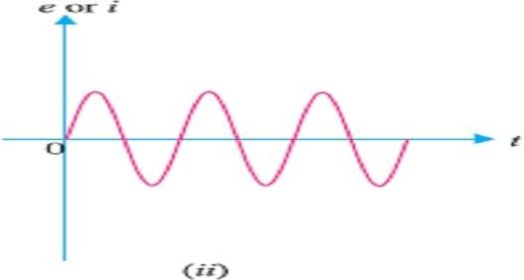
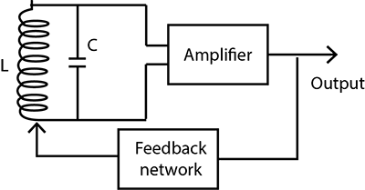
    - Sinusoidal oscillations can be of two types viz Damped Oscillations and Undamped Oscillations.
- Damped Oscillations: - The electrical oscillations whose amplitude goes on decreasing with
time are called damped oscillations. Fig (i) Shows waveform of damped electrical oscillations.

- Undamped Oscillations. The electrical oscillations whose amplitude remains constant with time are called undamped oscillations. Fig. (ii) Shows waveform of undamped electrical oscillations.

ESSENTIALS OF TRANSISTOR OSCILLATOR: -
  - Fig shows the block diagram of an oscillator. Its essential components are : -

Tank circuit:
- It consists of inductance coil (L) connected in parallel with capacitor (C).
- The frequency of oscillations circuit depend upon the values of inductance of the coil and capacitance of the capacitor.

Transistor Amplifier:
- The transistor amplifier receives D.C. power from the battery and changes it into a.c. power for supplying to the tank circuit.
- The oscillations occurring in the tank circuit are applied to the input of the transistor amplifier. Because of the amplifying properties of the transistor, we get increased output of these oscillations.
- This amplified output of oscillations is due to the D.C. power supplied by the battery.
- The output of the transistor can be supplied to the tank circuit to meet the losses.


Feedback Circuit:
  - The feedback circuit supplies a part of collector energy to the tank circuit in correct phase to aid the oscillations i.e., it provides positive feedback.

EXPLANATION OF BARKHAUSEN CRITERION: -
  - Barkhausen criterion is that in order to produce continuous undamped oscillations at the output of an amplifier, the positive feedback should be such that: mvAv = 1
  - Once this condition is set in the positive feedback amplifier, continuous undamped oscillations can be obtained at the output immediately after connecting the necessary power supplies.
(i) Mathematical Explanation. The voltage gain of a positive feedback amplifier is given by;
Avf = 𝑨𝒗
𝟏−𝑨𝒗𝒎𝒗

If mvAv = 1; then Avf → ∞.

RC OSCILLATORS – RC PHASE SHIFT, CRYSTAL, LC OSCILLATORS – COLPITTS, HARTLEY & WIEN BRIDGE OSCILLATORS: CIRCUIT OPERATION, CIRCUIT DIAGRAM, EQUATION FOR FREQUENCY OF OSCILLATION & FREQUENCY STABILITY.
    - The following are the transistor oscillators commonly used at various places in electronic circuits:
(i) Colpitt’s Oscillator (ii) Hartley Oscillator
(iii) Phase Shift Oscillator (iv) Wien Bridge Oscillator
(v) Crystal Oscillator

COLPITT’S OSCILLATOR: -
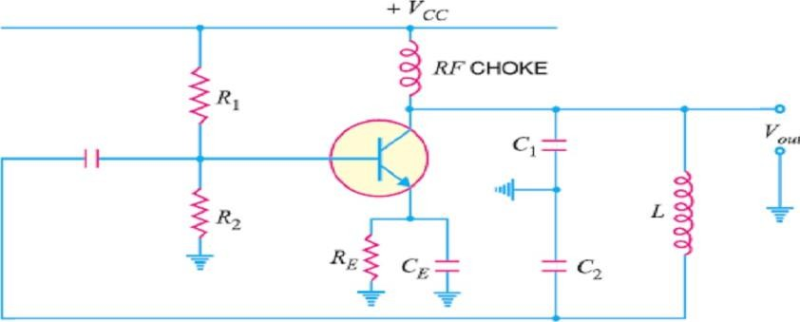
    - Fig shows a Colpitts’s oscillator. It uses two capacitors and placed across a common inductor L and the centre of the two capacitors is tapped.

    - The tank circuit is made up of C1, C2 and L. The frequency of oscillations is determined by the values of C1, C2 and L and is given by ;
𝟏
𝒇 =
𝟐𝝅√𝑳𝑪_{𝑻}
Where CT =C1+C2
    - Note that C1− C2− L is also the feedback circuit that produces a phase shift of 180°.
Circuit Operation.
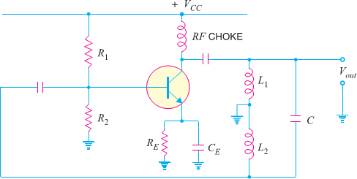
    - When the circuit is turned on, the capacitors C1 and C2 are charged. The capacitors discharge through L, setting up oscillations of frequency determined by exp.(i).
    - Output voltage of the amplifier appears across C1 and feedback voltage is developed across C2. The voltage across it is 180° out of phase with the voltage developed across C1 (Vout) as shown in Fig.
    - It is easyto see thatvoltagefeedback(voltageacross C2) to thetransistorprovidespositive feedback.
    - A phase shift of 180° is produced by transistor and a further phase shift of 180° is produced by C1− C2 voltage divider.
    - In this way, feedback is properly phased to produce continuous undamped oscillation.

HARTLEY OSCILLATOR: -
    - The Hartley oscillator is similar to Colpitts’s oscillator with minor modifications. Instead of using tapped capacitors, two inductors L1 and L2 are placed across a common capacitor C and the Centre of the inductors is tapped as shown in Fig.

    - The tank circuit is made up of L1, L2 and C. The frequency of oscillations is determined by the values of L1, L2 and C and is given by :

    - Where LT =L1 + L2 + 2M
𝟏
𝒇 =
𝟐𝝅√𝑪𝑳_{𝑻}

Here M= mutual inductance between L1 and L2
    - Note that L1 − L2 – C is also the feedback network that produces a phase shift of 180°.
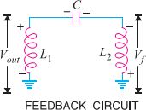
Circuit Operation. When the circuit is turned on, the capacitor is charged. When this capacitor is fully charged, it discharges through coils L1 and L2 setting up oscillations of frequency determined by equ (i).

    - The output voltage of the amplifier appears across L1 and feedback voltage across L2. The voltage across L2 is 180° out of phase with the voltage developed across L1 (Vout) as shown in Fig.
    - It is easy to see that voltage feedback (i.e., voltage across L2) to the transistor provides positive feedback.
    - A phase shift of 180° is produced by the transistor and a further phase shift of 180° is produced by L1 − L2 voltage divider.
    - Inthisway,feedbackisproperlyphasedtoproducecontinuousundamped oscillations.

PHASE SHIFT OSCILLATOR: -
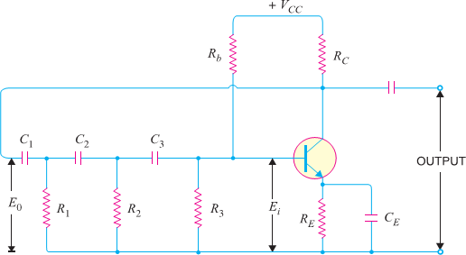
    - Fig. shows the circuit of a phase shift oscillator. It consists of a conventional single transistor amplifier and a RC phase shift network.

    - The phase shift network consists of three sections R1C1, R2C2 and R3C3. At some particular frequency f0, the phase shift in each RC section is 60º so that the total phase-shift produced by the RC network is 180º.
    - The frequency of oscillations is given by:

𝒇_{𝟎} =

Where R1 = R2 = R3 = R & C1 = C2 = C3 = C
𝟏
𝟐𝝅𝑹𝑪√𝟔𝟎

Circuit Operation.
      - When the circuit is switched on, it produces oscillations of frequency 0 by exp. (i). The output E0 of the amplifier is fed back to RC feedback network.
      - This network produces a phase shift of 180º and a voltage Ei appears at its output which is applied to the transistor amplifier.
      - Obviously, the feedback fraction m= Ei/E0. The feedback phase is correct. A phase shift of 180º is produced by the transistor amplifier.
      - A further phase shift of 180º is produced by the RC network. As a result, the phase shift around the entire loop is 360º.

Advantages
        - It does not require transformers or inductors.
        - It can be used to produce very low frequencies.
        - The circuit provides good frequency stability.

Disadvantages
- It is difficult for the circuit to start oscillations as the feedback is generally small.
- The circuit gives small output.

WIEN BRIDGE OSCILLATOR: -
  - The Wien-bridge oscillator is the standard oscillator circuit for all frequencies in the range of 10 Hz to about 1 MHz It is the most frequently used type of audio oscillator as the output is free from circuit fluctuations and ambient temperature.

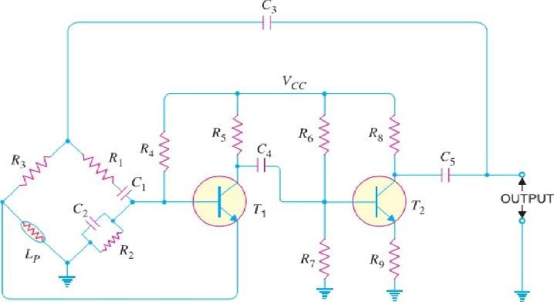
  - Fig. shows the circuit of Wien bridge oscillator. It is essentially a two-stage amplifier with R-C bridge circuit. The bridge circuit has the arms R1C1, R3, R2C2 and tungsten lamp Lp.

  - Resistances R3 and Lp are used to stabilize the amplitude of the output. The transistor T1 serves as an oscillator and amplifier while the other transistor T2 serves as an inverter (to produce 180º phase shift).
  - The circuit uses positive and negative feedbacks. The positive feedback is through R1C1, C2R2 tothe transistor T1. The negative feedback is through the voltage divider to the input of transistor T2.
  - The frequency of oscillations is determined by the series element R1C1 and parallel element R2C2 of the bridge.

𝒇 =
𝟏
𝟐𝝅√𝑹_{𝟏}𝑪_{𝟏}𝑹_{𝟐}𝑪_{𝟐}

  - If R1 = R2 = R and C1 = C2 = C, then f= 1
2𝜋𝑅𝐶
  - When the circuit is started, bridge circuit produces oscillations of frequency determined.
  - Thetwotransistorsproduceatotalphaseshift of360º so that proper positive feedback is ensured.
  - The negative feedback in the circuit ensuresconstant output. This is achieved by the temperature sensitive tungsten lamp Lp. Its resistance increases with current.
  - Shouldthe amplitude of output tend to increase, more current would provide more negative feedback.
  - The result is that the output would return to original value.
  - A reverse action would take place if the output tends to decrease.

Advantages
(i) It gives constant output. (ii) It works quite easily. (iii) Overall gain is high due to two transistors.
(iv)The frequency of oscillations can be easily changed by using a potentiometer.

Disadvantages
(i) It requires two transistors & large number of components. (ii) It cannot generate very high frequencies.

CRYSTAL OSCILLATOR: -
  - Fig. shows the transistor crystal oscillator. Note that it is a Collpit’s oscillator modified to act as a crystal oscillator.


  - The only change is the addition of the crystal (Y) in the feedback network. The crystal will act as a parallel-tuned circuit.
  - As we can see in this circuit that instead of Fig. resonance caused by L and (C1 + C2), we have the parallel resonance of the crystal. At parallel resonance, the impedance of the crystal is maximum.
  - This means that there is a maximum
voltage drop across C1. This in turn will allow the maximum energy transfer through the feedback network at fp.
  - Note that feedback is positive. A phase shift of 180° is produced by the transistor. A further phase shift of 180° is produced by the capacitor voltage divider.
  - This oscillator will oscillate only at fp. Even the smallest deviation from fp will cause the oscillator to act as an effective short. Consequently, we have an extremely
stable oscillator.
Q -factor of crystal = 𝟏 √𝑳
𝑹 𝑪

Advantages

- They have a high order of frequency stability.
- The quality factor (Q) of the crystal is very high.

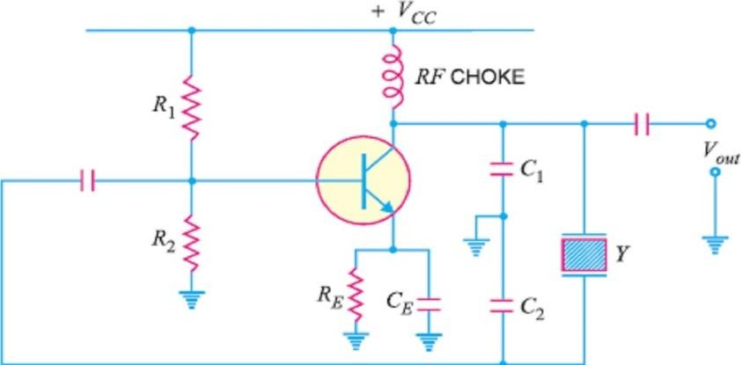
Disadvantages
  - They are fragile and consequently can only be used in low power circuits.
  - The frequency of oscillations cannot be changed appreciably.

POSSIBLE SHORT TYPE QUESTIONS WITH ANSWER

Define Damped oscillation?
Ans. The electrical oscillations whose amplitude goes on decreasing with time are called damped oscillations.

State barkhausen criterion.(S-23)
Ans .The Barkhausen criterion is a set of conditions that must be met for a circuit to produce sustained
oscillations. It states that the loop gain must be equal to unity and the phase shift around the loop must be zero or an integer multiple of 2𝜋 radians.
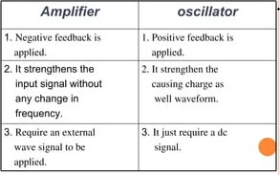
- Write the different types of oscillators? (2014-W, 2018-W) Ans.The different types of oscillators are,
(i) Colpitt’s Oscillator
(iii) Phase Shift Oscillator
(v) Crystal Oscillator
(ii) Hartley Oscillator
(iv) Wien Bridge Oscillator
4. write any two differences between amplifier and oscillator.(S-23)
POSSIBLE LONG TYPE QUESTIONS
- Explain the operation of Colpitts oscillators?
- Explain the operation of Wein bridge oscillators?
- Explain the operation of Hartley oscillators?(2014-W,2019-W)
- Explain the operation of Phase shift oscillators?(2019-W)
- Draw block diagram of voltage shunt feedback amplifier.(S-23)

UNIT NO.- 05
TUNED AMPLIFIER&WAVE SHAPING CIRCUIT

LEARING OBJECTIVES:
  - Defined and classify Tuned amplifier, Explain parallel Resonant circuit, Resonance Curve & sharpness of Resonance.
  - working principle of Single tuned Voltage& Double tuned Amplifier & its limitation.

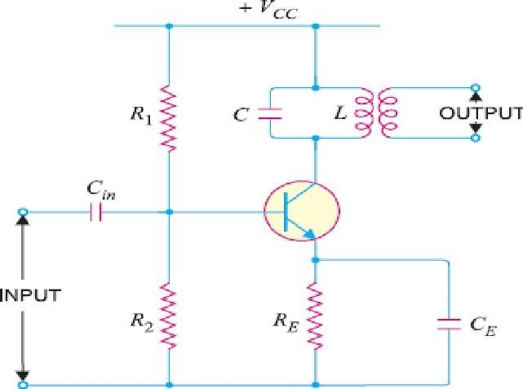
  - Different type of Non-linear circuits - Clipper, diode series &shunt, positive& negative biased & unbiased and combinational clipper clippers circuit & its application.
  - Different type of Clamper circuit (positive & negative clampers) & its application.
  - Working of Astable, Mono-stable & Bistable Multivibrator with circuit diagram.
  - Working& use of Integrator and Differentiator circuit using R- C circuit(Linear), input / output waveforms & frequency response.

DEFINED AND CLASSIFY TUNED AMPLIFIER, EXPLAIN PARALLEL RESONANT CIRCUIT, RESONANCE CURVE & SHARPNESS OF RESONANCE:

TUNED AMPLIFIERS
    - Amplifiers which amplify a specific frequency or narrow band of frequencies are called tuned amplifiers.
    - Tuned amplifiers are mostly used for the amplification of high or radio frequencies.

ANALYSIS OF PARALLEL RESONANT CIRCUIT: -
    - A parallel tuned circuit consists of a capacitor C and inductorL connected in parallel to each other with respect to a supply source.
    - Fig. shows a parallel resonant circuit connected across an ac supply source of variable frequency.
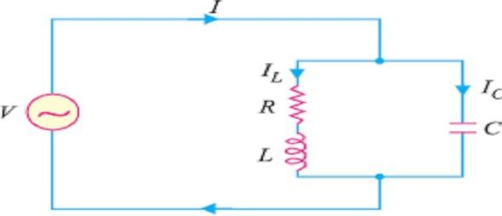
    - Here the resistance R represents the coil resistance. Its value is usually very small and the order of few ohms and hence it can be neglected as compare to the impedance of the resonance circuits.

      - Now consider the frequency of the ac supply to be varied suitably. As a result of this, the circuit will encounter different impedance at different frequencies.
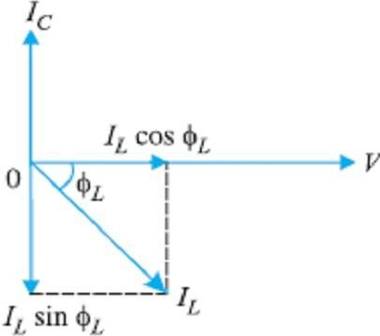
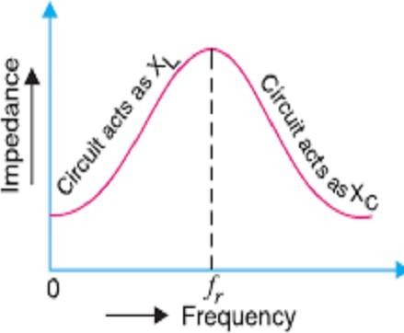
      - As the frequency is increased the inductive reactance [XL] is also increased and the capacitive reactance [XC] is increased. There is a certain frequency of the applied ac voltage at which the inductive reactance is equal to the capacitive reactance. This frequencyis called resonance frequency. It is designated by f0.

    - The frequency at which parallel resonance occurs (i.e. reactive component of circuit current becomes zero) is called the resonant frequency f0.
    - At resonant frequency, the circuit is said to be in electrical resonance. Under resonance condition the impendence of the resonant circuits becomes maximum and the line current (i.e. the current drawn from the source) is minimum.
    - Theexpressionforresonancefrequencymaybeobtainedfrom thecondition,
𝟏

𝒇_{𝟎} =
𝟐𝝅√𝑳𝑪

      - If value of inductance is Henry & the capacitance is farads Hertz then the resonance frequency is Hertz.
RESONANCE CURVE: -
    - It is a curve, which shows the variation of circuit impedance (or circuit current) with the change in frequency of the applied voltage.

    - Fig. showsthevariationofcircuit impedance (Zp) withchangeinfrequency of the applied voltage.
    - From the fig it is clear that the impedance is maximum at the resonance and is equal to L/CR. If the frequency is changed above or below the resonance, the value of impedance decreases rapidly.
    - If f1 and f2 are the lower & higher cutoff frequencies then Band width BW=f2-f1.
SHARPNESS OF RESONANCE: -
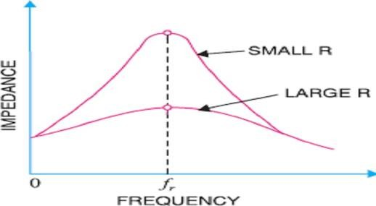
    - The resonance curve of a resonant circuit is required to be as sharp as possible in order to provide a high selectivity.

    - The sharp resonance curve means that the impedance falls off rapidly as the frequency is varied above and below the resonant frequency.
    - Mathematically the sharpness of a resonance curve is defined as ratioofthe bandwidth of the circuit to its resonant frequency. i.e.

Sharpness of Resonance = Band Width / Resonant frequency

𝐵𝑊
=
𝑓₀
𝑓₂ − 𝑓₁
=
𝑓₀
1
= 𝑄
0

    - Where Q0 is called the quality factor or Q-Factor.
    - The ratio of inductive reactance and resistance of the coil at resonance, therefore, becomes a measure ofthe quality of the tuned circuit.
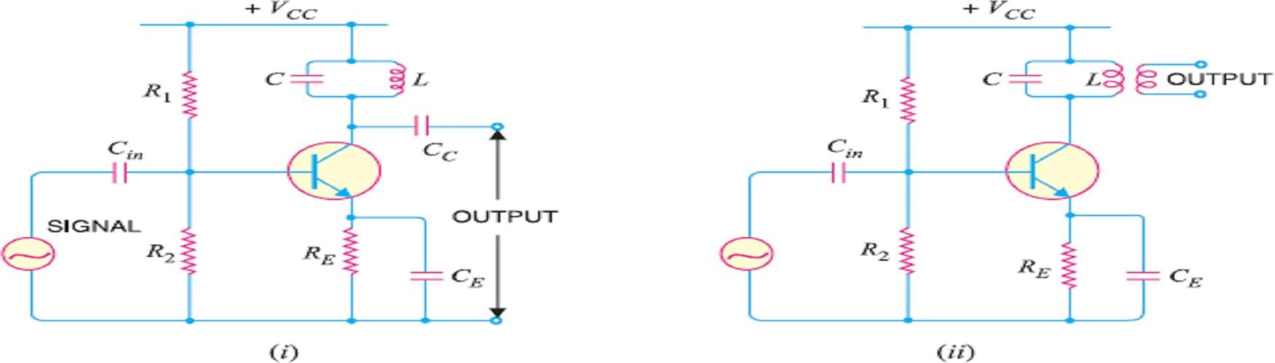
    - This is called quality factor and may be defined as under : The ratio of inductive reactance of the coil at resonance to its resistance is known as quality factor Q i.e. Q = XL/R= 2πfL/R
    - The quality factor Q of a parallel tuned circuit is very important as the sharpness of resonance curveand hence selectivity of the circuit depends upon it. Higher value of Q, more the selective of the tuned circuit.
    - The smaller the resistance of coil, the sharper is the resonance curve. This is due to the fact that a small resistance consumes less power and draws a relatively small line current.
    - Fig. shows the effect of resistance R of the coil on the sharpness of the resonance curve. It is clearthat when resistance is small, the resonance curve is very sharp. However, if the coil has large resistance, the resonance curve is less sharp. So where high selectivity is desired, the value of Q should be very large.

ADVANTAGES OF TUNED AMPLIFIERS: -
- Small power loss.
- High selectivity.
- Smaller collector supply voltage.

WORKING PRINCIPLE OF SINGLE TUNED VOLTAGE& DOUBLE TUNED AMPLIFIER & ITS LIMITATION:

CLASSIFICATION OF TUNED AMPLIFIER: -
Two types of tuned amplifiers are there,
- Single tuned voltage amplifier
- Double tuned voltage amplifier

SINGLE TUNED VOLTAGE AMPLIFIER: -
- A single tuned amplifier consists of a transistor amplifier containing a parallel tuned circuit as the collector load. The values of capacitance and inductance of the tuned circuit are so selected that its resonant frequency is equal to the frequency to be amplified.
- The output from a single tuned amplifier can be obtained either (a) by a coupling capacitor CC
as shown in Fig (i) or (b) by a secondary coil as shown in Fig (ii).
- Fig (i) is also called as single tuned voltage amplifier using Capacitive Coupled where as fig (ii) is calledas single tuned voltage amplifier using InductiveCoupled. Both these circuits consist of a

transistor amplifier and a tunes circuit as the load. The values of capacitance (C) and Inductance (L) of the tunes circuits are selected in such a way that the resonant frequency of the tunes circuit is equal to the frequency to be selected and amplified.
The resistors R1, R2 and RE are called biasing resisters. These resistors provide the d.c. operating current and voltage for the transistor.

OPERATION.
- The high frequency signal i.e. radio frequency signal to be amplified is given to the input of the amplifier.
- The resonant frequency of parallel tuned circuit is made equal to the frequency of the signal by changing the value of C.
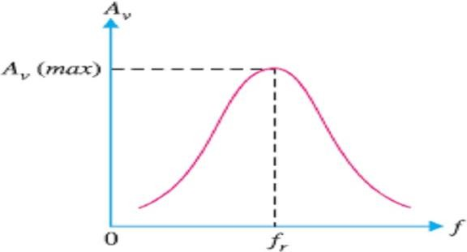
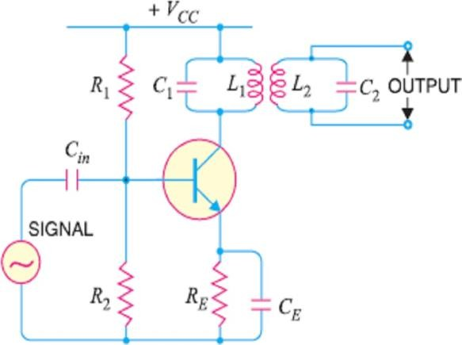
- Under such conditions, the tuned circuit will offer very high impedance to the signal frequency. Hence alarge output appears across the tuned circuit.
- In case the input signal is complex containing many frequencies, only that frequency which corresponds to the resonant frequency of the tuned circuit will be amplified.
- All other frequencies will be rejected by the tuned circuit. In this way, a tuned amplifier selects and amplifies the desired frequency.

Frequency Response of Single Tuned Voltage Amplifiers: -
- At the resonant frequency, the impedance of the parallel resonant circuit is very high and is purely resistive.
- Therefore, when the circuit is tuned to resonant frequency, the voltage across RL is maximum.
- In other words, the voltage gain is maximum at fr. However, above and below the resonant frequency, the voltage gain decreases rapidly.

- The higher the Q of the circuit, the faster the gain drops off on either side of resonance.
DOUBLE TUNED VOLTAGE AMPLIFIER: -
- Fig shows the circuit of a double tuned amplifier.
- It consists of a transistor amplifier containing two tuned circuits; one (L1C1) in the collector and the other (L2C2) in the output as shown.
- The resistors R1, R2 and RE are used to provide d.c. current and voltage for transistor operation.

- The high frequency signal to be amplified is applied to the input terminals of the amplifier.
- The resonant frequency of tuned circuit L1C1 is made equal to the signal frequency.

- Under such conditions, the tuned circuit offers very high impedance to the signal frequency.
- Hence, large output appears across the tuned circuit L1C1.
- The output from this tuned circuit is transferred to the second tuned circuit L2C2 through mutual induction. Double tuned circuits are extensively used for coupling the various circuits of radio and television receivers.

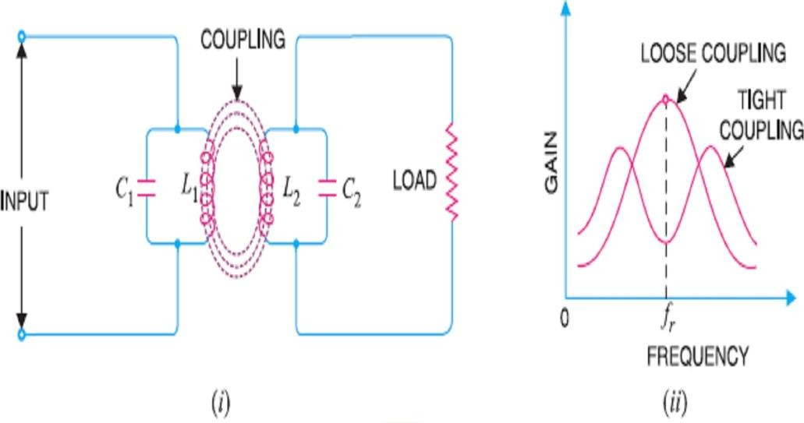
FREQUENCY RESPONSE OF DOUBLE TUNED VOLTAGE AMPLIFIERS: -

- The frequency response of a double tuned circuit depends upon the degree of coupling i.e. upon the amount of mutual inductance between the two tuned circuits.
- When coil L2 is coupled to coil L1 [See Fig. (i)], a portion of load resistance is coupled into the primary tank circuit L1C1 and affects the primary circuit in exactly the same manner as though a resistor had been added in series with the primary coil L1.
- When the coils are spaced apart, all the primary coil L1 flux will not link the secondary coil L2. The coils are said to have loose coupling.
- Under such conditions, the resistance reflected from the load (i.e. secondary circuit) is small. The resonance curve will be sharp and the circuit Q is high as shown in Fig. (ii).
- When the primary and secondary coils are very close together, they are said to have tight coupling.
- Under such conditions, the reflected resistance will be large and the circuit Q is lower.
- Two positions of gain maxima, one above and the other below the resonant frequency, are obtained.

DIFFERENT TYPE OF NON-LINEAR CIRCUITS - CLIPPER, DIODE SERIES &SHUNT, POSITIVE& NEGATIVEBIASED & UNBIASED AND COMBINATIONAL CLIPPER CLIPPERS CIRCUIT & ITS APPLICATION:
DIFFERENT TYPES OF NON-LINEAR CIRCUITS: -
    - We shall confine ourselves to the following two applications of diodes: -
- As a Clipper (ii) As a Clamper
    - A clipper (or limiter) is used to clip off or remove a portion of an A.C. signal. The half-wave rectifier is basically a clipper that eliminates one of the alternations of an A.C. signal.
    - A clamper (or dc restorer) is used to restore or change the dc reference of an ac signal. For example, you may have a 10 V pp ac signal that varies equally above and below 2 V dc. CLIPPING CIRCUITS: -
    - The circuit with which the waveform is shaped by removing (or clipping) a portion of the applied waveis known as a clipping circuit.
    - Clippers find extensive use in radar, digital and other electronic systems. Although several clipping circuits have been developed to change the wave shape, we shall confine our attention to diode clippers.
    - These clippers can remove signal voltages above or below a specified level.
    - Theimportantdiodeclippersare (i) Positive Clipper (ii) Biased Clipper (iii) Combination
Clipper.

POSITIVE CLIPPER: -
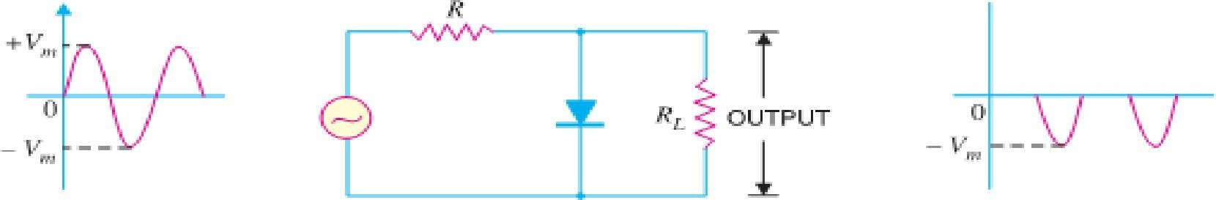
    - A positive clipper is that which removes the positive half-cycles of the input voltage. Fig. shows the typical circuit of a positive clipper using adiode.

    - As shown, the output voltage has all the positive half-cycles removed or clipped off.

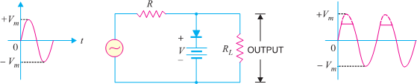
    - The circuit action is as follows: - During the positive half-cycle of the input voltage, the diode is forward biased and conducts heavily.
    - Therefore, the voltage across the diode (which behaves as a short) and hence the output voltage acrossthe load R is zero. Hence output voltage during positive half-cycles is zero.
    - During the negative half-cycle of the input voltage, the diode is reverse biased and behaves as an open.
    - In this condition, the circuit behaves as a voltage divider with an output given by :
𝑅_{𝐿}
𝑂𝑢𝑡𝑝𝑢𝑡 𝑣𝑜𝑙𝑡𝑎𝑔𝑒 = − 𝑅 + 𝑅 𝑉_{𝑀}
𝐿
Generally, RL is much greater than R.
      - It may be noted that if it is desired to remove the negative half-cycle of the input, the only thing to be done is to reverse the polarities of the diode in the circuit shown in Fig. Such a clipper is then called a negative clipper.

BIASED CLIPPER: -
    - Sometimes it is desired to remove a small portion of positive or negative half-cycle of the signal voltage. For this purpose, biased clipper is used. Fig. shows the circuit of a biased clipper using a diode with a battery of V volts.

    - With the polarities of battery shown, a portion of each positive half-cycle will be clipped. However, the negative half-cycles will appear as such across the load. Such a clipper is called biased positive clipper.
    - The circuit action is as follows: - When input voltage is greater than +V, the diode behaves as a short and the output equals +V. The output will stay at +V so long as the input voltage is greater than
+V.
    - During the period the input voltage is less than +V, the diode is reverse biased and behaves as an open.
    - Therefore, most of the input voltage appears across the output. In this way, the biased positive clipper removes input voltage above +V.
    - During the negative half-cycle of the input voltage, the diode remains reverse biased. Therefore, almost entire negative half-cycle appears across the load.
    - If it is desired to clip a portion of negative half-cycles of input voltage, the only thing to be done is to reverse the polarities of diode or battery. Such a circuit is then called a biased negative clipper.

COMBINATION CLIPPER: -
    - It is a combination of biased positive and negative clippers. With a combination clipper, a portion of both positive and negative half-cycles of input voltage can be removed or clipped as shown in Fig.

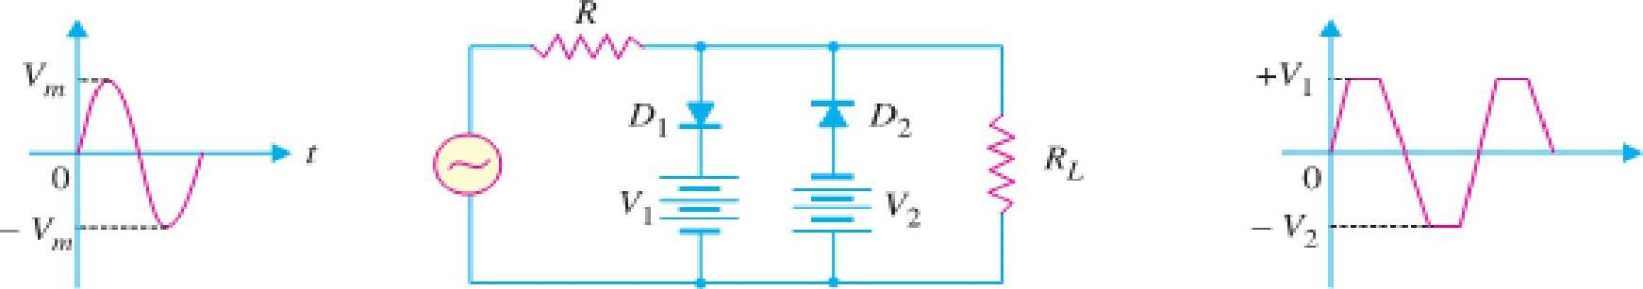
    - The circuit action is as follows: - When positive input voltage is greater than +V1, diode D1 conducts heavily while diode D2 remains reverse biased. Therefore, a voltage +V1 appear across the load. This output stays at +V1 so long as the input voltage exceeds +V1
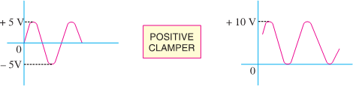
    - On the other hand, during the negative half-cycle, the diode D2 will conduct heavily and the output stays at −V2 so long as the input voltage is greater than −V2.
    - Note that +V1 and −V2 are less than + Vm and – Vm respectively.
    - Between +V1 and −V2 neither diode is on. Therefore, in this condition, most of the input voltage appears across the load. It is interesting to note that this clipping circuit can give square wave output if Vm is much greater than the clipping levels.

APPLICATIONS OF CLIPPERS
  - Changingtheshapeofawaveform
  - Circuittransient (SuddenriseofVoltageor Current) protection.

DIFFERENT TYPE OF CLAMPER CIRCUIT (POSITIVE & NEGATIVE CLAMPERS) & ITS APPLICATION:

CLAMPING CIRCUITS: -
    - A circuit that places either the positive or negative peak of a signal at a desired d.c. level is known as a

Clamping circuit.

    - A clamping circuit (or a clamper) essentially adds a d.c. component to the signal. Fig. shows thekey idea behind clamping. The input signal is a sine wave having a peak-to-peak value of 10 V.
    - The clamper adds the d.c. component and pushes the signal upwards so that the negative peaks fall on the zero level. As you can see, the waveform now has peak values of +10 V and 0 V.
    - It may be seen that the shape of the original signal has not changed; only there is vertical shift in the signal. Such a clamper is called a positive clamper. The negative clamper does the reverse i.e. it pushes the signal downwards so that the positive peaks fall on the zero level.
    - The following points may be noted carefully :
    - The clamping circuit does not change the peak-to-peak or r.m.s. value of the waveform. Thus referring to Fig. above, the input waveform and clamped output have the same peak-to-peak value i.e., 10 V in this case. If you measure the input voltage and clamped output with an a.c. voltmeter, the readings will be the same.
    - A clamping circuit changes the peak and average values of a waveform. Thus in the above circuit, it is easy to see that input waveform has a peak value of 5 V and average value over a cycle is zero. The clamped output varies between 10 V and 0 V. Thus the peak value is 10 V and average value is 5 V.

BASIC IDEA OF A CLAMPER
    - A clamping circuit should not change peak-to-peak value of the signal; it should only change the dc level.
    - To do so, a clamping circuit uses a capacitor, together with a diode and a load resistor R.

    - Fig. shows the circuit of a positive clamper.
    - The operation of a clamper is based on the principle that charging time of a capacitor is made very small as compared to its discharging time.

POSITIVE CLAMPER: -
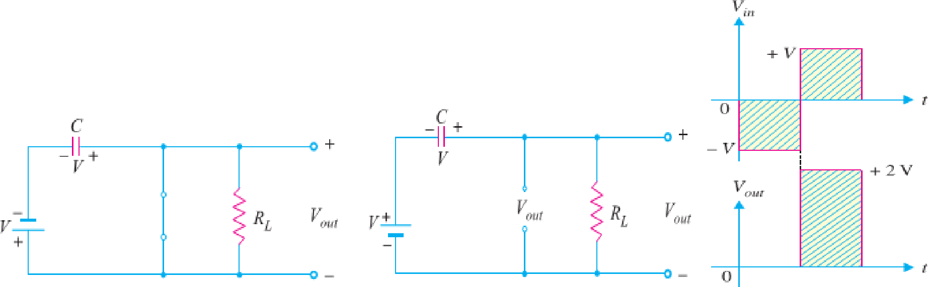
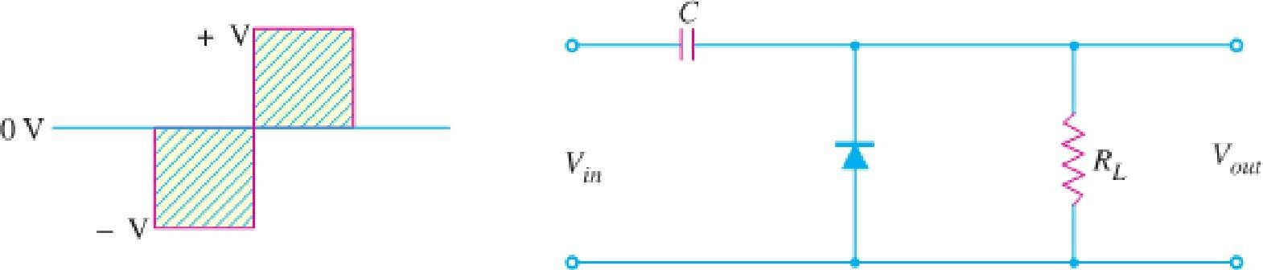
    - Fig. shows the circuit of a positive clamper. The input signal is assumed to be a square wave with time period T. The clamped output is obtained across RL.

    - The circuit design incorporates two main features.
    - Firstly, the values of C and RL are so selected that time constant τ= CRL is very large.
    - This means that voltage across the capacitor will not discharge significantly during the interval the diode is non-conducting.
    - Secondly, RLC time constant is deliberately made much greater than the time period T of the incoming signal.

CIRCUIT OPERATION: -

    - During the negative half-cycle of the input signal, the diode is forward biased. Therefore, the diode behaves as a short as shown in Fig (i). The charging time constant (= CRf, where Rf=forward resistance of the diode) is very small so that the capacitor will charge to V volts very quickly.
    - So, during this interval, the output voltage is directly across the short circuit. Therefore, Vout= 0.
    - (ii) When the input switches to +V state (i.e., positive half-cycle), the diode is reverse biased and behaves as an open as shown in Fig (ii).
    - Since the discharging time constant is much greater than the time period of the input signal, the capacitor remains almost fully charged to V volts during the off time of the diode.
    - Applying Kirchhoff ’s voltage law in Fig (ii) to the input loop, we have,
V+ V − Vout =0 or Vout=2V
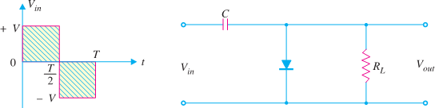
    - The resulting waveform is shown in Fig. (iii) It is clear that it is a positively clamped output. That is to say the input signal has been pushed upward by V volts so that negative peaks fall on the zero level.

NEGATIVE CLAMPER: -
    - Fig. showsthe circuit of a-ve clamper. The clamped output is taken across RL.
    - Note that only change from positive clamper is that the connections of diode are reversed.

CIRCUIT OPERATION: -
    - During the positive half-cycle of the input signal, the diode is forward biased.
    - Therefore, the diode behaves as a short as shown in Fig (i).
      - The charging time constant is very small so that the capacitor will charge to V volts very quickly.
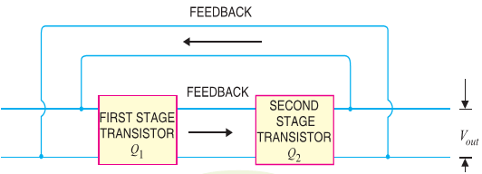
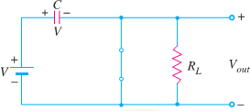
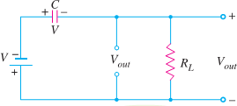
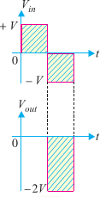
      - It is easy to see that during this interval, the output voltage is directly across the short circuit.

Therefore, Vout = 0.
    - When the input switches to –V state (i.e., negative half-cycle), the diode is reverse biased and behaves as an open as shown in Fig (ii).
    - Since the discharging time constant is much greater than the time period of the input signal, the capacitor almost remains fully charged to V volts during the off time of the diode.
    - Applying Kirchhoff ’s voltage law to the input loop in Fig (ii) Vout = - 2V
    - The resulting waveform is shown in Fig (iii). Note that total swing of the output signal is equal to the total swing of the input signal.

APPLICATIONS OF CLIPPERS
- Clamper circuit is used TV receiver to restore the original d.c. reference signal to the video signal,
- Used to produce dc voltage multiple of peak ac input voltage i.e. known as Voltage Multiplier.

WORKING OF ASTABLE, MONOSTABLE & BISTABLEMULTIVIBRATOR WITH CIRCUIT DIAGRAM: MULTIVIBRATORS: -
    - An electronic circuit that generates square waves (or other non-sinusoidal such as rectangular, sawtooth wave) is known as a multivibrator.

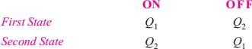
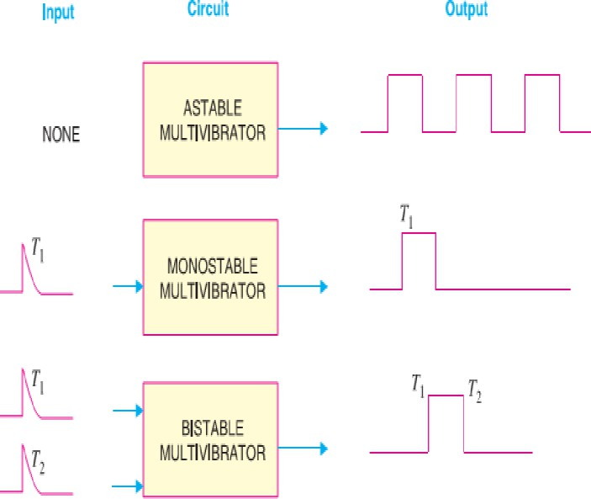
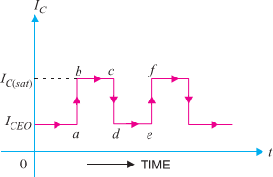
TYPES OF MULTIVIBRATORS: -
Themultivibratorsareclassifiedas:-
- A table or free running multivibrator
- Monostable or one-shot multivibrator
- Bi-stable or flip-flop multivibrator
- Fig. shows the input/output relations for the three types of multivibrators.

- The astable or free running multivibrator alternates automatically between the two states and remains in each for a time dependent upon the circuit constants.
- The monostable or one-shot multivibrator has one state stable and one quasi-stable state. The application of input pulse triggers the circuit into its quasi-stable state, in which it remains for a period determined by circuit constants.
- The bistable multivibrator has both the two states stable. It requires the application of an external triggering pulse to change the operation from either one state to the other.

ASTABLE MULTIVIBRATOR
- A multivibrator which generates square waves of its own (i.e. without any external triggering pulse) is known as an astable or free running multivibrator.
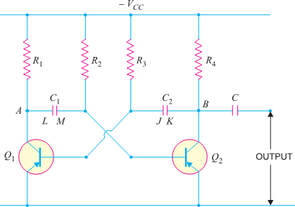
CIRCUIT DETAILS: - Fig. shows the circuit of a typical transistor a stable multivibrator using two identical transistors Q1 and Q2.

- The circuit essentially consists of two symmetrical CE amplifier stages, each providing a feedback to the other. Thus, collector loads of the two stages are equal i.e. R1= R4 and the biasing resistors are also equal i.e. R2 = R3.
- The output of transistor Q1 is coupled to the input of Q2 through C1 while the output of Q2 is fed to the input of Q1 through C2. The square wave output can be taken from Q1 or Q2.

CIRCUIT OPERATION: -
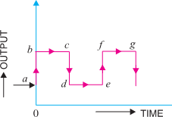
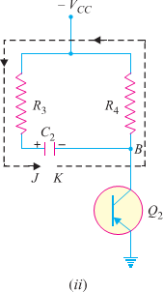
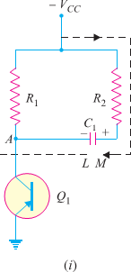
- When VCC is applied, collector currents start flowing in Q1and Q2. In addition, the coupling capacitors C1 and C2 also start charging up.

- As the characteristics of no two transistors (i.e. β, VBE) are exactly alike, therefore, one transistor, say Q1, will conduct more rapidly than the other.
- The rising collector current in Q1 drives its collector more and more positive. The increasing positive output at point A is applied to the base of transistor Q2 through C1.
- This establishes a reverse bias on Q2 and its collector current starts decreasing. As the collector of Q2 is connected to the base of Q1 through C2, therefore, base of Q1 becomes more negative i.e. Q1 is more forward biased.
- This further increases the collector current in Q1 and causes a further decrease of collector current in Q2.
- This series of actions is repeated until the circuit drives Q1 to saturation and Q2 to cut off.

- These actions occur very rapidly and may be considered practically instantaneous. The output of Q1 (ON state) is approximately zero and that of Q2 (OFF state) is approximately VCC.
- This is shown by ab in above Fig. When Q1 is at saturation and Q2 is cut off, the full voltage VCC appears across R1 and voltage across R4 will be zero.
- The charges developed across C1 and C2 are sufficient to maintain the saturation and cut off conditions at Q1and Q2 respectively. This condition is represented by time interval bc in Fig.
- However, the capacitors will not retain the charges indefinitely but will discharge through their respective circuits. The discharge path for C1, with plate L negative and Q1 conducting.
- The discharge path for C2, with plate K negative and Q2 cut off,.As the resistance of the discharge path for C1 is lower than that of C2, therefore, C1 will discharge more rapidly.
- As C1 discharges, the base bias at Q2 becomes less positive and at a time determined by R2 and C1, forward bias is re-established at Q2. This causes the collector current to start in Q2.
- The increasing positive potential at collector of Q2 is applied to the base of Q1 through the capacitor C2. Hence the base of Q1 will become more positive i.e. Q1 is reverse biased.
- The decrease in collector current in Q1 sends a negative voltage to the base of Q2 through C1, thereby causing further increase in the collector current of Q2.

- With this set of actions taking place, Q2 is quickly driven to saturation and Q1 to cut off. This condition is represented by cd in Fig. The period of time during which Q2 remains at saturation and Q1 at cut off is determined by C2 and R3.

MONOSTABLE MULTIVIBRATOR
- A multivibrator in which one transistor is always conducting (i.e. in the ON
state) and the other is non-conducting (i.e. in the OFF state) is called a monostable multivibrator CIRCUIT DETAILS: -
- Fig. shows the circuit of a transistor monostable multivibrator. It consists of two similar transistors Q1 and Q2 with equal collector loads i.e. R1 = R4.
- The values of VBB and R5 are such as to reverse bias Q1 and keep it at cut off. The collector supply VCC and R2 forward bias Q2 and keep it at saturation.
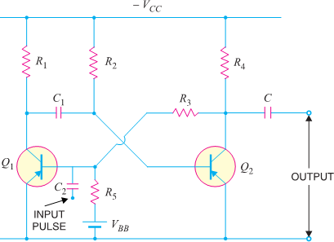
- The input pulse is given through C2 to obtain the square wave. Again output can be taken from Q1 or Q2.

CIRCUIT OPERATION: -
- With the circuit arrangement shown, Q1 is at cut off and Q2 is at saturation. This is the stable state for the circuit and it will continue to stay in this state until a triggering pulse is applied at C2.
- When a negative pulse of short duration and sufficient magnitude is applied to the base of Q1
through C2, the transistor Q1 starts conducting and positive potential is established at its collector.
- The positive potential at the collector of Q1 is coupled to the base of Q2 through capacitor C1. This decreases the forward bias on Q2 and its collector current decreases.
- The increasing negative potential on the collector of Q2 is applied to the base of Q1 through R3. This further increases the forward bias on Q1 and hence its collector current.
- With this set of actions taking place, Q1is quickly driven to saturation and Q2 to cut off. With Q1 at saturation and Q2 at cut off, the circuit will come back to the original stage (i.e. Q2 at saturation and Q1 at cut off) after some time as explained in the following discussion.
- The capacitor C1 (charged to approximately VCC) discharges through the path R2VCCQ1. As C1 discharges, it sends a voltage to the base of Q2 to make it less positive.
- This goes on until a point is reached when forward bias is re-established on Q2 and collector current starts to flow in Q2.
- The step by step events already explained occur and Q2 is quickly driven to saturation and Q1 to cut off.
- This is the stable state for the circuit and it remains in this condition until another pulse causes the circuit to switch over the states.

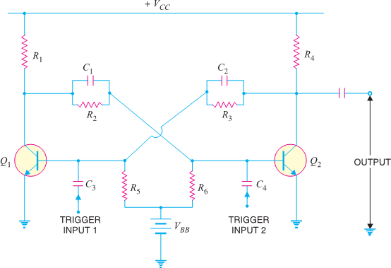
BISTABLE MULTIVIBRATOR: -

- A multivibrator which has both the states stable is called a Bistable Multivibrator. CIRCUIT DETAILS: -
- Circuit details. Fig. shows the circuit of a typical transistor bistable multivibrator.
- It consists of two identical CE amplifier stages with output of one fed to the input of the other.
- The feedback is coupled through resistors (R2, R3) shunted by capacitors C1 and C2.
- The main purpose of capacitors C1 and C2 is to improve the switching characteristics of the circuit by passing the high frequency components of the square wave.
- This allows fast rise and fall times and hence distortion less square wave output. The output can be taken across either transistor.

OPERATION: -
- When VCC is applied, one transistor will start conducting slightly ahead of the other due to some differences in the characteristics of the transistors.
- This will drive one transistor to saturation and the other to cut off in a manner described for the astable multivibrator.
- Assume that Q1 is turned ON and Q2 is cut OFF. If left to itself, the circuit will stay in this condition. In order to switch the multivibrator to its other state, a trigger pulse must be applied.
- A negative pulse applied to the base of Q1 through C3 will cut it off or a positive pulse applied to the base of Q2 through C4 will cause it to conduct.
- Suppose a negative pulse of sufficient magnitude is applied to the base of Q1 through C3.
- This will reduce the forward bias on Q1 and cause a decrease in its collector current and an increase in collector voltage.
- The rising collector voltage is coupled to base of Q2 where it forward biases base-emitter junction of Q2.
- This will cause an increase in its collector current and decrease in collector voltage.
- The decreasing collector voltage is applied to the base of Q1 where it further reverse biases the base- emitter junction of Q1 to decrease its collector current.
- With this set of actions taking place, Q2 is quickly driven to saturation and Q1 to cut off.
- The circuit will now remain stable in this state until a negative trigger pulse at Q2 (or a positive trigger pulse at Q1) changes this state.

WORKING& USE OF INTEGRATOR AND DIFFERENTIATOR CIRCUIT USING R- C CIRCUIT(LINEAR), INPUT / OUTPUT WAVEFORMS & FREQUENCY RESPONSE:

DIFFERENTIATING CIRCUIT:
    - A circuit in which output voltage is directly proportional to the derivative of the input is known as a Differentiating Circuit.

𝑶𝑼𝑻 𝑷𝑼𝑻 =
𝒅
𝒅𝒕
(𝑰𝑵𝑷𝑼𝑻)

    - A differentiating circuit is a simple RC series circuit with output taken across the resistor R.
    - The circuit is suitably designed so that output is proportional to the derivative of the input.
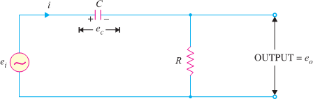
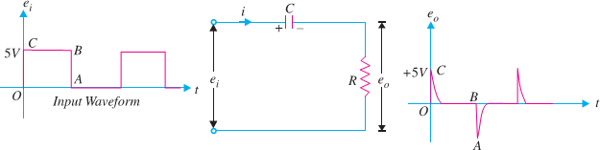
Thus if a d.c. or constant input is applied to such a circuit, the output will be zero. It is because the derivative of a constant is zero.

    - Fig shows a typical differentiating circuit. The output across R will be the derivative of the input.
    - It is important to note that merely using voltage across R does not make the circuit a differentiator; it is also necessary to set the proper circuit values.
    - In order to achieve good differentiation, the following two conditions should be satisfied :
    - The time constant RC of the circuit should be much smaller than the time period of the input wave.
    - The value of XC should be 10 or more times larger than Rat the operating frequency.
    - Fulfilled these conditions, the output across R in Fig. will be the derivative of the input. Let ei be the input alternating voltage and let i be the resulting alternating current.
    - The charge q on the capacitor at any instant is q =C ec

𝑶𝑈𝑇 𝑃𝑈𝑇 𝑉𝑂𝐿𝑇𝐴𝐺𝐸 =
𝑑
𝑑𝑡
(𝐼𝑁𝑃𝑈𝑇 𝑉𝑂𝐿𝑇𝐴𝐺𝐸)

OUTPUT WAVEFORMS: -
    - The output waveform from a differentiating circuit depends upon the time constant and shape of the input wave. Three important cases will be considered.
    - When input is a square wave: - In this case, output will consist of sharp narrow pulses as shown in Fig. During the OC part of input wave, its amplitude changes abruptly and hence the differentiated wave will be a sharp narrow pulse as shown in Fig.

    - However, during the constant part CB of the input, the output will be zero because derivative of a constant is zero. Let us look at the physical explanation of this behavior of the circuit.
    - Since time constant RC of the circuit is very small w.r.t. time period of input wave and XC >> R, the capacitor will become fully charged during the early part of each half-cycle of the input wave.
    - During the remainder part of the half-cycle, the output of the circuit will be zero because the capacitor voltage neutralizes the input voltage and there can be no current flow through R.

    - Thus we shall get sharp pulse at the output during the start of each half-cycle of input wave while for the remainder part of the half-cycle of input wave, the output will be zero.
    - In this way, a symmetrical output wave with sharp positive and negative peaks is produced. Such pulses are used in many ways in electronic circuits e.g. in television transmitters and receivers, in multivibrators to initiate action etc.
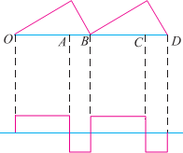
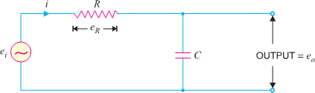
    - When input is a triangular wave: - When the input fed to a differentiating circuit is a triangular wave, the output will be a rectangular wave as shown in Fig.

    - During the period OA of the input wave, its amplitude changes at a constant rate and, therefore, the differentiated wave has a constant value for each constant rate of change.
    - During the period AB of the input wave, the change is less abrupt so that the output will be a very narrow pulse of rectangular form.
    - Thus, when a triangular wave is fed to a differentiating circuit, the output consists of a succession of rectangular waves of equal or unequal duration depending upon the shape of the input wave.
    - When input is a sine wave. A sine wave input becomes a cosine wave and a cosine wave input becomes an inverted sine wave at the output.

APPLICATIONS OF DIFFERENTIATING CIRCUIT: -
    - To generate a series of narrow pulses from rectangular or square waves.
    - To generate a step from a ramp input.
    - To generate a square wave from triangular wave inputs.

INTEGRATING CIRCUIT: -
    - A circuit in which output voltage is directly proportional to the integral of the input is known as an Integrating Circuit.
i.e 𝑶𝑼𝑻𝑷𝑼𝑻 = ∫(𝑰𝑵𝑷𝑼𝑻)
      - An integrating circuit is a simple RC series circuit with output taken across the capacitor C as shown inFig. It may be seen that R and C of the differentiating circuit have changed places.

    - Let ei be the input alternating voltage and let i be the resulting alternating current.
    - Since R is very large as compared to capacitive reactance XC of the capacitor, it is reasonable to assume that voltage across R (i.e. eR) is equal to the input voltage i.e.
ei = eR
    - Thechargeq on thecapacitor at anyinstant is
q = ∫ i dt = ∫ ei dt

POSSIBLE SHORT TYPE QUESTIONS WITH ANSWER

- Define astable multivibrator? (W-17)(S-23)
Ans. A multivibrator which generates square waves of its own (i.e. without any external triggering pulse) isknown as an astable or free running multivibrator.
- Define Bistable multivibrator?
Ans. A multivibrator which has both the states stable is called a Bistable Multivibrator.
- Define Mono-stable multivibrator?
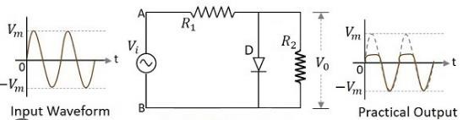
Ans. A multivibrator in which one transistor is always conducting (i.e. in the ON
state) and the other is non-conducting (i.e. in the OFF state) is called a monostable multivibrator.
- Draw the positive shunt clipper circuit.(S-23)

POSSIBLE LONG TYPE QUESTIONS

  - Explain the operation of A stable multivibrator? (2019-S)
  - Explain the operation of Bi stable multivibrator?(W-17)
  - Explain the operation of Mono stable multivibrator?(2019-S)
  - Explain the operation of integrator & differentiator? (2019-S)
  - With a neat circuit diagram explain the working of a –ve clamper circuit, draw its i/p and o/p waveforms.(S-23)

UNIT NO.- 06
OPERATIONAL AMPLIFIER CIRCUITS & FEEDBACK CONFIGURATION

LEARING OBJECTIVES:
  - Differential amplifier & explain its configuration &significance.

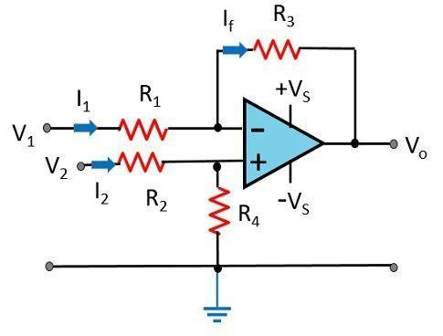
  - Block diagram representation of a typical Op- Amp, its equivalent circuits and draw the schematic symbol.
  - Discuss the types of integrated circuits manufacturer’s designations of ICs, Package types, pin identification and temperature and ordering information.
  - Define the following electrical characteristics input offset voltage, input offset current, CMMR, Large signal voltage gain, Slew rate .
  - Draw and explain the Open Loop configuration (inverting, non-inverting Amplifier).
  - Draw the circuit diagram of the voltage series feedback amplifier and derive the close loop Voltage gain, gain of feedback circuits input resistance, and output resistance, bandwidth and total output offset voltage with feedback.
  - Draw the circuit diagram of the voltage shunt feedback amplifier and derive the close loop, Voltage gain, gain of feedback circuits and input resistance, and output resistance, bandwidth and total output offset voltage with feedback.

:- DIFFERENTIAL AMPLIFIER & EXPLAIN ITS CONFIGURATION & SIGNIFICANCE:-

Differential Amplifier
    - Definition: Differential Amplifier is a device that is used to amplify the difference in voltage of the two input signals. Differential Amplifier is an important building block in integrated circuits of analog system.
    - It typically forms input stages of operational amplifiers. In simple words, we can say It is a device that amplifies the difference of 2 input signals.
    - Let’s have a look at the below-shown diagram where an operational amplifier is used as a differential amplifier:

    - Here, the voltage difference present at the inverting and non-inverting terminal gets amplified and thus an amplified output is received. Because of input configuration, all op-amps are considered to be differential amplifiers.

    - When two inputs are applied at the two terminals the voltage difference produced resultantly will be proportional to the difference of the two applied input signals. Differential amplifier behaves as subtractor circuit, that basically subtracts the two-input signal. The differential amplifier can be constructed by making use of BJTs and FETs.

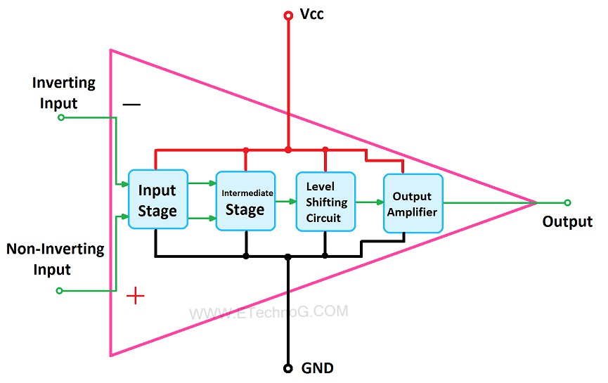
: -BLOCK DIAGRAM REPRESENTATION OF A TYPICAL OP- AMP, ITS EQUIVALENT CIRCUITS & DRAW THE SCHEMATIC SYMBOL:

Operational amplifier (op-amp): -
    - An op-amp is a multi-stage, direct coupled, high gain negative feedback amplifier that has one or more differential amplifiers and it’s concluded with a level translator and an output stage.
    - Voltage-shunt feedback is provided in an op-amp to obtain a stabilized voltage gain.

Block Diagram of Operational Amplifier (Op-amp)
    - The block diagram of a multi-stage operational amplifier is given below.

    - The op-amp begins with a differential amplifier stage, which operates in the differential mode. Thus, the inputs noted with ‘+’ & ‘- ‘.
    - The positive sign is for the non-inverting input and negative is for the inverting input.
    - The non-inverting input is the ac signal (or dc) applied to the differential amplifier which produces the same polarity of the signal at the output of op-amp.
    - The inverting signal input is the ac signal (or dc) applied to the differential amplifier. This produces 180 degrees out of phase signal at the output.
    - The inverting and non-inverting inputs are provided to the input stage which is a dual input, balanced output differential amplifier.

    - The voltage gain required for the amplifier is provided in this stage along with the input resistance for the op-amp.
    - The output of the initial stage is given to the intermediate stage, which is driven by the output of the input stage. IN this stage direct coupling is used, which makes the dc voltage at the output of the intermediate stage above ground potential.
    - Therefore, the dc level at its output must be shifted down to 0Volts with respect to the ground. For this, the level shifting stage is used where usually an emitter follower with the constant current source is applied.
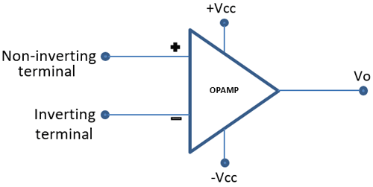
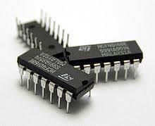
    - The level shifted signal is then given to the output stage where a push-pull amplifier increases the output voltage swing of the signal and also increases the current supplying capability of the op- amp.
Symbol of Operational Amplifier (Op-amp)
      - The schematic symbol of an op-amp is shown below.

      - The above shown symbol is the most widely used op-amp symbol for all electronic circuits.
      - V1 (Volts) – Non-inverting input voltage.
      - V2 (Volts) – Inverting input voltage.
      - V0 (Volts) – Output voltage

: - DISCUSS THE TYPES OF INTEGRATED CIRCUITS MANUFACTURER’S DESIGNATIONS OF IC’S, PACKAGETYPES, PIN IDENTIFICATION AND TEMPERATURE AND ORDERING INFORMATION: -

INTEGRATED CIRCUITS(IC): -
    - An IC is one in which ckt components such as transistor, diode, resister, capacitor etc are automatically part of a small semiconductor chip.

Types of Integrated Circuits based on Classes
    - Integrated circuits are available in three classes based on the techniques used while manufacturing them.
- Thin and thick film ICs
- Monolithic ICs
- Hybrid or multichip ICs

Thin & Thick ICs
  - In these types of integrated circuits, passive components like capacitors and resistors are used however the transistors and diodes are connected like separate components to design a circuit.

Monolithic ICs
  - In this kind of integrated circuits, the interconnections of the active, the passive, and discrete components on a silicon chip can be formed.

Dual-in-line package (DIP) IC
  - A DIP (a dual in-line package) or DIPP (dual in-line pin package) is an electronic component package in terms of microelectronics or electronics with a rectangular board & two parallel rows with electrical connecting pins.

Hybrid or Multi-Chip ICs
  - As the name suggests, multi means above one individual chip which is interconnected. The active components like diodes or diffused transistors include these ICs whereas the passive components are the diffused capacitors or resistors on a single chip.

Types of IC Packages
  - The IC packages are categorized into two types like Through-Hole Mount & Surface Mount Packaging.
- Through-Hole Mount Packages
  - The designing of these can be done where the lead pins are fixed through one face of the board & soldered on the other side. As compared with other types, the size of these packages is bigger.
  - The different through-hole mount IC packages are PDIP, DIP, ZIP, PENTAWATT, T7-TO220, TO2205, TO220, TO99, TO92, TO18, TO03.
- Surface Mount Packaging
  - This kind of packaging mainly follows the mounting technology otherwise locating the components straight on the PCB. Even though his fabrication methods will help to do things rapidly, it also improves the chances of faults due to the tiny components & they are arranged very close to each other.
  - The different surface mount IC packages are SOT23, SOT223, TO252, TO263, DDPAK, SOP, TSOP, TQFP, QFN, and BGA.
Advantages
The advantages of types of Integrated circuits are discussed below.
  - Power Consumption is Low
  - Size is Compact
  - Less Cost
  - Less Weight

Disadvantages
The disadvantages of different types of integrated circuits include the following.
  - The heat cannot be dissipated at a necessary rate due to its small size and overflow of current can cause the IC damage
  - In Integrated circuits, the transformers, as well as inductors, cannot be incorporated
  - It handles a limited range of power
  - Assembly of high-grade PNP is not achievable.

OPERATING TEMPERATURE RANGE OF ICS:
  - The temperature range for operation of silicon integrated circuits (ICs or chips) is -55C to
+125C, which is meant to ensure operation in virtually any field situation, with plenty of margin (125C is 25% hotter than the boiling point of water).

: - DEFINE THE FOLLOWING ELECTRICAL CHARACTERISTICS INPUT OFFSET VOLTAGE, INPUT OFFSET CURRENT, CMMR, LARGE SIGNAL VOLTAGE GAIN, SLEW RATE :

INPUT OFFSET VOLTAGE: -
    - The input offset voltage is defined as the voltage that must be applied between the
two input terminals of the op amp to obtain zero volts at the output. Ideally the output of
the op amp should be at zero volts when the inputs are grounded. In reality the input terminals are at slightly different dc potentials.

INPUT OFFSET CURRENT: -
    - There is a difference in the input current that flows in or out of each of the input pins, even if the output voltage of the operational amplifier is 0 V, due to the fact the pair characteristics (hFE,VBE) of the differential transistor do not match. This difference is known as the input offset current (IIO).

CMRR: -
    - The CMRR is defined as the ratio of the powers of the differential gain over the common- mode gain, measured in positive decibels (thus using the 20 log rule): As differential gain should exceed common-mode gain, this will be a positive number, and the higher the better.

LARGE SIGNAL VOLTAGE GAIN: -
    - This is the open loop voltage gain measured at DC with the amplifier producing a large (just less than maximum) voltage output, usually quoted in V/mV.

SLEW RATE: -
    - Slew rate is defined as the maximum rate of change of an op amp's output voltage and is given units of volts per microsecond. Slew rate is measured by applying a large signal step, such as 1V, to the input of the op amp, and measuring the rate of change from 10% to 90% of the output signal's amplitude.

: - DRAW AND EXPLAIN THE OPEN LOOP CONFIGURATION (INVERTING, NON-INVERTING AMPLIFIER):

INVERTING AMPLIFIER: -
    - An inverting amplifier (also known as an inverting operational amplifier or an inverting op- amp) is a type of operational amplifier circuit which produces an output which is out of phase with respect to its input by 180º.

    - This means that if the input pulse is positive, then the output pulse will be negative and vice versa. The figure below shows an inverting operational amplifier built by using an op-amp and two resistors.

    - Here we apply the input signal to the inverting terminal of the op-amp via the resistor Ri. We connect the non-inverting terminal to ground. Further, we provide the feedback necessary to stabilize the circuit, and hence to control the output, through a feedback resistor Rf.
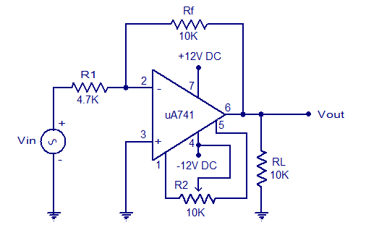
- Mathematically the voltage gain offered by the circuit is given as
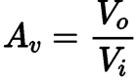
Where,
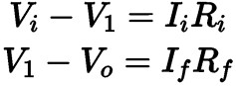

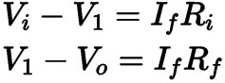
- However, we know that an ideal op amp has infinite input impedance due to which the currents
flowing into its input terminals are zero i.e. I1 = I2 = 0. Thus, Ii = If. Hence,
- We also know that in an ideal op amp the voltage at inverting and non-inverting inputs are always equal.
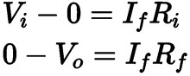
- As we have grounded the non-inverting terminal, zero voltage appears at the non – inverting terminal. That means V2 = 0. Hence, V1 = 0, also. So, we can write

- From, above two equations, we get,
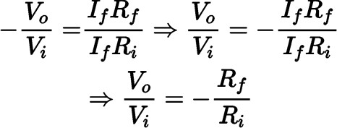
- The voltage gain of the inverting operational amplifier or inverting op amp is,
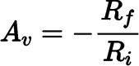

- This indicates that the voltage gain of the inverting amplifier is decided by the ratio of the feedback resistor to the input resistor with the minus sign indicating the phase-reversal. Further, it is to be noted that the input impedance of the inverting amplifier is nothing but Ri.
- Inverting amplifiers exhibit excellent linear characteristics which make them ideal as DC amplifiers.

USES: -
- They are often used to convert input current to the output voltage in the form of Transresistance or Transimpedance Amplifiers.
- These can also be used in audio mixers when used in the form of Summing Amplifiers.

NON-INVERTING AMPLIFIER: -
- A non-inverting amplifier is an op-amp circuit configuration that produces an amplified output signal and this output signal of the non-inverting op-amp is in-phase with the applied input signal.
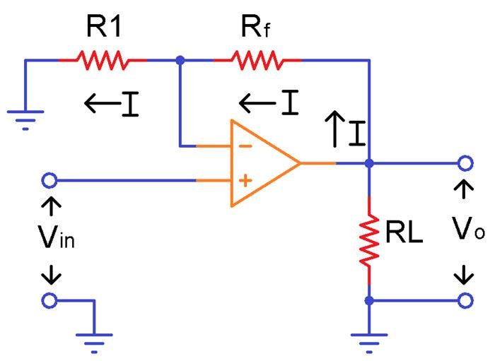
- The circuit diagram of an ideal non-inverting amplifier is as shown in the figure below.
- From the circuit, it can be seen that the R2 (Rf in the above picture) and R1 (R1 in the above picture) act as a potential divider for the output voltage and the voltage across resistor R1 is applied to the inverting input.
- When the non-inverting input is connected to the ground, i.e., VIN = 0, the voltage at the inverting input terminal must also be at ground level; if not, any voltage difference between the input terminals would be amplified to move the inverting input terminal back to the ground level (inputs of the Op Amp will always be at the same voltage).
- Since the inverting input terminal is at ground level, the junction of the resistors R1 and R2 must also be at ground level. This implies that the voltage drop across R1 will be zero. As a result, the current flowing through R1 and R2 must be zero. Thus, there are zero voltage drops across R2, and therefore the output voltage is equal to the input voltage, which is 0V.
- When a positive-going input signal is applied to the non-inverting input terminal, the output voltage will shift to keep the inverting input terminal equal to that of the input voltage applied. Hence, there will be a feedback voltage developed across resistor R1,

VR1=VIN=VOUTR1/(R1+R2)

: -DRAW THE CKT DIAG. OF THE VOLTAGE SERIES FEED BACK AMPLIFIER AND DERIVE THE CLOSE LOOP VOLTAGE GAIN, GAIN OF FEED BACK CKTS INPUT RESISTANCE, AND OUT PUT RESISTANCE, BANDWIDTH AND TOTAL OUTPUT OFFSET VOLTAGE WITH FEED BACK: -
DRAW THE CKT DIAG. OF THE VOLTAGE SERIES FEED BACK AMPLIFIER: -

Voltage-Series Feedback
    - In the voltage series feedback circuit, a fraction of the output voltage is applied in series with the input voltage through the feedback circuit. This is also known as shunt-driven series-
fed feedback, i.e., a parallel-series circuit.

Voltage Series Feedback Amplifier
    - In this type of circuit, a portion of the o/p voltage can be applied to the input voltage in series through the feedback circuit. The block diagram of the voltage series feedback-amplifier is shown below
    - When the feedback circuit is allied in shunt through the output, then the o/p impedance will be reduced and the i/p impedance is enlarged because of the series connection with the input.
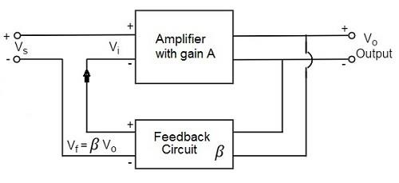

DERIVE THE CLOSE LOOP VOLTAGE GAIN, GAIN OF FEED BACK CKTS:
    - From the above figure, the gain of the amplifier is represented as A. the gain of the amplifier is the ratio of output voltage Vo to the input voltage Vi. the feedback network extracts a voltage Vf = β Vo from the output Vo of the amplifier.
    - This voltage is added for positive feedback and subtracted for negative feedback, from the signal voltage Vs. Now,
Vi=Vs+Vf=Vs+βVo Vi=Vs−Vf=Vs−βVo
      - The quantity β = Vf/Vo is called as feedback ratio or feedback fraction.
      - Let us consider the case of negative feedback. The output Vo must be equal to the input voltage (Vs - βVo) multiplied by the gain A of the amplifier.

Hence, (Vs−βVo) A=Vo

Or AVs−AβVo=Vo Or AVs=Vo(1+Aβ)
Therefore, Vo/Vs=A/(1+Aβ)
      - Let Af be the overall gain (gain with the feedback) of the amplifier. This is defined as the ratio of output voltage Vo to the applied signal voltage Vs, i.e.,

Af=Output voltage/Input signal voltage=Vo/Vs

      - So, from the above two equations, we can understand that, The equation of gain of the feedback amplifier, with negative feedback is given by

Af=A/(1+Aβ)

      - The equation of gain of the feedback amplifier, with positive feedback is given by

Af=A/(1−Aβ)

      - These are the standard equations to calculate the gain of feedback amplifiers.

: -DRAW THE CKT DIAG. OF THE VOLTAGE SHUNT FEED BACK AMPLIFIER AND DERIVE THE CLOSE LOOP VOLTAGE GAIN, GAIN OF FEED BACK CKTS INPUT RESISTANCE, AND OUT PUT RESISTANCE, BANDWIDTH AND TOTAL OUTPUT OFFSET VOLTAGE WITH FEED BACK:

Voltage Shunt Feedback Amplifier
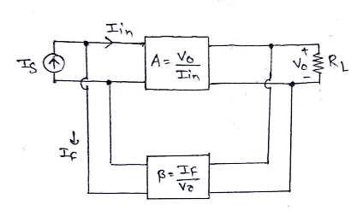
    - In this type of circuit, a portion of the o/p voltage can be applied to the input voltage in parallel with through the feedback circuit.
    - The block diagram of the voltage shunt feedback-amplifier is shown below, by which it is apparent that the feedback circuit is located in shunt by means of the output as well as the input.
    - When the feedback circuit is allied in shunt through the o/p as well as the input, then both the o/p impedance & the i/p impedance will be decreased.

- The input signal IS is applied as a input, If is the feedback current and VO is the output voltage.
- Af indicate relationship between VO and input current IS. The feedback current is given by If=βVO.
- Resistance amplifier is called so because output is voltage and input is current, hence ratio gives us resistance gain.
- The sample of output voltage is applied as a input to feedback network which feeds back the output signal to the input.
- The difference of input signal and feedback signal gets amplified by the resistance amplifier.

DERIVE THE CLOSE LOOP VOLTAGE GAIN, GAIN OF FEED BACK CKTS: -

Af (Resistance gain with feedback):

𝐴𝑓 = 𝑉₀𝐼_{𝑠} = 𝐴 𝐼_{𝑓}

Apply KCL at input side,

𝐼_{𝑖𝑛} = 𝐼_{𝑠} − 𝐼_{𝑓}

𝐼_{𝑠} = 𝐼_{𝑖𝑛} + 𝐼_{𝑓} = 𝐼_{𝑖𝑛} + 𝛽𝑉₀

𝐴𝑓 = 𝑉₀𝐼_{𝑖𝑛} + 𝛽𝑉₀
Divide numerator & denominator by 𝐼_{𝑖𝑛},

𝐴𝑓 = 𝑉₀𝐼_{𝑖𝑛} + 𝛽𝑉₀𝐼_{𝑖𝑛}
Since, 𝐴 = 𝑉₀𝐼_{𝑖𝑛}

𝐴𝑓 = 𝐴 + 𝛽𝐴
Due to negative feedback, gain decreases by a factor 1 + 𝛽𝐴.

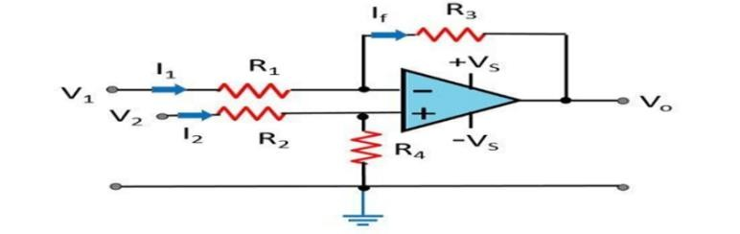
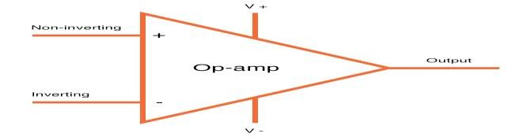
POSSIBLE SHORT TYPE QUESTIONS WITH ANSWER

Define Differential Amplifier? ( 2019-W)
Ans: - Differential Amplifier is a device that is used to amplify the difference in voltage of the two input signals. Differential Amplifier is an important building block in integrated circuits of analog system.

Define Operational amplifier (op-amp)
Ans: - An op-amp is a multi-stage, direct coupled, high gain negative feedback amplifier that has one or more differential amplifiers and it’s concluded with a level translator and an output stage.

Define I.C?
Ans: - An IC is one in which ckt components such as transistor, diode, resister, capacitor etc are automatically part of a small semiconductor chip.

Define CMRR? ( 2019-W)
Ans: - The CMRR is defined as the ratio of the powers of the differential gain over the common-mode gain, measured in positive decibels (thus using the 20 log rule): As differential gain should exceed common-mode gain, this will be a positive number, and the higher the better.

Define SLEW RATE? ( 2017-W)
Ans: - Slew rate is defined as the maximum rate of change of an op amp's output voltage and is given units of volts per microsecond. Slew rate is measured by applying a large signal step, such as 1V, to the input of the op amp, and measuring the rate of change from 10% to 90% of the output signal's amplitude.

Define LARGE SIGNAL VOLTAGE GAIN?
Ans: - This is the open loop voltage gain measured at DC with the amplifier producing a large (just less than maximum) voltage output, usually quoted in V/mV.

Define INPUT OFFSET CURRENT?
Ans: - There is a difference in the input current that flows in or out of each of the input pins, even if the output voltage of the operational amplifier is 0 V, due to the fact the pair characteristics (hFE,VBE) of the differential transistor do not match. This difference is known as the input offset current (IIO).

Define INPUT OFFSET VOLTAGE?
Ans: - The input offset voltage is defined as the voltage that must be applied between the
two input terminals of the op amp to obtain zero volts at the output. Ideally the output of the op
amp should be at zero volts when the inputs are grounded. In reality the input terminals are at slightly different dc potentials.
POSSIBLE LONG TYPE QUESTIONS:
  - Explain the block dig. Of typical opamp?( 2018-W)
  - Define I.C? Explain its manufacturing process?
  - Explain the operation of integrater and differentiator using OP-AMP with neat diagram. (S-23)

UNIT NO.-07
APPLICATION OF OPERATIONAL AMPLIFIER, TIMER CIRCUTS & IC VOLTAGE REGULATOR

LEARING OBJECTIVES:

  - Discuss the summing scaling and averaging of inverting and non-inverting amplifiers.
  - DC & AC Amplifier using OP-AMP.
  - Integrator and differentiator using op-amp.
  - Active filter and describe the filter design of fast order low Pass Butterworth.
  - Concept of Zero-Crossing Detector using Op-Amp.
  - Block diagram and operation of IC 555 timer &IC 565 PLL& its applications.
  - Working of Current to voltage Convertor using Operational Amplifier.
  - Working of the Voltage to Frequency Convertor using Operational Amplifier.
  - Working of the Frequency to Voltage Conversion using Operational Amplifier.
  - Operation of power supply using 78XX and 79XX,LM 317 Series with their PIN configuration.
  - Functional block diagram & Working of IC regulator LM 723 & LM 317.

: - DISCUSS THE SUMMING SCALING AND AVERAGING OF INVERTING AND NON-INVERTING AMPLIFIERS: -

Summing Amplifier
    - One of the important applications of an Operational Amplifier is the Summing Amplifier otherwise known as Adder. As the name suggests, a Summing Amplifier is an Op-amp based circuit where multiple input signals of different voltages are added.

Inverting Summing Amplifier
    - The most commonly used Summing Amplifier is an extended version of the Inverting Amplifier configuration i.e., multiple inputs are applied to the inverting input terminal of the Op Amp, while the non-inverting input terminal is connected to ground.
    - Due to this configuration, the output of Voltage Adder circuit is out of phase by 180o with respect to the input.
    - A general design of the Summing Amplifier is shown in the following circuit. Normal Inverting Amplifier circuit has only one voltage / input at its inverting input terminal.
    - If more input voltages are connected to the inverting input terminal as shown, the resulting output will be the sum of all the input voltages applied, but inverted.

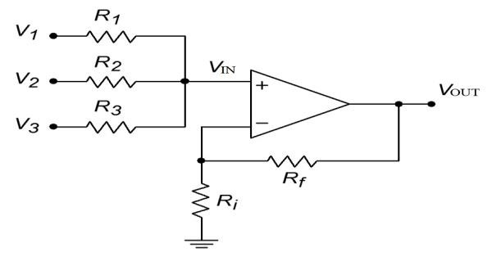
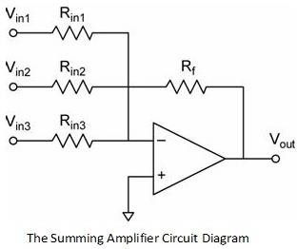
Non-Inverting Summing Amplifier
- A Non-Inverting Summing Amplifier can also be constructed using the Non-Inverting Amplifier configuration of the Op Amp.
- Here, the input voltages are applied to the non-inverting input terminal of the Op Amp and a part of the output is fed back to the inverting input terminal, through voltage-divider-bias feedback.
- The circuit of a Non-Inverting Summing Amplifier is shown in the following image. For the sake of convenience, the following circuit consists of only three inputs, but more inputs can be added.

  - Averaging Circuit: An averaging circuit can be made from the above circuit by making the all-input resistor equal in value i.e.; Ra = Rb = Rc =R and the gain must be selected such that if there are m inputs, then Rf/R must be equal to 1/m.
  - Scaling amplifier: In a scaling amplifier each input will be multiplied by a different factor and then summed together. Scaling amplifier is also called a weighted amplifier. Here different values are chosen for Ra, Rb and Rc. The governing equation is Vo = - ((Rf/Ra) Va + (Rf/Rb) Vb + (Rf/Rc) Vc).

: -DC & AC AMPLIFIER USING OP-AMP: -
    - With direct coupling between op-amps' internal transistor stages, they can amplify DC signals just as well as AC (up to certain maximum voltage-rise time limits).
    - For these reasons, op-amps have all but obsoleted discrete-transistor signal amplifiers in many applications.

: - INTEGRATOR AND DIFFERENTIATOR USING OP-AMP: -

Differentiator
    - A differentiator is an electronic circuit that produces an output equal to the first derivative of its input. This section discusses about the op-amp based differentiator in detail.
    - An op-amp based differentiator produces an output, which is equal to the differential of input voltage that is applied to its inverting terminal. The circuit diagram of an op-amp based differentiator is shown in the following figure −

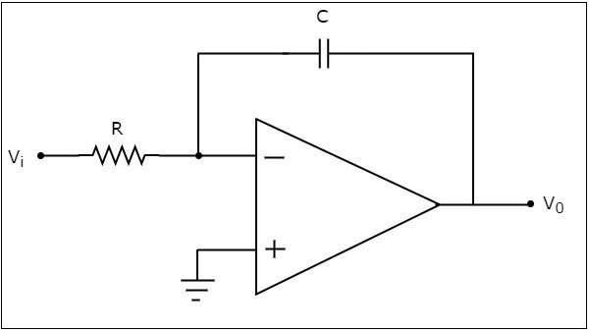
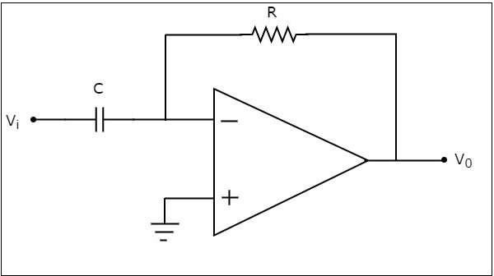
    - In the above circuit, the non-inverting input terminal of the op-amp is connected to ground. That means zero volts is applied to its non-inverting input terminal.
    - According to the virtual short concept, the voltage at the inverting input terminal of opamp will be equal to the voltage present at its non-inverting input terminal. So, the voltage at the inverting input terminal of op-amp will be zero volts.
    - The nodal equation at the inverting input terminal's node is −
Cd(0−Vi)dt+0−V0R=0
⇒−CdVidt=V0R
⇒V0=−RCdVidt
    - If RC=1sec, then the output voltage V0 will be
V0=−dVidt
    - Thus, the op-amp based differentiator circuit shown above will produce an output, which is the differential of input voltage Vi, when the magnitudes of impedances of resistor and capacitor are reciprocal to each other.
    - Note that the output voltage V0 is having a negative sign, which indicates that there exists a 180⁰ phase difference between the input and the output.

Integrator
    - An integrator is an electronic circuit that produces an output that is the integration of the applied input. This section discusses about the op-amp based integrator.
    - An op-amp based integrator produces an output, which is an integral of the input voltage applied to its inverting terminal. The circuit diagram of an op-amp based integrator is shown in the following figure .

    - In the circuit shown above, the non-inverting input terminal of the op-amp is connected to ground. That means zero volts is applied to its non-inverting input terminal.
    - According to virtual short concept, the voltage at the inverting input terminal of op-amp will be equal to the voltage present at its non-inverting input terminal. So, the voltage at the inverting input terminal of op-amp will be zero volts.
    - The nodal equation at the inverting input terminal is −
0−ViR+Cd(0−V0)dt=0
⇒−ViR=CdV0dt

⇒dV0dt=−ViRC
⇒dV0=(−ViRC)dt
    - Integrating both sides of the equation shown above, we get −
∫dV0=∫(−ViRC)dt
⇒V0=−1RC∫Vtdt
    - If RC=1secRC=1sec, then the output voltage, V0 will be −

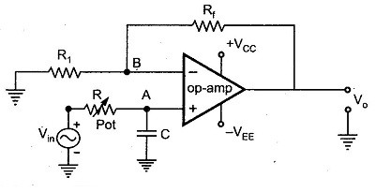
V0=−∫Vidt
    - So, the op-amp based integrator circuit discussed above will produce an output, which is the integral of input voltage Vi, when the magnitude of impedances of resistor and capacitor are reciprocal to each other.
    - Note − The output voltage, V0 is having a negative sign, which indicates that there exists 180⁰ phase difference between the input and the output.

: - ACTIVE FILTER AND DESCRIBE THE FILTER DESIGN OF 1ST ORDER LOW PASS BUTTERWORTH: -

ACTIVE FILTER:
    - An active filter is a type of analog circuit implementing an electronic filter using active components, typically an amplifier. Amplifiers included in a filter design can be used to improve the cost, performance and predictability of a filter.

THE FILTER DESIGN OF 1ST ORDER LOW PASS BUTTERWORTH:
    - The first order low pass butterworth filter is realised by R-C circuit used along with an op-amp, used in the noninverting configuration. The circuit diagram is shown in Fig.. This also called one pole low pass butterworth filter.

    - The resistances Rf and R1 decide the gain of the filter in the pass band.
Design Steps

The design steps for the first order low pass Butterworth filter are
- Choose the cut off frequency, fH.
- Choose the capacitance C usually between 0.001 and 1 μF. Generally, it is selected as 1 μF or less than that. For better performance, mylar or tantalum capacitors are selected.
- Now, for the RC circuit,

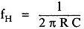

Hence, as fH and C are known, calculate the value of R.
- The resistances Rf and R1 can be selected depending on the required gain in the pass band.
𝑅_{𝑓}
𝐴_{𝑓} = 1 + 𝑅
1

CONCEPT OF ZERO-CROSSING DETECTOR USING OP-AMP: -
- A Zero Crossing Detector Circuit is a useful application of Op-amp as Comparator. It is used to track the changing in the sine waveform from positive to negative or vice versa while it crosses Zero voltage.
- It can also be used as a Square Wave Generator. Zero Crossing Detector has many applications like time marker generator, phase meter, frequency counter etc.
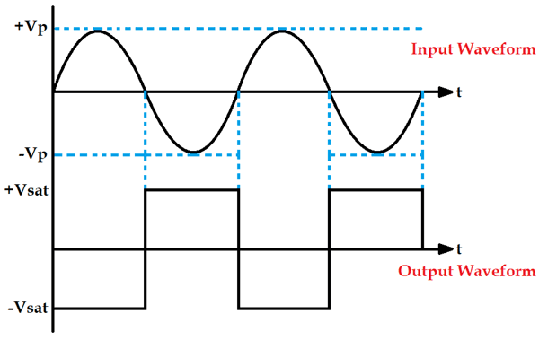
- A Zero Crossing Detector can be designed in many ways like using transistor, using op-amp or using optocoupler IC.
- It can be seen in the above waveform that whenever the sine wave crosses zero, the output of the Op- amp will shift either from negative to positive or from positive to negative.
- It shifts negative to positive when sine wave crosses positive to negative and vice versa. This is how a Zero Crossing Detector detects when the waveform is crossing zero every time.
- As you can observe that the output waveform is a square wave, so a Zero Crossing Detector is also called a square wave Generator Circuit.

: - BLOCK DIAG. & OPERATION OF IC 555 TIMER & IC 565 PLL & ITS APPLICATIONS: -

555 IC Timer Block Diagram

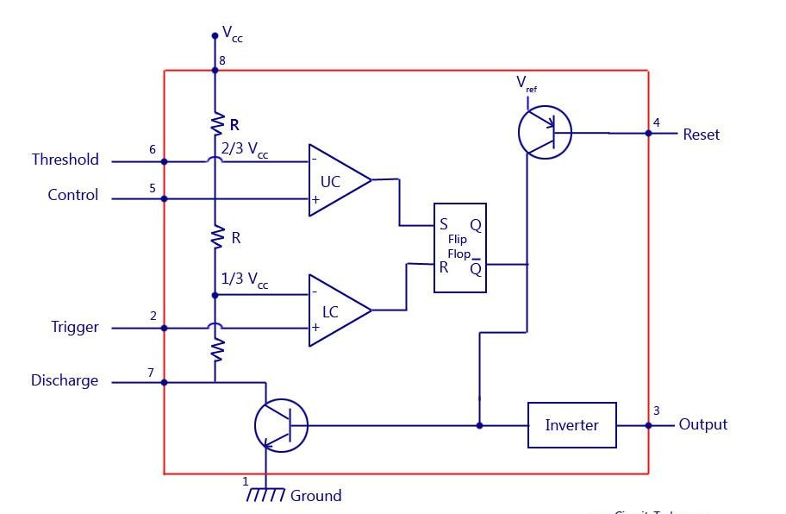
    - The block diagram of a 555 timer is shown in the above figure. A 555 timer has two comparators, which are basically 2 op-amps), an R-S flip-flop, two transistors and a resistive network.
    - Resistive network consists of three equal resistors and acts as a voltage divider.
    - Comparator 1 compares threshold voltage with a reference voltage + 2/3 VCC volts. Comparator 2 compares the trigger voltage with a reference voltage + 1/3 VCC volts.
    - Output of both the comparators is supplied to the flip-flop. Flip-flop assumes its state according to the output of the two comparators. One of the two transistors is a discharge transistor of which collector is connected to pin 7.
    - This transistor saturates or cuts-off according to the output state of the flip-flop. The saturated transistor provides a discharge path to a capacitor connected externally.
    - Base of another transistor is connected to a reset terminal. A pulse applied to this terminal resets the whole timer irrespective of any input.

Applications of 555 Timer circuits
To know more about applications of 555 Timer IC take a look at the following posts:
      - 555 timers as an astable multivirator
      - 555 timers as a monostable multivibrator
      - 555 timer oscillators

IC 565 PLL & ITS APPLICATIONS: -
    - The PLL IC 565 is usable over the frequency range 0.1 Hz to 500 kHz. It has highly stable centre frequency and is able to achieve a very linear FM detection. The output of VCO is capable of producing TTL compatible square wave.
    - The dual supply is in the range of ±6V to ±12V. The IC can also be operated from single supply in the range 12V to 24V.
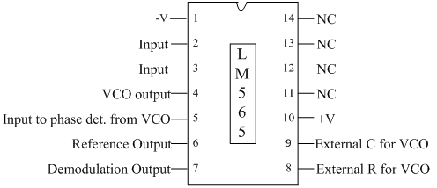
    - The following figure shows the pin-out and the internal block schematic of PLL IC LM 565.

      - It is a 14 pin IC, operated from a dual power supply +V (at pin no. 10) and –V (at pin no. 1).
      - Pin no 2 & 3 - Signal input for phase detector.
      - Pin no 4 -VCO output is available
      - Pin no 4 & 5 are shorted externally so that VCO output is applied for phase detection. In some applications PLL loop is broken and some circuit is to be connected between pin no 4 and 5.
      - Pin no 6- reference dc voltage is available.
      - Pin no 7 -demodulated output. If input signal between pin no 2 and 3 is FM signal then at pin no 7 we get FM demodulation output.

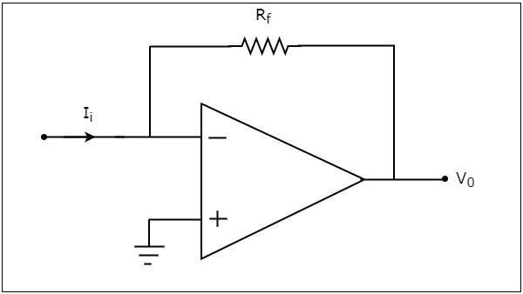
      - Pin no 8 and 9 - external R1 and C1 for VCO (determines free running frequency of VCO)
      - Internal resistance R2 and external capacitor C2 forms a LPF. The value of internal resistance R2 is 3.6kΩ.

Applications of IC 565 PLL
        - Phase-locked loops are widely employed in radio, telecommunications, computers and other electronic applications.

: - WORKING OF CURRENT TO VOLTAGE CONVERTOR USING OPAMP: -
    - A current to voltage converter or I to V converter is an electronic circuit that takes current as the input and produces voltage as the output.
    - An op-amp based current to voltage converter produces an output voltage when current is applied to its inverting terminal. The circuit diagram of an op-amp based current to voltage converter is shown in the following figure.

      - In the circuit shown above, the non-inverting input terminal of the op-amp is connected to ground. That means zero volts is applied at its non-inverting input terminal.
      - The nodal equation at the inverting terminal's node is −
−Ii+(0−V0)/Rf=0
−Ii=V0/Rf V0=−RtIi
      - Thus, the output voltage, V0 of current to voltage converter is the (negative) product of the feedback resistance, Rf and the input current, It. Observe that the output voltage, V0 is having a negative sign, which indicates that there exists a 180⁰ phase difference between the input current and output voltage.
We can re-write the above equation as ,
V0/Ii=−Rf

      - The above equation represents the ratio of the output voltage V0 and the input current Ii, and it is equal to the negative of feedback resistance, Rf. The ratio of output voltage V0 and input current Ii is called as Trans resistance.

: - WORKING OF VOLTAGE TO FREQUENCY CONVERTOR USING OPAMP: -
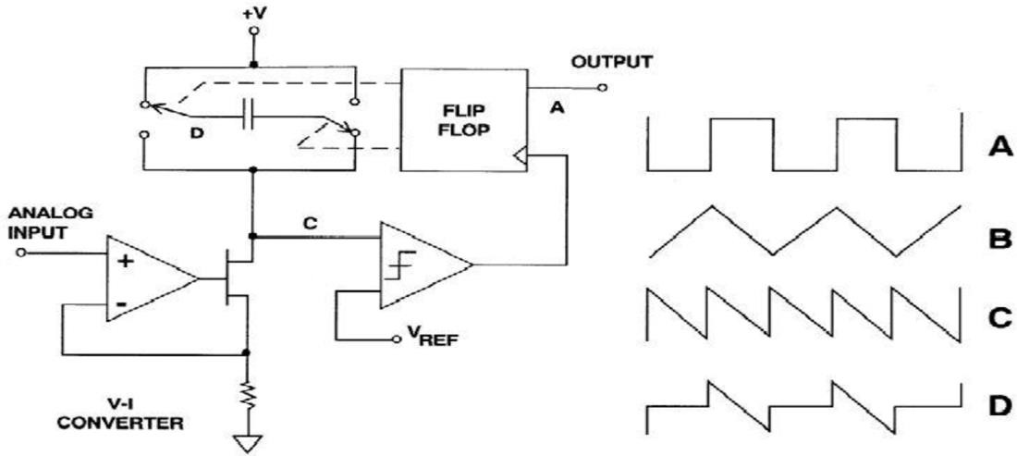
    - An op-Amp based voltage to frequency converter is designed whose output is obtained through a 555 timer. The main operation of the op-Amp is to serve as a voltage integrator which is necessary for triangular wave generation and also as a comparator for converting the triangular wave into square wave.
    - A voltage-to-frequency converter (VFC) is an oscillator. Its frequency is linearly proportional to the control voltage. The voltage to frequency (VFC)/counter ADC is monotonic and free of missing codes. It integrates noise and can consume very small amount of power. The voltage to frequency converter (VFC) is also very useful for telemetry applications, since the VFC, which is cheap, small, and low-powered can be mounted.

: - WORKING OF FREQUENCY TO VOLTAGE CONVERSION USING OPERATIONAL AMPLIFIER: -
    - Frequency to voltage converter is an electronic device which converts the sinusoidal input frequency into a proportional current or output voltage. The basic circuit includes operational amplifiers and RC circuits (Resistor Capacitor networks).
    - The operational amplifiers are used for signal processing. And the RC networks are used to remove the frequency dependent ripples. The diagram below shows the basic circuit of frequency to voltage converter using op-amp and RC networks:

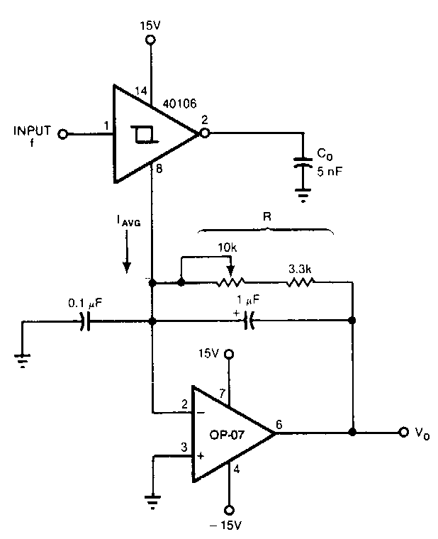
: - OPERATION OF POWER SUPPLY USING 78XX &79XX ,LM 317 SERISE WITH THEIR PIN CONFIGURATION: -
    - The voltage regulation and current regulation can be done with a variation to some of the additional components.
    - Here 78xx series of voltage regulators are most commonly used to provide a stable output voltage from a slightly higher input voltage. And 79xx series of voltage regulators perform in pretty much the same way but they are intended to output a negative voltage.
    - LM317 provides an adjustable technique filling the gap where the fixed voltage regulator isn’t available or a variable voltage supply is required.

Voltage Regulators 78xx Family:
    - The 78xx Voltage regulators are sometime referred to as (L78xx, LM78xx, or MC78xx). When required to supply a specific voltage to your circuit from a higher voltage input 78xx family of voltage regulators are champion still commonly used today in a considerable no of electronic devices due to their reliability robustness and simplicity. The 78xx series of voltage regulators are used in regulated power supplies.
    - Pin 1it is left hand pin connected to +VE or red terminal on a suitable battery acting as supply voltage input or VIN.
    - Pin 2 it is the center pin and the heat sink tab is connected to ground both on your supply voltage - VE or black terminal on the battery and it is also to the ground of your target circuit Shown as V or GNDon your schematic. The center pin may sometimes be cropped with the heat sink tab taking over its function.
    - Pin 3it is the output voltage that your target circuit will use as V+.

79xx Features Series of ICs:
    - The Negative voltage regulators are equally important as positive voltage regulators. The 79xx series of voltage regulators are the usually used negative voltage regulators. They are three terminal regulators and is available with fixed output voltages of -5V, -12V and -15V.
    - Pin 1it is left hand pin connected to +VE or red terminal on a suitable battery acting as supply voltage input or VIN.

    - Pin 2 it is the center pin and the heat sink tab is connected to ground both on your supply voltage - VE or black terminal on the battery and it is also to the ground of your target circuit Shown as V or GNDon your schematic. The center pin may sometimes be cropped with the heat sink tab taking over its function.
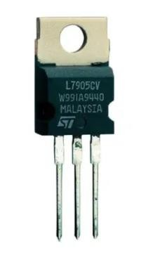
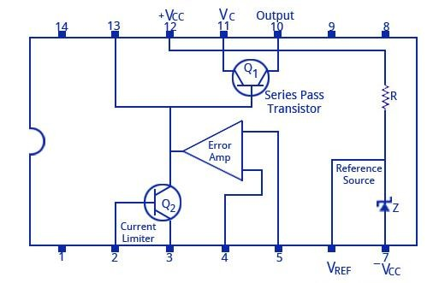
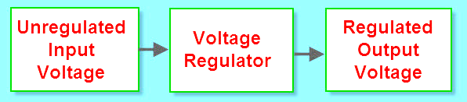
    - Pin 3it is the output voltage that your target circuit will use as V+.

: - FUNCTIONAL BLOCK DIAGRAM & WORKING OF IC REGULATOR LM 723 & LM 317: -
FUNCTIONAL BLOCK DIAGRAM & WORKING OF IC REGULATOR LM 723
    - The functional diagram of LM 723 the voltage regulator is shown below.
    - It consists of a voltage reference source (Pin 6), an error amplifier with its inverting input on pin 4 and non-inverting input on pin 5, a series pass transistor (pins 10 and 11), and a current limiting transistor on pins 2 and 3.
    - The device can be set to work as both posistive and negaive voltage regulators with an output voltage ranging from 2 V to 37 V, and output current levels upto 150 m .
    - The maximum supply voltage is 40 V, and the line and load regulations are each specified as 0.01%.

FUNCTIONAL BLOCK DIAGRAM & WORKING OF IC REGULATOR LM 317: -

    - It is a three-terminal-adjustable-voltage regulator and is easy to use because to set the output voltage it requires only two external resistors in the LM317 voltage regulator circuit. It is majorly used for local and on-card regulation.

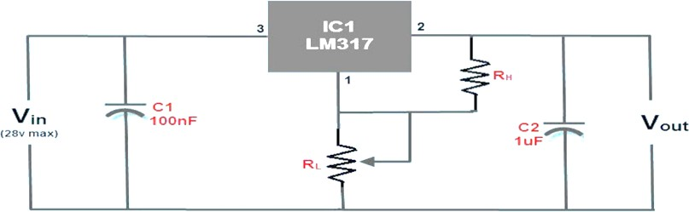
    - The three terminals are input pin, output pin, and adjustment pin. The LM317 circuit is shown in the below figure is a typical configuration of the LM317 voltage regulator circuit diagram including the decoupling capacitors.
    - This LM317 circuit is capable to provide variable DC power supply with an output of 1A and can be adjusted up to 30V. The circuit consists of a low-side resistor and high-side resistor connected in series forming a resistive voltage divider which is a passive linear circuit used to produce an output voltage which is a fraction of its input voltage.
    - Decoupling capacitors are used for decoupling or to prevent undesired coupling of one part of an electrical circuit from another part.
    - To avoid the effect of noise caused by some circuit elements over the remaining elements of the circuit, the decoupling capacitors in the circuit are used for addressing the input noise and output transients.

POSSIBLE SHORT TYPE QUESTIONS WITH ANSWER
- Define Summing Amplifier? (W-18)
ANS: One of the important applications of an Operational Amplifier is the Summing Amplifier otherwise known as Adder. As the name suggests, a Summing Amplifier is an Op-amp based circuit where multiple input signals of different voltages are added.
- Define Active Filter?
ANS: An active filter is a type of analog circuit implementing an electronic filter using active components, typically an amplifier. Amplifiers included in a filter design can be used to improve the cost, performance and predictability of a filter.
- Define Zero Crossing Detector?
ANS: A Zero Crossing Detector Circuit is a useful application of Op-amp as Comparator. It is used to track the changing in the sine waveform from positive to negative or vice versa while it crosses Zero voltage.
- Define PLL IC 565?

ANS: The PLL IC 565 is usable over the frequency range 0.1 Hz to 500 kHz. It has highly stable centre frequency and is able to achieve a very linear FM detection. The output of VCO is capable of producing TTL compatible square wave.
- Mention any two application of 555 timer.(S-23)
ANS: i)Pulse generation ii)Multivibrator
POSSIBLE LONG TYPE QUESTIONS

- Explain functional block diagram & working of ic regulator lm 317?
- Explain operation of power supply using 78xx &79xx? (w-18)
- Explain working of current to voltage convertor using OPAMP?
- Explain IC 565 PLL & its applications?
- Explain inverting summing amplifier? (w-19)
- With neat block diagram explain the operation of IC555 timer.(S-23)

